Revision History
Revision | Description of Change | Revision date
1.0 | Test report phase 1 and phas 2 | 2018-08-13
2.0 | Test report phase 3 | 2018-08-17
3.0 | Test report phase 4 | 2018-08-25
4.0 | Test report phase 5 | 2018-08-31
5.0 | Test report phase 6 | 2018-09-03
6.0 | Test report phase 7 | 2018-09-04

TABLE OF CONTENTS

Introduction 5
1 Test Object 5
2 Test Environment 7
3 Testing work （Phase 1） 8
3.1 Test Environment 8
3.2 Test scenario and strategy 9
3.3 Test Tool 9
3.4 Database setting 9
3.5 IIS setting 10
3.6 Test Object version 10
3.7 Background data 10
3.8 Test Conclusion 11
3.9 Suggestion 11
4 Testing work （Phase 2） 12
4.1 Test Environment 12
4.2 Test scenario and strategy 12
4.3 Test Tool 13
4.4 Database setting 13
4.5 IIS setting 13
4.6 Test Object version 13
4.7 Background data 14
4.8 Test Error 15
4.9 Test result of PS server 15
Test result of PS transactions 15
Test Statistic Report of PS 16
Transaction summary result of PS 17
Transaction response time result of PS 17
4.10 Test result of Web service 19
Test result of web transactions 19
Test Statistic Report of Web 19
Transaction summary result of Web 21
Transaction response time result of Web 21
4.11 Performance bottleneck analysis 23
Hardware usage analysis 23
SQL Server resource usage analysis 27
4.12 Test Conclusion 30
5 Testing work （Phase 3） 31
5.1 Test Environment 31
5.2 Test scenario and strategy 31
5.3 Test Tool 32
5.4 Database setting 32
5.5 IIS setting 32
5.6 Test Object version 32
5.7 Background data 32
5.8 Test Error 33
5.9 Test result of PS server 34
Test result of PS transactions 34
Test Statistic Report of PS 35
Transaction summary result of PS 36
Transaction response time result of PS 36
5.10 Test result of Web service 37
Test result of web transactions 38
Test Statistic Report of Web 38
Transaction summary result of Web 40
Transaction response time result of Web 40
5.11 Performance bottleneck analysis 42
Hardware usage analysis 42
SQL Server resource usage analysis 47
5.12 Test Conclusion 50
5.13 Tune suggestion: 51
6 Testing work （Phase 4） 54
6.1 Test Environment 55
6.2 Test scenario and strategy 55
6.3 Test Tool 56
6.4 Database setting 56
6.5 IIS setting 56
6.6 Test Object version 56
6.7 Background data 56
6.8 Test Error 57
6.9 Test result of PS server 58
Test result of PS transactions 58
Test Statistic Report of PS 58
Transaction summary result of PS 60
Transaction response time result of PS 60
6.10 Test result of Web service 61
Test result of web transactions 62
Test Statistic Report of Web 62
Transaction summary result of Web 64
Transaction response time result of Web 65
6.11 Performance bottleneck analysis 66
Hardware usage analysis 66
SQL Server resource usage analysis 70
6.12 Test Conclusion 74
7 Testing work （Phase 5） 75
7.1 Test Environment 75
7.2 Test scenario and strategy 75
7.3 Test Tool 76
7.4 Database setting 76
7.5 IIS setting 76
7.6 Test Object version 76
7.7 Background data 77
7.8 Test Error 78
7.9 Test result of PS server 78
Test result of PS transactions 78
Test Statistic Report of PS 78
Transaction summary result of PS 80
Transaction response time result of PS 80
7.10 Test result of Web service 81
Test result of web transactions 81
Test Statistic Report of Web 82
Transaction summary result of Web 84
Transaction response time result of Web 84
7.11 Performance bottleneck analysis 86
Hardware usage analysis 86
SQL Server resource usage analysis 91
7.12 Test Conclusion 95
8 Testing work （Phase 6） 97
8.1 Test Environment 97
8.2 Test scenario and strategy 98
8.3 Test Tool 98
8.4 Database setting 98
8.5 IIS setting 99
8.6 Test Object version 99
8.7 Background data 99
8.8 Test Error 100
8.9 Test result of PS server 100
Test result of PS transactions 100
Test Statistic Report of PS 101
Transaction summary result of PS 103
Transaction response time result of PS 103
8.10 Test result of Web service 104
Test result of web transactions 104
Test Statistic Report of Web 105
Transaction summary result of Web 107
Transaction response time result of Web 107
8.11 Performance bottleneck analysis 108
Hardware usage analysis 109
SQL Server resource usage analysis 113
8.12 Test Conclusion 116
9 Testing work （Phase 7） 117
9.1 Test Environment 117
9.2 Test scenario and strategy 118
9.3 Test Tool 118
9.4 Database setting 118
9.5 IIS setting 119
9.6 Test Object version 119
9.7 Background data 119
9.8 Test Error 120
9.9 Test result of PS server 121
Test result of PS transactions 121
Test Statistic Report of PS 121
Transaction summary result of PS 123
Transaction response time result of PS 123
9.10 Test result of Web service 124
Test result of web transactions 125
Test Statistic Report of Web 125
Transaction summary result of Web 127
Transaction response time result of Web 127
9.11 Performance bottleneck analysis 129
Hardware usage analysis 129
SQL Server resource usage analysis 134
9.12 Test Conclusion 137

Introduction
The PUMA performance testing works will focus on main work flow of the Print Server of Kiosk (PS).
The PUMA PS system will integrated with other 3rd systems like HIS, RIS, LIS etc. System will synchronize 3rd party data and provide the film and report printing services. The Cloud Film system will integrate with PS and get the patient information and images data from PS system.
We should confirm the performance of PS system will meet the requirements on real work environments. Ensure the images upload service of Cloud Film will not affect main workflow of PS system.

Test Object
The PUMA system will support film and report printing and notice push service for different departments of entire hospital.
We will integrate the 3rd party system and patients can print their reports in ONE terminal. The message push service will also be included in the product. Patients can query different information, and get report status notice service from the product.
PUMA MR1 system will provide the patient images data upload service for Cloud Film system. The patient can view the image files including picture and DICOM type from WeChat platform or by scanning from 2D image code.
The architecture as follow:
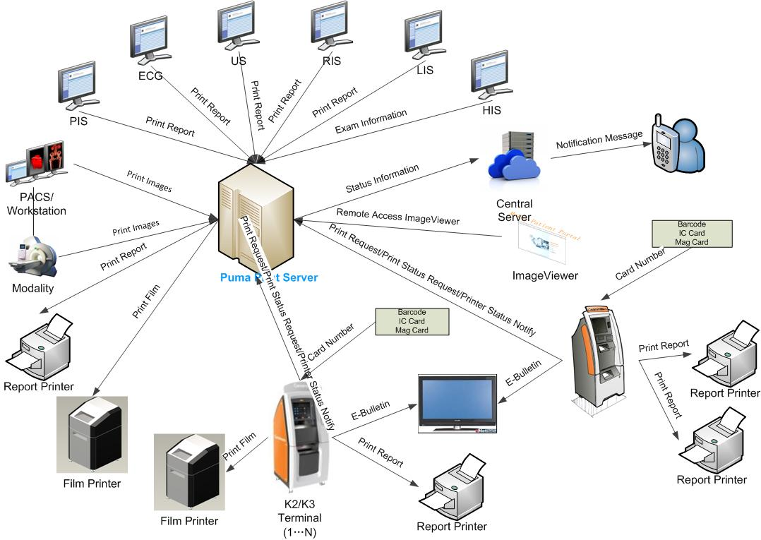Figure 3.1.2

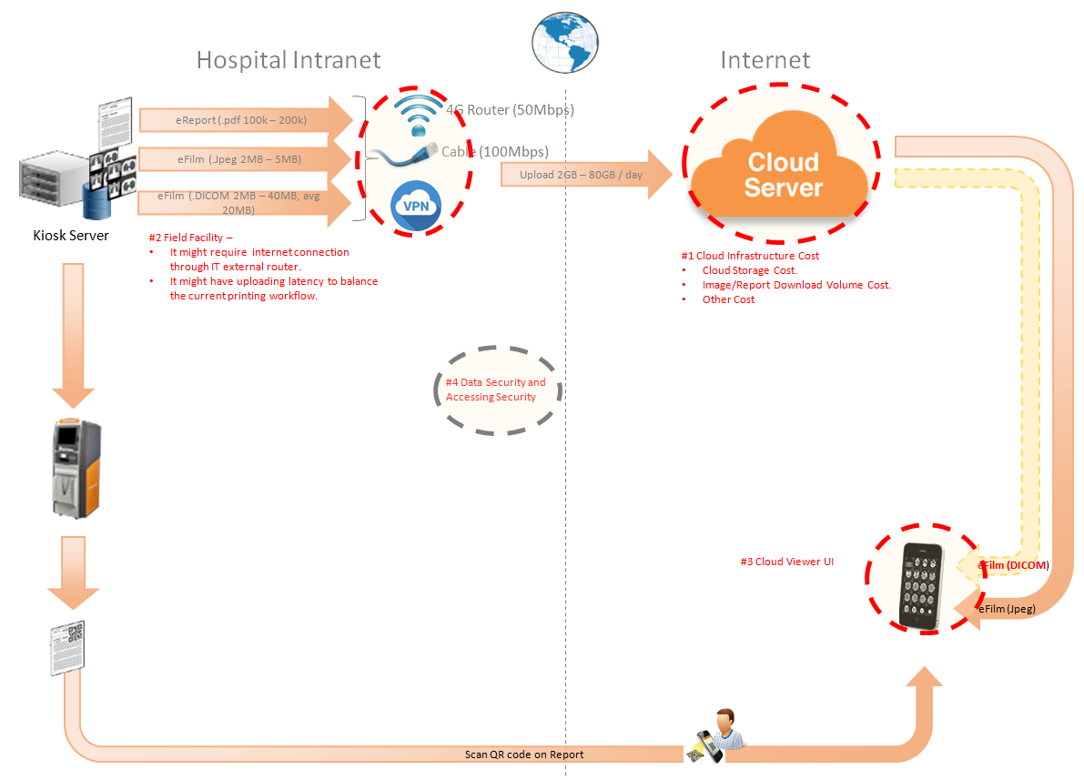Figure 3.1.2
The performance testing work will focus on the PS system. We will simulate the web service call and send them to PS server, and monitor the transactions response time, service performance and hardware resource usage. This scenario will include the 3rd request, report archived, film and report print, image files upload and web query, update operations etc.

Test Environment
The detailed hardware configurations of all servers are described as follow:

Computer name | CPU | Memory | HD | OS | Other | Comments
PS Server Panda upgrade | Interl(R) Xeon® CPU E5-2350 @ 1.80 * 6 | 16GB | 1TB | Windows 2008 R2 64bit | SQL server workgroup 2008 | Limit the local net width to 20MBps.
Workstation Server | Intel i3-2120 3.3GHz | 2GB | 80GB | Windows 7 SP1 64bit | QTP 11 | 6 virtual machine in server
Terminal | Intel Atom D525 1.8GHz | 4GB | 450GB | Windows Embedded Standard SP1 64bit | UTF 12.0 trail
Cloud Film Server | Interl(R) Xeon® CPU E5-2620 @ 2.40 * 6 | 64GB | 1T | Windows server2016 Standard 64 bit | Mock server from develop
Cloud film DB Server | Interl(R) Xeon® CPU E5-2620 @ 2.40 * 6 | 64GB | 1T | Windows server2016 Standard 64 bit | Mysql 5.6

Table 1 Hardware Configuration

Testing work （Phase 1）

Test Environment
The detailed hardware configurations of all servers are described as follow:

Computer name | CPU | Memory | HD | OS | Other | Comments
PS Server Panda upgrade | Interl(R) Xeon® CPU E5-2350 @ 1.80 * 6 | 16GB | 1TB | Windows 2008 R2 64bit | SQL server workgroup 2008 | Limit the local net width to 20MBps.
Workstation Server | Intel i3-2120 3.3GHz | 2GB | 80GB | Windows 7 SP1 64bit | QTP 11 | 6 virtual machine in server
Terminal | Intel Atom D525 1.8GHz | 4GB | 450GB | Windows Embedded Standard SP1 64bit | UTF 12.0 trail
Cloud Film Server | Interl(R) Xeon® CPU E5-2620 @ 2.40 * 6 | 64GB | 1T | Windows server2016 Standard 64 bit | Mock server from develop
Cloud film DB Server | Interl(R) Xeon® CPU E5-2620 @ 2.40 * 6 | 64GB | 1T | Windows server2016 Standard 64 bit | Mysql 5.6

Table 1 Hardware Configuration

Test scenario and strategy
Virtual User: 21 Users
Duration: 8 hour
Description: Use the test tool simulates the patient operations. Monitor the server software and hardware resource usage. The detail information as follow:
- Use automation tool simulate the doctor print film work. Simulate 6 GX Platform by using QTP and WinDPSTester tool. Each client prints one film which size is 10MB every 30 seconds.
- Use LR tool simulate 8 K2/K3 terminals to print film. Each client prints one film which size is 10MB random 5 to 30 seconds.
- Use LR tool simulate 8 users to do report archive operations. Each client archive report in random 5 to 30 seconds and size is random with 100kb and 4Mb.
- Use LR tool simulate 8 terminals to print paper reports. Each client prints report random 5 to 30 seconds.
- The OCR setting is not has rule for GX platforms in step1 and other setting are set as default. The OCR service will under the strong stress without configure the rule.
- Simulate 5 users to do the query information, view monitor page, query reconciliation films and report, expand the record, change the status, set holding time and other operations in worklist.
- Monitor the transaction response time.
- Monitor the hardware resource usage on PS.
- Monitor the resource usage for database on PS.
- Start/Stop 2 virtual users every 10 seconds and run the scenario for 8 hours.
- Simulate the Upload network bandwidth to 20M.

Note:
We will do the performance testing work under big stress for system. If system can work well under current stress and the transaction process ability meets the requirement, we will give the conclusion the system performance is pass.

Test Tool
Load Runner 12.

Database setting
Memory: Set the min and max memory size to 4GB.
Index fill factor: 80.
File: Increase the data and log files size and the rule is increase 200Mb as fixed size.

IIS setting
Connection: Set the max connection value to 4000 and keep other setting as default.

Test Object version
KIOSK cloud film 3.0.3.0 B23

Background data
We prepared a background records in the PS system. The data size is calculated by the typical site which printed 3,000 films in a workday. That means the records of films in db should more than 972,000 (3000records / day *54 weeks * 6 workday). QA team had prepared these data with SQL script and automation script. These data can backup and import by DB tool.
The detail data records in DB as follow:

Table Name | Data Volume (records)
printer.dbo.DeliveryJob | 995199
printer.dbo.ImageBox | 3530116
printer.dbo.Page | 314893
printer.dbo.Session | 571212
wggc.dbo.Patient | 1224710
wggc.dbo.Study | 1434574
wggc.dbo.AFP_PrintTerminalInfo | 70
wggc.dbo.Series | 1434524
wggc.dbo.Image | 1434527
wggc.dbo.AFP_FilmInfo | 1420905
wggc.dbo.AFP_ReportInfo | 1232003
wggc.dbo.AFP_ExamInfo | 2308723
wggc.dbo.AFP_PrintTask | 4324918
wggc.dbo.T_Integration_ExamInfo | 1421769
AFP_PrintMode | 523684
wggc.dbo.vi_KIOSK_ExamInfo_Order | 838208

Test Conclusion
The develop team offer a mock service and QA team limit the net width to 20Mbps. The system performance does not meet the requirements of design. The DICOM and report upload operation cannot work well and some issues exist in the database. The detail information as follow:
- The upload file queue will block if the queue is more than default value. It cause by the SQL statement in the database.
- The ACQ service will cause the database locks if script try to insert patient information to table patient in database wggc.
- The patient report will not upload if patient only has report because the patient has not patient information in database. The patient information will create when their image archived in system.
- The patient information created will failed when the patient age has character like “YMD” in DICOM files. Need change the column property in database.

QA team had submitted the defects in PLI to record these issues:
Event Number | Title
100048496 | [Performance] The upload queue will block when maxuploadfile value more than default one.
100048495 | [Performance]There are table lock issue exist in the database for acq service of PS.
100048438 | [Cloud Film]The patient report will not upload if patient only has report.
100048437 | [Cloud Film] The column patientage type should not be int in ECS and CS database .

Suggestion

- Fix the defects which had submitted by QA team.
- Enhance the SQL statement of “wggc.dbo.AFP_SP_GetExamsForSyncToECS”. This store procedure is the root reason of defect 10048496.
- Change the design of files upload logic. Reduce the number of upload thread. The reliability of service is important than the performance for our system.

Testing work （Phase 2）

Test Environment
The detailed hardware configurations of all servers are described as follow:

Computer name | CPU | Memory | HD | OS | Other | Comments
PS Server Panda upgrade | Interl(R) Xeon® CPU E5-2350 @ 1.80 * 6 | 16GB | 1TB | Windows 2008 R2 64bit | SQL server workgroup 2008 | Limit the local net width to 20MBps.
Workstation Server | Intel i3-2120 3.3GHz | 2GB | 80GB | Windows 7 SP1 64bit | QTP 11 | 6 virtual machine in server
Terminal | Intel Atom D525 1.8GHz | 4GB | 450GB | Windows Embedded Standard SP1 64bit | UTF 12.0 trail
Cloud Film Server | Interl(R) Xeon® CPU E5-2620 @ 2.40 * 6 | 64GB | 1T | Windows server2016 Standard 64 bit | Mock server from develop
Cloud film DB Server | Interl(R) Xeon® CPU E5-2620 @ 2.40 * 6 | 64GB | 1T | Windows server2016 Standard 64 bit | Mysql 5.6

Test scenario and strategy
Virtual User: 21 Users
Duration: 8 hour
Description: Use the test tool simulates the patient operations. Monitor the server software and hardware resource usage. The detail information as follow:
- Use automation tool simulate the doctor print film work. Simulate 6 GX Platform by using QTP and WinDPSTester tool. Each client prints one film which size is 10MB every 30 seconds.
- Use LR tool simulate 8 K2/K3 terminals to print film. Each client prints one film which size is 10MB random 5 to 30 seconds.
- Use LR tool simulate 8 users to do report archive operations. Each client archive report in random 5 to 30 seconds and size is random with 100kb and 4Mb.
- Use LR tool simulate 8 terminals to print paper reports. Each client prints report random 5 to 30 seconds.
- The OCR setting is not has rule for GX platforms in step1 and other setting are set as default. The OCR service will under the strong stress without configure the rule.
- Simulate 5 users to do the query information, view monitor page, query reconciliation films and report, expand the record, change the status, set holding time and other operations in worklist.
- Monitor the transaction response time.
- Monitor the hardware resource usage on PS.
- Monitor the resource usage for database on PS.
- Start/Stop 2 virtual users every 10 seconds and run the scenario for 8 hours.
- Simulate the Upload network bandwidth to 20M.

Note:
We will do the performance testing work under big stress for system. If system can work well under current stress and the transaction process ability meets the requirement, we will give the conclusion the system performance is pass.

Test Tool
Load Runner 12.

Database setting
Memory: Set the min and max memory size to 4GB.
Index fill factor: 80.
File: Increase the data and log files size and the rule is increase 200Mb as fixed size.

IIS setting
Connection: Set the max connection value to 4000 and keep other setting as default.

Test Object version
KIOSK cloud film 3.0.3.0 B23 + ACQ Path + Upload service Path

Background data
We prepared a background records in the PS system. The data size is calculated by the typical site which printed 3,000 films in a workday. That means the records of films in db should more than 972,000 (3000records / day *54 weeks * 6 workday). QA team had prepared these data with SQL script and automation script. These data can backup and import by DB tool.
The detail data records in DB as follow:

Table Name | Data Volume (records)
printer.dbo.DeliveryJob | 995199
printer.dbo.ImageBox | 3530116
printer.dbo.Page | 314893
printer.dbo.Session | 571212
wggc.dbo.Patient | 1224710
wggc.dbo.Study | 1434574
wggc.dbo.AFP_PrintTerminalInfo | 70
wggc.dbo.Series | 1434524
wggc.dbo.Image | 1434527
wggc.dbo.AFP_FilmInfo | 1420905
wggc.dbo.AFP_ReportInfo | 1232003
wggc.dbo.AFP_ExamInfo | 2308723
wggc.dbo.AFP_PrintTask | 4324918
wggc.dbo.T_Integration_ExamInfo | 1421769
AFP_PrintMode | 523684
wggc.dbo.vi_KIOSK_ExamInfo_Order | 838208

Test Error
There are some errors exist in the testing work and logged as follow:
No | Description | count
1. | Windows Resources. Cannot access data for measurement System|Context Switches/sec| on machine 10.184.129.108.  Details: A counter with a negative value was detected.
2 | Error: Query report records to print from databse failed: the accessionnumber is A201808***** the count is 2

Error analyzes:
- It caused by the test tool means some performance counter cannot find or get the value. It`s not test error
- It caused by the test data means the patient has two reports. The test script can only process the transaction that patient has only one report. Script will output this warning and execute next iterations. They are not test error.

Test result of PS server

Test result of PS transactions
After the performance testing works, the transactions result of PS print module as follow:
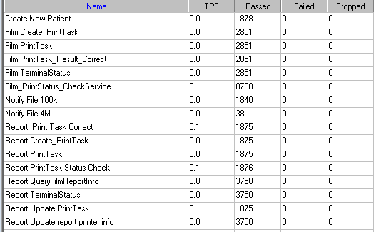

Test Statistic Report of PS
Analysis Summary | Period: 2018/8/12 9:07 - 2018/8/12 17:17

Scenario Name: | E:\ECS\Performance\Script\208\ScenarioPUMA_Reliability_171.lrs
Results in Session: | c:\Users\Administrator\AppData\Local\Temp\res119\res119.lrr
Duration: | 8 hours, 9 minutes and 27 seconds.

Statistics Summary

Maximum Running Vusers: |  | 16
Total Throughput (bytes): |  | 16,706,770
Average Throughput (bytes/second): |  | 569
Total Hits: |  | 17,261
Average Hits per Second: |  | 0.588 | View HTTP Responses Summary
Total Errors: |  | 2

You can define SLA data using the SLA configuration wizard
You can analyze transaction behavior using the Analyze Transaction mechanism

Transaction Summary

Transactions: | Total Passed: 44,494 | Total Failed: 0 | Total Stopped: 0 | Average Response Time

Transaction Name | SLA Status | Minimum | Average | Maximum | Std. Deviation | 90 Percent | Pass | Fail | Stop
Create New Patient |  | 0.078 | 0.188 | 7.289 | 0.272 | 0.328 | 1,878 | 0 | 0
Film Create_PrintTask |  | 0.827 | 1.252 | 10.797 | 0.465 | 1.81 | 2,851 | 0 | 0
Film PrintTask |  | 0.016 | 0.097 | 1.186 | 0.123 | 0.218 | 2,851 | 0 | 0
Film PrintTask_Result_Correct |  | 0 | 0 | 0.016 | 0.001 | 0 | 2,851 | 0 | 0
Film TerminalStatus |  | 0 | 0.08 | 4.867 | 0.148 | 0.187 | 2,851 | 0 | 0
Film_PrintStatus_CheckService |  | 0 | 0.086 | 8.002 | 0.187 | 0.218 | 8,708 | 0 | 0
Notify File 100k |  | 0.031 | 0.409 | 9.064 | 0.482 | 0.863 | 1,840 | 0 | 0
Notify File 4M |  | 0.094 | 0.527 | 2.153 | 0.373 | 1.026 | 38 | 0 | 0
Report Print Task Correct |  | 0 | 0 | 0 | 0 | 0 | 1,875 | 0 | 0
Report Create_PrintTask |  | 0.406 | 0.796 | 7.414 | 0.397 | 1.232 | 1,875 | 0 | 0
Report PrintTask |  | 0.016 | 0.13 | 5.374 | 0.209 | 0.318 | 1,875 | 0 | 0
Report PrintTask Status Check |  | 0 | 0.093 | 9.032 | 0.287 | 0.212 | 1,876 | 0 | 0
Report QueryFilmReportInfo |  | 0.499 | 0.902 | 18.169 | 0.513 | 1.364 | 3,750 | 0 | 0
Report TerminalStatus |  | 0 | 0.078 | 6.412 | 0.169 | 0.196 | 3,750 | 0 | 0
Report Update PrintTask |  | 0.016 | 0.159 | 11.99 | 0.345 | 0.359 | 1,875 | 0 | 0
Report Update report printer info |  | 0 | 0.074 | 9.108 | 0.204 | 0.187 | 3,750 | 0 | 0

Service Level Agreement Legend: |  | Pass |  | Fail |  | No Data

HTTP Responses Summary

HTTP Responses | Total | Per second
HTTP_200 | 17,261 | 0.588

Follow the summary report, we can see all the transactions have passed and transaction response time can accept.

Transaction summary result of PS
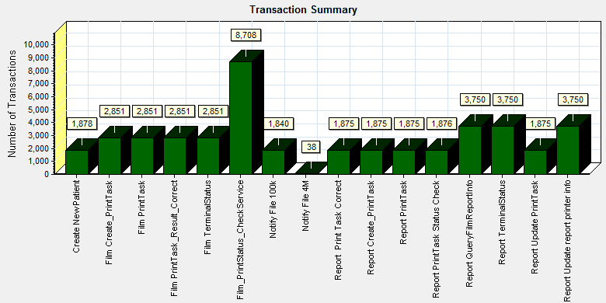
Color | Scale | Measurement
 | 1 | Pass

We can see that there is no transaction failed during the testing works.

Transaction response time result of PS
We can get the transaction response time information from the figure as follow:
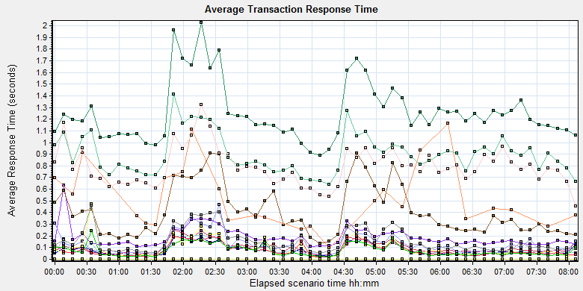

Color | Scale | Measurement | Graph's Minimum | Graph's Average | Graph's Maximum | Graph's Median
 | 1 | Create New Patient | 0.108 | 0.187 | 0.63 | 0.158
 | 1 | Film Create_PrintTask | 0.888 | 1.253 | 2.026 | 1.194
 | 1 | Film PrintTask | 0.031 | 0.099 | 0.253 | 0.077
 | 1 | Film PrintTask_Result_Correct | 0 | 0 | 0.001 | 0
 | 1 | Film TerminalStatus | 0.022 | 0.081 | 0.206 | 0.064
 | 1 | Film_PrintStatus_CheckService | 0.019 | 0.083 | 0.209 | 0.058
 | 1 | Notify File 100k | 0.137 | 0.407 | 0.911 | 0.358
 | 1 | Notify File 4M | 0.094 | 0.519 | 1.162 | 0.432
 | 1 | Report Print Task Correct | 0 | 0 | 0 | 0
 | 1 | Report Create_PrintTask | 0.456 | 0.793 | 1.326 | 0.773
 | 1 | Report PrintTask | 0.033 | 0.131 | 0.468 | 0.103
 | 1 | Report PrintTask Status Check | 0.021 | 0.093 | 0.474 | 0.063
 | 1 | Report QueryFilmReportInfo | 0.638 | 0.9 | 1.414 | 0.873
 | 1 | Report TerminalStatus | 0.017 | 0.078 | 0.193 | 0.056
 | 1 | Report Update PrintTask | 0.055 | 0.159 | 0.459 | 0.116
 | 1 | Report Update report printer info | 0.018 | 0.075 | 0.24 | 0.054

Transaction response time

This figure information shows all transaction response time. We can analysis that there are no transaction response time more than 3 seconds. It`s good performance for our system.

Test result of Web service

Test result of web transactions
After the performance testing works, the transactions result of we module as follow:
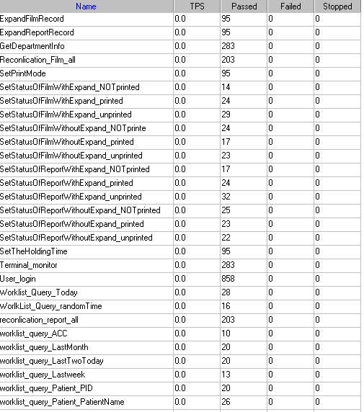
Follow the figure, we can see that there are no transactions failed.

Test Statistic Report of Web
Analysis Summary | Period: 12/08/2018 09:33:23 - 12/08/2018 15:37:40

Scenario Name: | D:\Performance\ScenarioPUMA_Reliability_171.lrs
Results in Session: | c:\Users\administrator\appdata\local\temp\res1190\res1190.lrr
Duration: | 6 hours, 4 minutes and 17 seconds.

Statistics Summary

Maximum Running Vusers: |  |  |  | 5
Total Throughput (bytes): |  |  | 226,980,963
Average Throughput (bytes/second): |  |  |  | 10,384
Total Hits: |  |  |  | 20,836
Average Hits per Second: |  |  |  | 0.953
 | Transaction Summary

Transactions: | Total Passed: 2,637 | Total Failed: 0 | Total Stopped: 0 | Average Response Time

 | Pass | Fail | Stop
Total | 2,637 | 0 | 0

Transaction Name | Minimum | Average | Maximum | Std. Deviation | 90 Percent | Pass | Fail | Stop
ExpandFilmRecord | 0.039 | 1.636 | 9.702 | 2.061 | 4.59 | 95 | 0 | 0
ExpandReportRecord | 0.006 | 0.017 | 0.194 | 0.027 | 0.027 | 95 | 0 | 0
GetDepartmentInfo | 0.005 | 0.015 | 0.35 | 0.032 | 0.018 | 283 | 0 | 0
Reconlication_Film_all | 0.162 | 0.488 | 4.097 | 0.755 | 0.833 | 203 | 0 | 0
reconlication_report_all | 0.026 | 0.208 | 3.47 | 0.553 | 0.295 | 203 | 0 | 0
SetPrintMode | 0.026 | 0.931 | 3.892 | 1.344 | 3.338 | 95 | 0 | 0
SetStatusOfFilmWithExpand_NOTprinted | 0.08 | 2.396 | 7.782 | 2.219 | 5.492 | 14 | 0 | 0
SetStatusOfFilmWithExpand_printed | 0.1 | 2.833 | 8.503 | 2.932 | 7.124 | 24 | 0 | 0
SetStatusOfFilmWithExpand_unprinted | 0.082 | 3.186 | 13.433 | 2.968 | 5.791 | 29 | 0 | 0
SetStatusOfFilmWithoutExpand_NOTprinte | 0.04 | 0.662 | 3.324 | 1.024 | 3.193 | 24 | 0 | 0
SetStatusOfFilmWithoutExpand_printed | 0.045 | 1.22 | 5.011 | 1.606 | 3.369 | 17 | 0 | 0
SetStatusOfFilmWithoutExpand_unprinted | 0.052 | 0.906 | 3.501 | 1.275 | 3.244 | 23 | 0 | 0
SetStatusOfReportWithExpand_NOTprinted | 0.041 | 0.989 | 4.447 | 1.494 | 3.54 | 17 | 0 | 0
SetStatusOfReportWithExpand_printed | 0.038 | 0.931 | 3.613 | 1.388 | 3.214 | 24 | 0 | 0
SetStatusOfReportWithExpand_unprinted | 0.039 | 0.769 | 3.68 | 1.299 | 3.284 | 32 | 0 | 0
SetStatusOfReportWithoutExpand_NOTprinted | 0.049 | 1.372 | 4.112 | 1.564 | 3.572 | 25 | 0 | 0
SetStatusOfReportWithoutExpand_printed | 0.04 | 1.212 | 4.621 | 1.522 | 3.372 | 23 | 0 | 0
SetStatusOfReportWithoutExpand_unprinted | 0.048 | 1.059 | 3.992 | 1.484 | 3.373 | 22 | 0 | 0
SetTheHoldingTime | 0.023 | 1.033 | 3.762 | 1.478 | 3.353 | 95 | 0 | 0
Terminal_monitor | 0.097 | 0.242 | 2.258 | 0.286 | 0.479 | 283 | 0 | 0
User_login | 0.169 | 0.498 | 4.516 | 0.494 | 1.063 | 858 | 0 | 0
worklist_query_ACC | 0.011 | 0.023 | 0.063 | 0.016 | 0.037 | 10 | 0 | 0
worklist_query_LastMonth | 0.037 | 0.089 | 0.259 | 0.063 | 0.212 | 20 | 0 | 0
worklist_query_LastTwoToday | 0.013 | 0.061 | 0.218 | 0.057 | 0.128 | 20 | 0 | 0
worklist_query_Lastweek | 0.04 | 0.099 | 0.513 | 0.127 | 0.208 | 13 | 0 | 0
worklist_query_Patient_PatientName | 0.014 | 0.037 | 0.11 | 0.028 | 0.084 | 26 | 0 | 0
worklist_query_Patient_PID | 0.014 | 0.057 | 0.396 | 0.09 | 0.091 | 20 | 0 | 0
Worklist_Query_Today | 0.02 | 0.174 | 3.171 | 0.582 | 0.23 | 28 | 0 | 0
WorlkList_Query_randomTime | 0.033 | 0.07 | 0.283 | 0.057 | 0.093 | 16 | 0 | 0

Service Level Agreement Legend: |  | Pass |  | Fail |  | No Data

HTTP Responses Summary

HTTP Responses | Total | Per second
HTTP_200 | 19,978 | 0.914
HTTP_302 | 858 | 0.039
Follow the summary report, we can see all the transactions have passed and transaction response time can accept.

Transaction summary result of Web
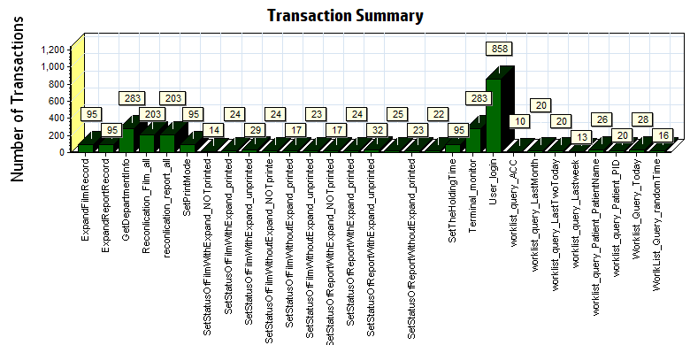
Color | Scale | Measurement
 | 1 | Pass

We can see that there is no transaction failed during the testing works.

Transaction response time result of Web
We can get the transaction response time information from the figure as follow:
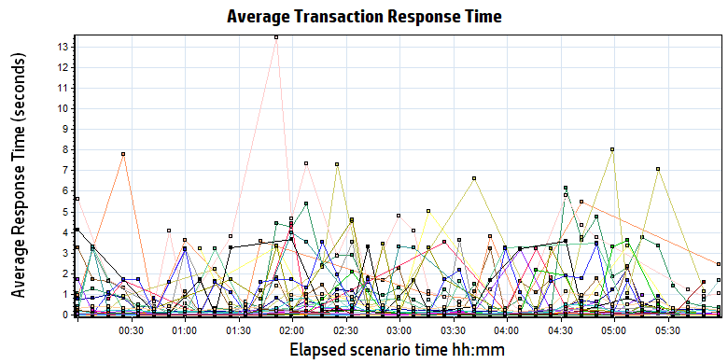
Color | Scale | Measurement | Minimum | Average | Maximum
 | 1 | ExpandFilmRecord | 0.039 | 1.636 | 9.702
 | 1 | ExpandReportRecord | 0.006 | 0.017 | 0.194
 | 1 | GetDepartmentInfo | 0.005 | 0.015 | 0.350
 | 1 | Reconlication_Film_all | 0.162 | 0.488 | 4.097
 | 1 | reconlication_report_all | 0.026 | 0.208 | 3.470
 | 1 | SetPrintMode | 0.026 | 0.931 | 3.892
 | 1 | SetStatusOfFilmWithExpand_NOTprinted | 0.080 | 2.396 | 7.782
 | 1 | SetStatusOfFilmWithExpand_printed | 0.100 | 2.833 | 8.503
 | 1 | SetStatusOfFilmWithExpand_unprinted | 0.082 | 3.186 | 13.433
 | 1 | SetStatusOfFilmWithoutExpand_NOTprinte | 0.040 | 0.662 | 3.324
 | 1 | SetStatusOfFilmWithoutExpand_printed | 0.045 | 1.220 | 5.011
 | 1 | SetStatusOfFilmWithoutExpand_unprinted | 0.052 | 0.906 | 3.501
 | 1 | SetStatusOfReportWithExpand_NOTprinted | 0.041 | 0.989 | 4.447
 | 1 | SetStatusOfReportWithExpand_printed | 0.038 | 0.931 | 3.613
 | 1 | SetStatusOfReportWithExpand_unprinted | 0.039 | 0.769 | 3.680
 | 1 | SetStatusOfReportWithoutExpand_NOTprinted | 0.049 | 1.372 | 4.112
 | 1 | SetStatusOfReportWithoutExpand_printed | 0.040 | 1.212 | 4.621
 | 1 | SetStatusOfReportWithoutExpand_unprinted | 0.048 | 1.059 | 3.992
 | 1 | SetTheHoldingTime | 0.023 | 1.033 | 3.762
 | 1 | Terminal_monitor | 0.097 | 0.242 | 2.258
 | 1 | User_login | 0.169 | 0.498 | 4.516
 | 1 | worklist_query_ACC | 0.011 | 0.023 | 0.063
 | 1 | worklist_query_LastMonth | 0.037 | 0.089 | 0.259
 | 1 | worklist_query_LastTwoToday | 0.013 | 0.061 | 0.218
 | 1 | worklist_query_Lastweek | 0.040 | 0.099 | 0.513
 | 1 | worklist_query_Patient_PatientName | 0.014 | 0.037 | 0.110
 | 1 | worklist_query_Patient_PID | 0.014 | 0.057 | 0.396
 | 1 | Worklist_Query_Today | 0.020 | 0.174 | 3.171
 | 1 | WorlkList_Query_randomTime | 0.033 | 0.070 | 0.283
Transaction response time

Follow the figure: we can see that the transaction average response time is less than 4 seconds. But some transactions response time is not smoothly. We should monitor that and try to fix the issues.

Performance bottleneck analysis

Hardware usage analysis
During the testing work, we use the test tool to monitor the server hardware usage include the CPU, Memory, hard disk and etc.
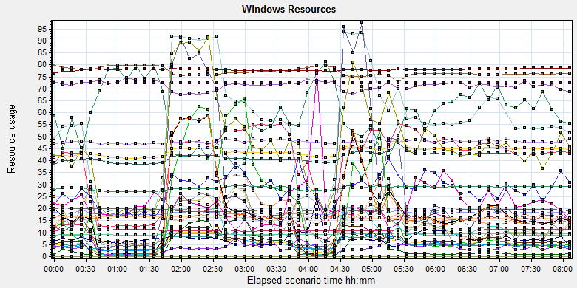
Color | Scale | Measurement | Minimum | Average | Maximum | Std. Deviation
 | 0.1 | % Disk Time (PhysicalDisk _Total):10.184.129.108 | 1.943 | 144.704 | 13112.083 | 271.074
 | 1 | % Idle Time (PhysicalDisk _Total):10.184.129.108 | 0 | 59.179 | 98.59 | 23.017
 | 100 | % Interrupt Time (Processor _Total):10.184.129.108 | 0 | 0.143 | 1.128 | 0.134
 | 1 | % Privileged Time (Processor _Total):10.184.129.108 | 0 | 5.556 | 17.444 | 3.418
 | 10 | % Processor Time (Process CloudDataUploadService):10.184.129.108 | 0 | 0.752 | 14.508 | 1.384
 | 1 | % Processor Time (Processor _Total):10.184.129.108 | 0.781 | 55.217 | 100 | 26.888
 | 0.01 | Available MBytes (Memory):10.184.129.108 | 6973 | 7704.322 | 8213 | 172.525
 | 0.0001 | Avg. Disk Bytes/Transfer (PhysicalDisk _Total):10.184.129.108 | 972.8 | 179682.53 | 1249028.655 | 157075.381
 | 10 | Avg. Disk Queue Length (PhysicalDisk _Total):10.184.129.108 | 0.019 | 1.447 | 131.121 | 2.711
 | 10 | Avg. Disk Write Queue Length (PhysicalDisk _Total):10.184.129.108 | 0.019 | 1.252 | 22.579 | 1.338
 | 0.001 | Bytes Total/sec (Server):10.184.129.108 | 14471.872 | 18151.065 | 260978.525 | 2498.784
 | 1E-07 | Cache Bytes (Memory):10.184.129.108 | 269893632 | 286209815.961 | 308727808 | 8582073.467
 | 1E-09 | Committed Bytes (Memory):10.184.129.108 | 8835493888 | 9398247526.568 | 10406977536 | 217787863.82
 | 0.001 | Context Switches/sec (System):10.184.129.108 | 2642.54 | 40765.966 | 108561.299 | 22466.931
 | 10 | Current Disk Queue Length (PhysicalDisk _Total):10.184.129.108 | 0 | 1.426 | 132 | 3.626
 | 1E-05 | Disk Read Bytes/sec (PhysicalDisk _Total):10.184.129.108 | 0 | 1799025.922 | 71561318.841 | 3207552.076
 | 1 | Disk Reads/sec (PhysicalDisk _Total):10.184.129.108 | 0 | 19.102 | 707.705 | 27.274
 | 1 | Disk Transfers/sec (PhysicalDisk _Total):10.184.129.108 | 2.325 | 46.907 | 725.639 | 33.724
 | 1E-06 | Disk Write Bytes/sec (PhysicalDisk _Total):10.184.129.108 | 2551.376 | 5571317.968 | 31155380.416 | 4575272.12
 | 1 | Disk Writes/sec (PhysicalDisk _Total):10.184.129.108 | 1.329 | 27.805 | 253.988 | 15.736
 | 0.001 | File Data Operations/sec (System):10.184.129.108 | 273.011 | 9351.431 | 33335.757 | 7679.698
 | 1E-05 | Free Megabytes (LogicalDisk _Total):10.184.129.108 | 1586554 | 1626565.694 | 1665603 | 23994.447
 | 0.001 | Interrupts/sec (Processor _Total):10.184.129.108 | 540.718 | 5630.306 | 31290.07 | 4445.903
 | 0.0001 | Page Faults/sec (Memory):10.184.129.108 | 73.071 | 62247.542 | 196282.521 | 45635.606
 | 0.1 | Page Faults/sec (Process CloudDataUploadService):10.184.129.108 | 0 | 223.618 | 6395.67 | 485.312
 | 1E-06 | Page File Bytes (Process CloudDataUploadService):10.184.129.108 | 42242048 | 47898709.754 | 83550208 | 1904724.8
 | 1 | Page Reads/sec (Memory):10.184.129.108 | 0 | 18.315 | 723.978 | 27.247
 | 0.01 | Pages/sec (Memory):10.184.129.108 | 0 | 416.062 | 5295.336 | 690.214
 | 1E-06 | Pool Nonpaged Bytes (Memory):10.184.129.108 | 75587584 | 77938021.307 | 80072704 | 488807.469
 | 0.0001 | Pool Nonpaged Bytes (Server):10.184.129.108 | 630463 | 714018.259 | 790207 | 24692.478
 | 1E-07 | Pool Paged Bytes (Memory):10.184.129.108 | 187564032 | 194669019.429 | 203177984 | 3612893.68
 | 0.001 | Pool Paged Bytes (Server):10.184.129.108 | 72245 | 72245 | 72245 | 0
 | 1 | Pool Paged Failures (Server):10.184.129.108 | 0 | 0 | 0 | 0
 | 1E-08 | Private Bytes (Process _Total):10.184.129.108 | 3653181440 | 4158895589.097 | 5109260288 | 192712363.521
 | 10 | Processor Queue Length (System):10.184.129.108 | 0 | 2.728 | 51 | 5.205
 | 1 | Split IO/Sec (PhysicalDisk _Total):10.184.129.108 | 0 | 3.776 | 220.744 | 8.469
 | 1E-07 | System Cache Resident Bytes (Memory):10.184.129.108 | 269893632 | 286210413.714 | 308727808 | 8582120.015
 | 0.001 | Threads (Objects):10.184.129.108 | 10441 | 11017.358 | 11623 | 283.241
 | 1E-08 | Working Set (Process _Total):10.184.129.108 | 3924684800 | 4395821813.071 | 5384916992 | 193010110.831

Description: Displays a summary of the System Resources usage for each Windows based host.

Follow this information we can get that:
The CPU resource has the bottleneck. The average process time is 55%, but if the system has the upload task, the usage will grow up and value is more than 80%.
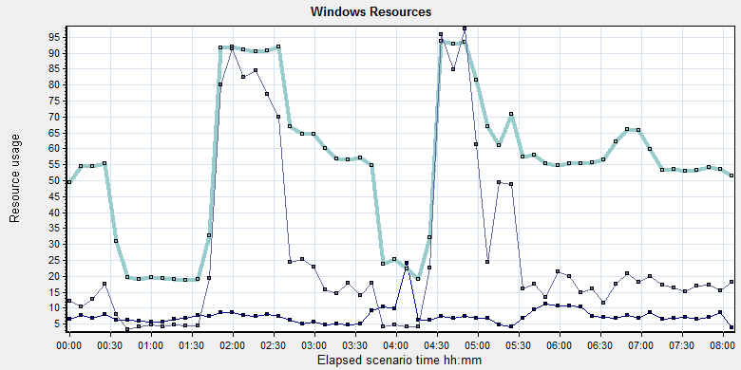
Color | Scale | Measurement | Minimum | Average | Maximum
 | 10 | % Processor Time (Process CloudDataUploadService):10.184.129.108 | 0 | 0.752 | 14.508
 | 1 | % Processor Time (Processor _Total):10.184.129.108 | 0.781 | 55.217 | 100
 | 10 | Processor Queue Length (System):10.184.129.108 | 0 | 2.728 | 51
If the system exist a lot image need to upload, the system processor usage time will more than 80% and queue length will be 8-9. The CPU processor queue is less than the threshold value 12 (6*2). But the process time is more than the threshold 80%. The CPU resource will used to zip the DICOM files and upload operations.

The memory resource do not has the bottleneck. There is enough resource for system to use.
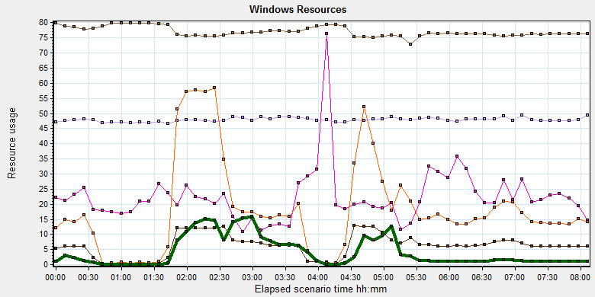
Color | Scale | Measurement | Minimum | Average | Maximum | Std. Deviation
 | 0.01 | Available MBytes (Memory):10.184.129.108 | 6973 | 7704.322 | 8213 | 172.525
 | 0.0001 | Page Faults/sec (Memory):10.184.129.108 | 73.071 | 62247.542 | 196282.521 | 45635.606
 | 0.1 | Page Faults/sec (Process CloudDataUploadService):10.184.129.108 | 0 | 223.618 | 6395.67 | 485.312
 | 1E-06 | Page File Bytes (Process CloudDataUploadService):10.184.129.108 | 42242048 | 47898709.754 | 83550208 | 1904724.8
 | 1 | Page Reads/sec (Memory):10.184.129.108 | 0 | 18.315 | 723.978 | 27.247
 | 0.01 | Pages/sec (Memory):10.184.129.108 | 0 | 416.062 | 5295.336 | 690.214

The disk has stress during performance testing works:
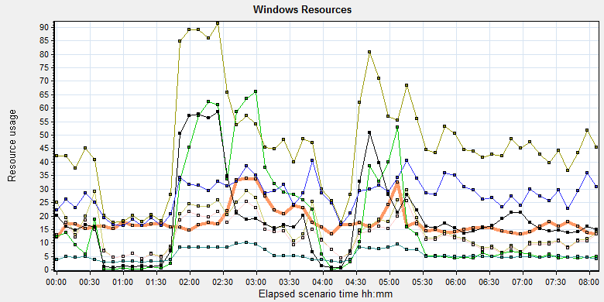
Color | Scale | Measurement | Minimum | Average | Maximum | Std. Deviation
 | 0.0001 | Avg. Disk Bytes/Transfer (PhysicalDisk _Total):10.184.129.108 | 972.8 | 179682.53 | 1249028.655 | 157075.381
 | 10 | Avg. Disk Queue Length (PhysicalDisk _Total):10.184.129.108 | 0.019 | 1.447 | 131.121 | 2.711
 | 10 | Avg. Disk Write Queue Length (PhysicalDisk _Total):10.184.129.108 | 0.019 | 1.252 | 22.579 | 1.338
 | 1E-05 | Disk Read Bytes/sec (PhysicalDisk _Total):10.184.129.108 | 0 | 1799025.922 | 71561318.841 | 3207552.076
 | 1 | Disk Reads/sec (PhysicalDisk _Total):10.184.129.108 | 0 | 19.102 | 707.705 | 27.274
 | 1 | Disk Transfers/sec (PhysicalDisk _Total):10.184.129.108 | 2.325 | 46.907 | 725.639 | 33.724
 | 1E-06 | Disk Write Bytes/sec (PhysicalDisk _Total):10.184.129.108 | 2551.376 | 5571317.968 | 31155380.416 | 4575272.12
 | 1 | Disk Writes/sec (PhysicalDisk _Total):10.184.129.108 | 1.329 | 27.805 | 253.988 | 15.736

Follow the figure: we can see that there are many disk tasks exist in the system during the testing work. The thought for disk is accepted, the stress is too many queue need to process for disk.

SQL Server resource usage analysis
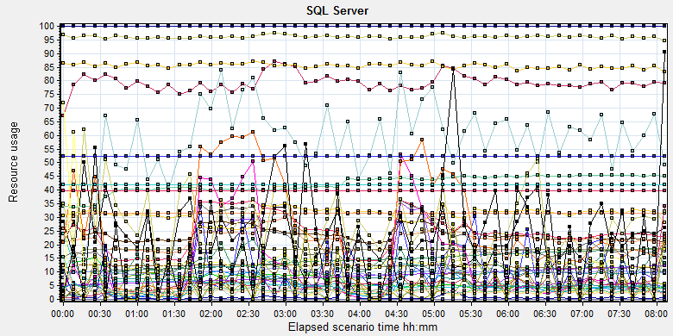
Color | Scale | Measurement | Minimum | Average | Maximum
 | 1 | Average Latch Wait Time (ms) (MSSQL$GCPACSWS|Latches):10.184.129.108 | 0.071 | 9.822 | 339.12
 | 1 | Buffer cache hit ratio (MSSQL$GCPACSWS|Buffer Manager):10.184.129.108 | 74.508 | 99.997 | 100
 | 1 | Cache Hit Ratio (MSSQL$GCPACSWS|Catalog Metadata _Total):10.184.129.108 | 9.704 | 14.292 | 18.79
 | 1 | Cache Hit Ratio (MSSQL$GCPACSWS|Cursor Manager by Type _Total):10.184.129.108 | 52.86 | 79.243 | 91.066
 | 1 | Cache Hit Ratio (MSSQL$GCPACSWS|Plan Cache _Total):10.184.129.108 | 70.129 | 85.558 | 95.93
 | 1 | Checkpoint pages/sec (MSSQL$GCPACSWS|Buffer Manager):10.184.129.108 | 0 | 3.368 | 109.989
 | 0.01 | Connection Memory (KB) (MSSQL$GCPACSWS|Memory Manager):10.184.129.108 | 1392 | 2377.505 | 3152
 | 0.1 | Connection Reset/sec (MSSQL$GCPACSWS|General Statistics):10.184.129.108 | 27.567 | 121.785 | 295.213
 | 1 | CPU usage % (MSSQL$GCPACSWS|Resource Pool Stats default):10.184.129.108 | 0.232 | 22.033 | 95.046
 | 1 | CPU usage target % (MSSQL$GCPACSWS|Resource Pool Stats default):10.184.129.108 | 44 | 96.139 | 99
 | 1 | Current latch waits (MSOLAP$GCPACSWS|Locks):10.184.129.108 | 0 | 0 | 0
 | 1 | Cursor flushes (MSSQL$GCPACSWS|Cursor Manager Total):10.184.129.108 | 0 | 0 | 0
 | 0.0001 | Cursor memory usage (MSSQL$GCPACSWS|Cursor Manager by Type _Total):10.184.129.108 | 88 | 41979.349 | 742576
 | 0.0001 | Database pages (MSSQL$GCPACSWS|Buffer Manager):10.184.129.108 | 334059 | 422797.795 | 457491
 | 10 | Errors/sec (MSSQL$GCPACSWS|SQL Errors _Total):10.184.129.108 | 0 | 2.45 | 32.57
 | 1 | Free list stalls/sec (MSSQL$GCPACSWS|Buffer Manager):10.184.129.108 | 0 | 0 | 0
 | 0.0001 | Free pages (MSSQL$GCPACSWS|Buffer Manager):10.184.129.108 | 22455 | 67404.094 | 182596
 | 0.001 | Granted Workspace Memory (KB) (MSSQL$GCPACSWS|Memory Manager):10.184.129.108 | 0 | 22433.926 | 757000
 | 1000 | Latch waits/sec (MSOLAP$GCPACSWS|Locks):10.184.129.108 | 0 | 0.005 | 0.358
 | 0.01 | Latch Waits/sec (MSSQL$GCPACSWS|Latches):10.184.129.108 | 0 | 895.222 | 3210.907
 | 100 | Lazy writes/sec (MSSQL$GCPACSWS|Buffer Manager):10.184.129.108 | 0 | 0.094 | 5.647
 | 0.001 | Lock Memory (KB) (MSSQL$GCPACSWS|Memory Manager):10.184.129.108 | 3928 | 5868.252 | 23928
 | 1 | Lock Timeouts (timeout > 0)/sec (MSSQL$GCPACSWS|Locks _Total):10.184.129.108 | 0 | 0 | 0
 | 10 | Lock Timeouts/sec (MSSQL$GCPACSWS|Locks _Total):10.184.129.108 | 0 | 0.474 | 13.617
 | 0.1 | Lock Wait Time (ms) (MSSQL$GCPACSWS|Locks _Total):10.184.129.108 | 0 | 118.467 | 14332.015
 | 1 | Lock waits/sec (MSOLAP$GCPACSWS|Locks):10.184.129.108 | 0 | 0 | 0
 | 100 | Lock Waits/sec (MSSQL$GCPACSWS|Locks _Total):10.184.129.108 | 0 | 0.259 | 16.274
 | 1E-05 | Max memory (KB) (MSSQL$GCPACSWS|Resource Pool Stats default):10.184.129.108 | 3984568 | 3984568 | 3984568
 | 1E-05 | Maximum Workspace Memory (KB) (MSSQL$GCPACSWS|Memory Manager):10.184.129.108 | 2481480 | 3139575.739 | 3151800
 | 1 | Memory grant timeouts/sec (MSSQL$GCPACSWS|Resource Pool Stats default):10.184.129.108 | 0 | 0 | 0
 | 10 | Memory Grants Outstanding (MSSQL$GCPACSWS|Memory Manager):10.184.129.108 | 0 | 1.952 | 8
 | 1 | Memory Grants Pending (MSSQL$GCPACSWS|Memory Manager):10.184.129.108 | 0 | 0 | 0
 | 1E-18 | Number of active cursor plans (MSSQL$GCPACSWS|Cursor Manager by Type _Total):10.184.129.108 | 725 | 1.80719025993054E+19 | 1.84467440737096E+19
 | 1 | Number of Deadlocks/sec (MSSQL$GCPACSWS|Locks _Total):10.184.129.108 | 0 | 0 | 0
 | 1 | Number of SuperLatches (MSSQL$GCPACSWS|Latches):10.184.129.108 | 0 | 0 | 0
 | 0.001 | Optimizer Memory (KB) (MSSQL$GCPACSWS|Memory Manager):10.184.129.108 | 5008 | 8638.26 | 15632
 | 1 | Page Deallocations/sec (MSSQL$GCPACSWS|Access Methods):10.184.129.108 | 0 | 11.98 | 410.726
 | 0.001 | Page life expectancy (MSSQL$GCPACSWS|Buffer Manager):10.184.129.108 | 196 | 5322.994 | 86904
 | 0.0001 | Page lookups/sec (MSSQL$GCPACSWS|Buffer Manager):10.184.129.108 | 0 | 311309.724 | 677770.149
 | 0.1 | Page reads/sec (MSSQL$GCPACSWS|Buffer Manager):10.184.129.108 | 0 | 11.685 | 24852.543
 | 10 | Page Splits/sec (MSSQL$GCPACSWS|Access Methods):10.184.129.108 | 0 | 5.792 | 65.425
 | 1 | Page writes/sec (MSSQL$GCPACSWS|Buffer Manager):10.184.129.108 | 0 | 5.436 | 185.979
 | 1E-05 | Query exec memory target (KB) (MSSQL$GCPACSWS|Resource Pool Stats default):10.184.129.108 | 2483400 | 3139736.453 | 3151800
 | 0.01 | Reserved pages (MSSQL$GCPACSWS|Buffer Manager):10.184.129.108 | 0 | 2741.471 | 94577
 | 0.001 | SQL Cache Memory (KB) (MSSQL$GCPACSWS|Memory Manager):10.184.129.108 | 1912 | 3650.066 | 13600
 | 0.1 | SQL Compilations/sec (MSSQL$GCPACSWS|SQL Statistics):10.184.129.108 | 29.228 | 99.516 | 266.805
 | 100 | SQL Re-Compilations/sec (MSSQL$GCPACSWS|SQL Statistics):10.184.129.108 | 0 | 0.139 | 87.35
 | 0.0001 | Stolen pages (MSSQL$GCPACSWS|Buffer Manager):10.184.129.108 | 3544 | 34084.111 | 167035
 | 1E-05 | Target memory (KB) (MSSQL$GCPACSWS|Resource Pool Stats default):10.184.129.108 | 3984568 | 3984568 | 3984568
 | 0.0001 | Target pages (MSSQL$GCPACSWS|Buffer Manager):10.184.129.108 | 524286 | 524286 | 524286
 | 1E-05 | Target Server Memory (KB) (MSSQL$GCPACSWS|Memory Manager):10.184.129.108 | 4194288 | 4194288 | 4194288
 | 100 | Temp Tables Creation Rate (MSSQL$GCPACSWS|General Statistics):10.184.129.108 | 0 | 0.209 | 12.29
 | 10 | Temp Tables For Destruction (MSSQL$GCPACSWS|General Statistics):10.184.129.108 | 0 | 0.582 | 43
 | 0.001 | Total Latch Wait Time (ms) (MSSQL$GCPACSWS|Latches):10.184.129.108 | 30.882 | 5819.228 | 188735.349
 | 0.0001 | Total pages (MSSQL$GCPACSWS|Buffer Manager):10.184.129.108 | 524286 | 524286 | 524286
 | 1E-05 | Total Server Memory (KB) (MSSQL$GCPACSWS|Memory Manager):10.184.129.108 | 4194288 | 4194288 | 4194288
 | 1E-05 | Used memory (KB) (MSSQL$GCPACSWS|Resource Pool Stats default):10.184.129.108 | 15720 | 278447.202 | 2023712

Database result
Follow the SQL server monitor resource, we can find the Database has some issues:

There are some latches and locks exist in the database:
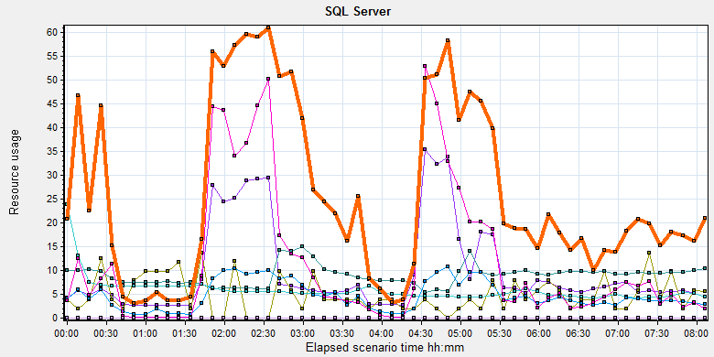
Color | Scale | Measurement | Minimum | Average | Maximum | Std. Deviation
 | 1 | Average Latch Wait Time (ms) (MSSQL$GCPACSWS|Latches):10.184.129.108 | 0.071 | 9.822 | 339.12 | 15.78
 | 1000 | Latch waits/sec (MSOLAP$GCPACSWS|Locks):10.184.129.108 | 0 | 0.005 | 0.358 | 0.04
 | 0.01 | Latch Waits/sec (MSSQL$GCPACSWS|Latches):10.184.129.108 | 0 | 895.222 | 3210.907 | 449.088
 | 0.001 | Lock Memory (KB) (MSSQL$GCPACSWS|Memory Manager):10.184.129.108 | 3928 | 5868.252 | 23928 | 2944.787
 | 1 | Lock Timeouts (timeout > 0)/sec (MSSQL$GCPACSWS|Locks _Total):10.184.129.108 | 0 | 0 | 0 | 0
 | 10 | Lock Timeouts/sec (MSSQL$GCPACSWS|Locks _Total):10.184.129.108 | 0 | 0.474 | 13.617 | 0.876
 | 0.1 | Lock Wait Time (ms) (MSSQL$GCPACSWS|Locks _Total):10.184.129.108 | 0 | 118.467 | 14332.015 | 541.824
 | 1 | Lock waits/sec (MSOLAP$GCPACSWS|Locks):10.184.129.108 | 0 | 0 | 0 | 0
 | 100 | Lock Waits/sec (MSSQL$GCPACSWS|Locks _Total):10.184.129.108 | 0 | 0.259 | 16.274 | 0.486

There are 895 latches every seconds during the testing work( Latch Waits/sec (MSSQL$GCPACSWS|Latches)). That means there are many recourse compete exist in the system. There are also has some locks and lock time out issues. Some SQL statement needs to enhance to fix these issues.
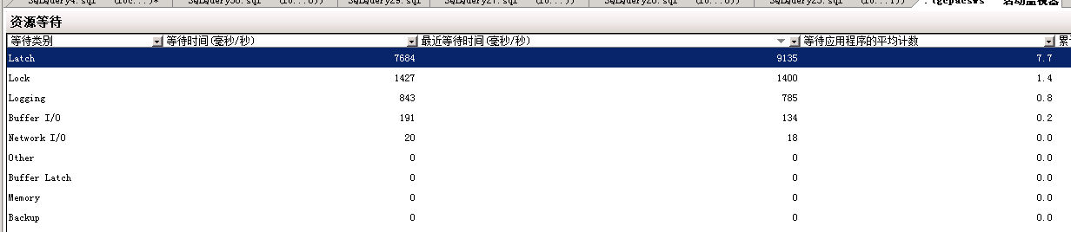
QA team guesses these issue caused by the store procedure which to synchronize upload files in wggc. The SQL statement will query the result which records need to update every 5 seconds. The SQL will full scan the main work flow table. It will lock the tables and other operations like print, change status and query will block by the SQL statement.
We captured some SQL statements which use too much system resource in testing work. There are some SQL belong to this store procedure .
We suggest develop team to resolve the issue as soon as quickly.

Test Conclusion
We executed the performance testing scenario for 8 hours. The CPU resource has the bottleneck and some SQL statement need to enhance and change design. The cloud film service does not influence the operations of PS. We will continue the testing works for B24.
I collect some SQL statements which cause much resource during the testing works. Develop team need to review and try to resolve them as possible:

Testing work （Phase 3）

Test Environment
The detailed hardware configurations of all servers are described as follow:

Computer name | CPU | Memory | HD | OS | Other | Comments
PS Server Panda upgrade | Interl(R) Xeon® CPU E5-2350 @ 1.80 * 6 | 12GB | 1TB | Windows 2008 R2 64bit | SQL server workgroup 2008 | Use the network 100Mbps
Workstation Server | Intel i3-2120 3.3GHz | 2GB | 80GB | Windows 7 SP1 64bit | QTP 11 | 6 virtual machine in server
Terminal | Intel Atom D525 1.8GHz | 4GB | 450GB | Windows Embedded Standard SP1 64bit | UTF 12.0 trail
Cloud Film Server | Interl(R) Xeon® CPU E5-2620 @ 2.40 * 6 | 64GB | 1T | Windows server2016 Standard 64 bit | Mock server from develop
Cloud film DB Server | Interl(R) Xeon® CPU E5-2620 @ 2.40 * 6 | 64GB | 1T | Windows server2016 Standard 64 bit | Mysql 5.6

Table 1 Hardware Configuration

Test scenario and strategy
Virtual User: 21 Users
Duration: 8 hour
Description: Use the test tool simulates the patient operations. Monitor the server software and hardware resource usage. The detail information as follow:
- Use automation tool simulate the doctor print film work. Simulate 6 GX Platform by using QTP and WinDPSTester tool. Each client prints one film which size is 10MB every 30 seconds.
- Use LR tool simulate 8 K2/K3 terminals to print film. Each client prints one film which size is 10MB random 5 to 30 seconds.
- Use LR tool simulate 8 users to do report archive operations. Each client archive report in random 5 to 30 seconds and size is random with 100kb and 4Mb.
- Use LR tool simulate 8 terminals to print paper reports. Each client prints report random 5 to 30 seconds.
- The OCR setting is not has rule for GX platforms in step1 and other setting are set as default. The OCR service will under the strong stress without configure the rule.
- Simulate 5 users to do the query information, view monitor page, query reconciliation films and report, expand the record, change the status, set holding time and other operations in worklist.
- Monitor the transaction response time.
- Monitor the hardware resource usage on PS.
- Monitor the resource usage for database on PS.
- Start/Stop 2 virtual users every 10 seconds and run the scenario for 8 hours.
- Simulate the Upload network bandwidth to 20M.

Note:
We will do the performance testing work under big stress for system. If system can work well under current stress and the transaction process ability meets the requirement, we will give the conclusion the system performance is pass.

Test Tool
Load Runner 12.

Database setting
Memory: Set the min and max memory size to 4GB.
Index fill factor: 80.
File: Increase the data and log files size and the rule is increase 200Mb as fixed size.

IIS setting
Connection: Set the max connection value to 4000 and keep other setting as default.

Test Object version
KIOSK cloud film 3.0.3.0 B24 + ACQ Path

Background data
We prepared a background records in the PS system. The data size is calculated by the typical site which printed 3,000 films in a workday. That means the records of films in db should more than 972,000 (3000records / day *54 weeks * 6 workday). QA team had prepared these data with SQL script and automation script. These data can backup and import by DB tool.
The detail data records in DB as follow:

Table Name | Data Volume (records)
printer.dbo.DeliveryJob | 995199
printer.dbo.ImageBox | 3530116
printer.dbo.Page | 314893
printer.dbo.Session | 571212
wggc.dbo.Patient | 1224710
wggc.dbo.Study | 1434574
wggc.dbo.AFP_PrintTerminalInfo | 70
wggc.dbo.Series | 1434524
wggc.dbo.Image | 1434527
wggc.dbo.AFP_FilmInfo | 1420905
wggc.dbo.AFP_ReportInfo | 1232003
wggc.dbo.AFP_ExamInfo | 2308723
wggc.dbo.AFP_PrintTask | 4324918
wggc.dbo.T_Integration_ExamInfo | 1421769
AFP_PrintMode | 523684
wggc.dbo.vi_KIOSK_ExamInfo_Order | 838208

Test Error
There are some errors exist in the testing work and logged as follow:
No | Description | count
1. | Error: The accession number is A201*****,Terminal1 | 16
2 | Error: Query report records to print from databse failed: the accessionnumber is A201808***** the count is 2 | 2
3 | Error: The task do not finish correct: TaskID: 43**** From Terminal: K2_1 | 5

Error analyzes:
- It caused by the service http://10.184.129.108/EHDPS/printtask/items. That means the service cannot get the report path and id to print. I will retry this service for 10 times get the result. There are two patients caused 16 failed but they still printed finally. I guess it caused by the database lock, the query operations failed.
- It caused by the test data means the patient has two reports. The test script can only process the transaction that patient has only one report. Script will output this warning and execute next iterations. They are not test error.
- For these 5 errors, the task is passed in database. Others status is 4 in database and error code are 80905007 and 80905009.
80905007: "Task Schedule Service"-"Software Error"-"Send film data to printer timeout"
80905007: "Task Schedule Service"-"Software Error"-"Task is failed because of long time unexecution"
These three issues caused by our system or the printer simulater. We should monitor them in next testing works.

Test result of PS server

Test result of PS transactions
After the performance testing works, the transactions result of PS print module as follow:
N/A Data lost by error opertations, please refer the chapter of ‘Test Statistic Report of PS’.

Test Statistic Report of PS
Analysis Summary | Period: 2018/8/16 15:10 - 2018/8/16 23:19

Scenario Name: | E:\ECS\Performance\Script\208\ScenarioPUMA_Reliability_171.lrs
Results in Session: | c:\Users\Administrator\AppData\Local\Temp\res125\res125.lrr
Duration: | 8 hours, 9 minutes and 27 seconds.

Statistics Summary

Maximum Running Vusers: |  | 16
Total Throughput (bytes): |  | 19,274,800
Average Throughput (bytes/second): |  | 656
Total Hits: |  | 19,946
Average Hits per Second: |  | 0.679 | View HTTP Responses Summary
Total Errors: |  | 23

You can define SLA data using the SLA configuration wizard
You can analyze transaction behavior using the Analyze Transaction mechanism

Transaction Summary

Transactions: | Total Passed: 53,794 | Total Failed: 16 | Total Stopped: 0 | Average Response Time

Transaction Name | SLA Status | Minimum | Average | Maximum | Std. Deviation | 90 Percent | Pass | Fail | Stop
Create New Patient |  | 0.078 | 0.153 | 1.3 | 0.075 | 0.218 | 2,347 | 0 | 0
Film Create_PrintTask |  | 0.811 | 1.201 | 12.808 | 0.392 | 1.544 | 3,350 | 0 | 0
Film PrintTask |  | 0.016 | 0.06 | 0.983 | 0.055 | 0.109 | 3,350 | 0 | 0
Film PrintTask_Result_Correct |  | 0 | 0 | 0.016 | 0 | 0 | 3,344 | 0 | 0
Film PrintTask_Result_Fail |  | 0 | 0 | 0 | 0 | 0 | 5 | 0 | 0
Film TerminalStatus |  | 0 | 0.042 | 1.108 | 0.052 | 0.078 | 3,350 | 0 | 0
Film_PrintStatus_CheckService |  | 0 | 0.04 | 0.967 | 0.048 | 0.078 | 9,897 | 0 | 0
Notify File 100k |  | 0.078 | 0.343 | 13.915 | 0.48 | 0.562 | 2,304 | 0 | 0
Notify File 4M |  | 0.159 | 0.473 | 1.092 | 0.213 | 0.764 | 43 | 0 | 0
Report Print Task Correct |  | 0 | 0 | 0 | 0 | 0 | 2,344 | 0 | 0
Report Create_PrintTask |  | 0.442 | 0.835 | 2.808 | 0.309 | 1.248 | 2,344 | 0 | 0
Report GetReportPath_fail |  | 0 | 0 | 0 | 0 | 0 | 0 | 16 | 0
Report PrintTask |  | 0.016 | 0.062 | 0.781 | 0.06 | 0.125 | 2,344 | 0 | 0
Report PrintTask Status Check |  | 0 | 0.041 | 0.624 | 0.046 | 0.08 | 2,345 | 0 | 0
Report QueryFilmReportInfo |  | 0.464 | 0.974 | 12.402 | 0.387 | 1.38 | 4,704 | 0 | 0
Report TerminalStatus |  | 0 | 0.037 | 0.827 | 0.046 | 0.078 | 4,689 | 0 | 0
Report Update PrintTask |  | 0.015 | 0.081 | 0.92 | 0.076 | 0.159 | 2,344 | 0 | 0
Report Update report printer info |  | 0 | 0.044 | 1.513 | 0.056 | 0.083 | 4,690 | 0 | 0

Service Level Agreement Legend: |  | Pass |  | Fail |  | No Data

HTTP Responses Summary

HTTP Responses | Total | Per second
HTTP_200 | 19,946 | 0.679

Follow the summary report, we can see there are 21 failed transactions during the testing work.

Transaction summary result of PS
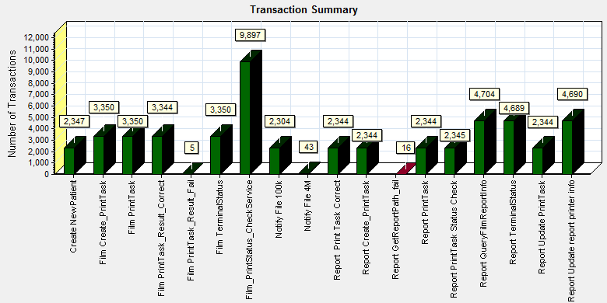
Color | Scale | Measurement
 | 1 | Pass
 | 1 | Fail

We can see that there are 21 transactions failed during the testing works.

Transaction response time result of PS
We can get the transaction response time information from the figure as follow:
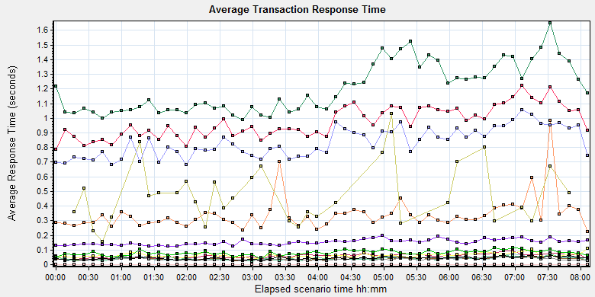
Color | Scale | Measurement | Graph's Minimum | Graph's Average | Graph's Maximum | Graph's Median | Graph's Std. Deviation
 | 1 | Create New Patient | 0.124 | 0.153 | 0.197 | 0.153 | 0.019
 | 1 | Film Create_PrintTask | 0.99 | 1.203 | 1.649 | 1.153 | 0.168
 | 1 | Film PrintTask | 0.038 | 0.06 | 0.093 | 0.064 | 0.013
 | 1 | Film PrintTask_Result_Correct | 0 | 0 | 0 | 0 | 0
 | 1 | Film PrintTask_Result_Fail | 0 | 0 | 0 | 0 | 0
 | 1 | Film TerminalStatus | 0.025 | 0.042 | 0.075 | 0.04 | 0.011
 | 1 | Film_PrintStatus_CheckService | 0.026 | 0.04 | 0.065 | 0.039 | 0.008
 | 1 | Notify File 100k | 0.222 | 0.341 | 0.985 | 0.321 | 0.115
 | 1 | Notify File 4M | 0.159 | 0.473 | 1.03 | 0.425 | 0.197
 | 1 | Report Print Task Correct | 0 | 0 | 0 | 0 | 0
 | 1 | Report Create_PrintTask | 0.681 | 0.834 | 1.055 | 0.824 | 0.099
 | 1 | Report PrintTask | 0.037 | 0.063 | 0.112 | 0.06 | 0.015
 | 1 | Report PrintTask Status Check | 0.023 | 0.041 | 0.074 | 0.039 | 0.011
 | 1 | Report QueryFilmReportInfo | 0.788 | 0.973 | 1.222 | 0.945 | 0.106
 | 1 | Report TerminalStatus | 0.025 | 0.037 | 0.055 | 0.035 | 0.007
 | 1 | Report Update PrintTask | 0.039 | 0.08 | 0.116 | 0.081 | 0.017
 | 1 | Report Update report printer info | 0.03 | 0.044 | 0.065 | 0.043 | 0.009
Transaction response time

This figure information shows all transaction response time. We can analysis that there are no transaction response time more than 3 seconds. It`s good performance for our system.

Test result of Web service

Test result of web transactions
After the performance testing works, the transactions result of we module as follow:
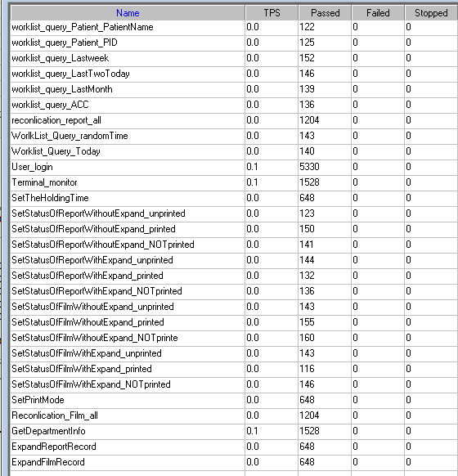
Follow the figure, we can see that there is no transactions failed.

Test Statistic Report of Web
Analysis Summary | Period: 16/08/2018 15:37:10 - 16/08/2018 23:38:37

Scenario Name: | D:\Performance\ScenarioPUMA_Reliability_171.lrs
Results in Session: | c:\Users\administrator\appdata\local\temp\res1203\res1203.lrr
Duration: | 8 hours, 1 minute and 27 seconds.

Statistics Summary

Maximum Running Vusers: | 5
Total Throughput (bytes): | 1,679,757,395
Average Throughput (bytes/second): | 58,147
Total Hits: | 140,385
Average Hits per Second: | 4.86

You can define SLA data using the SLA configuration wizard
You can analyze transaction behavior using the Analyze Transaction mechanism

Transaction Summary

Transactions: | Total Passed: 17,746 | Total Failed: 0 | Total Stopped: 0 | Average Response Time

Transaction Name | Minimum | Average | Maximum | Std. Deviation | 90 Percent | Pass | Fail | Stop
ExpandFilmRecord | 0.047 | 0.9 | 5.784 | 0.859 | 1.919 | 710 | 0 | 0
ExpandReportRecord | 0.005 | 0.01 | 0.139 | 0.011 | 0.016 | 711 | 0 | 0
GetDepartmentInfo | 0.004 | 0.009 | 0.117 | 0.009 | 0.014 | 1,674 | 0 | 0
Reconlication_Film_all | 0.141 | 0.323 | 1.689 | 0.174 | 0.546 | 1,322 | 0 | 0
reconlication_report_all | 0.019 | 0.048 | 0.472 | 0.036 | 0.084 | 1,320 | 0 | 0
SetPrintMode | 0.016 | 0.08 | 1.178 | 0.078 | 0.147 | 710 | 0 | 0
SetStatusOfFilmWithExpand_NOTprinted | 0.175 | 0.909 | 4.501 | 0.782 | 1.974 | 150 | 0 | 0
SetStatusOfFilmWithExpand_printed | 0.173 | 1.105 | 6.23 | 0.982 | 2.359 | 124 | 0 | 0
SetStatusOfFilmWithExpand_unprinted | 0.151 | 1.163 | 4.06 | 0.845 | 2.08 | 162 | 0 | 0
SetStatusOfFilmWithoutExpand_NOTprinte | 0.019 | 0.093 | 1.361 | 0.122 | 0.154 | 178 | 0 | 0
SetStatusOfFilmWithoutExpand_printed | 0.025 | 0.088 | 0.506 | 0.073 | 0.151 | 169 | 0 | 0
SetStatusOfFilmWithoutExpand_unprinted | 0.025 | 0.096 | 1.115 | 0.108 | 0.168 | 154 | 0 | 0
SetStatusOfReportWithExpand_NOTprinted | 0.025 | 0.092 | 0.644 | 0.08 | 0.154 | 145 | 0 | 0
SetStatusOfReportWithExpand_printed | 0.021 | 0.076 | 0.463 | 0.052 | 0.127 | 143 | 0 | 0
SetStatusOfReportWithExpand_unprinted | 0.023 | 0.078 | 0.376 | 0.061 | 0.144 | 160 | 0 | 0
SetStatusOfReportWithoutExpand_NOTprinted | 0.021 | 0.08 | 0.273 | 0.053 | 0.135 | 163 | 0 | 0
SetStatusOfReportWithoutExpand_printed | 0.025 | 0.079 | 0.462 | 0.056 | 0.139 | 169 | 0 | 0
SetStatusOfReportWithoutExpand_unprinted | 0.022 | 0.082 | 0.338 | 0.054 | 0.166 | 136 | 0 | 0
SetTheHoldingTime | 0.013 | 0.052 | 0.565 | 0.049 | 0.1 | 714 | 0 | 0
Terminal_monitor | 0.119 | 0.248 | 1.489 | 0.14 | 0.379 | 1,674 | 0 | 0
User_login | 0.194 | 0.421 | 2.41 | 0.201 | 0.629 | 5,845 | 0 | 0
worklist_query_ACC | 0.007 | 0.019 | 0.077 | 0.013 | 0.031 | 155 | 0 | 0
worklist_query_LastMonth | 0.017 | 0.052 | 0.248 | 0.032 | 0.09 | 151 | 0 | 0
worklist_query_LastTwoToday | 0.018 | 0.06 | 1.102 | 0.088 | 0.088 | 162 | 0 | 0
worklist_query_Lastweek | 0.018 | 0.054 | 0.181 | 0.027 | 0.09 | 165 | 0 | 0
worklist_query_Patient_PatientName | 0.007 | 0.028 | 0.506 | 0.048 | 0.039 | 133 | 0 | 0
worklist_query_Patient_PID | 0.007 | 0.029 | 0.313 | 0.043 | 0.048 | 143 | 0 | 0
Worklist_Query_Today | 0.021 | 0.082 | 2.422 | 0.198 | 0.114 | 151 | 0 | 0
WorlkList_Query_randomTime | 0.018 | 0.06 | 0.225 | 0.031 | 0.094 | 153 | 0 | 0

Service Level Agreement Legend: |  | Pass |  | Fail |  | No Data

HTTP Responses Summary

HTTP Responses | Total | Per second
HTTP_200 | 134,469 | 4.655
HTTP_302 | 5,915.6 | 0.205

Follow the summary report, we can see all the transactions had passed and transaction response time can accept.

Transaction summary result of Web
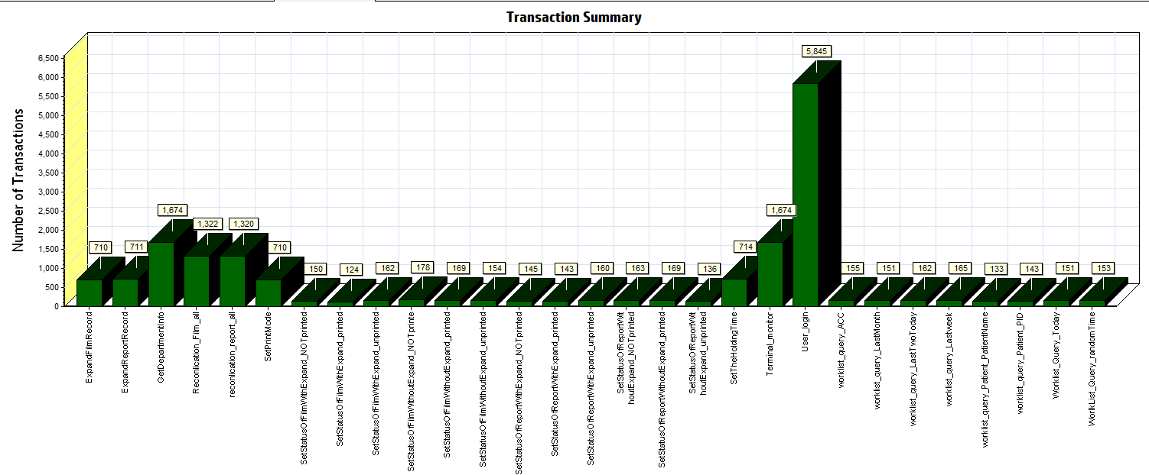
Color | Scale | Measurement
 | 1 | Pass

We can see that there is no transaction failed during the testing works.

Transaction response time result of Web
We can get the transaction response time information from the figure as follow:
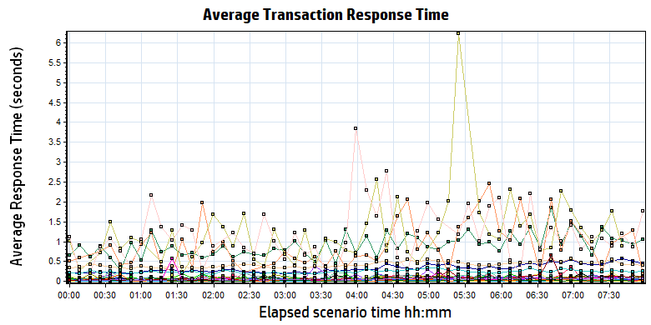
Color | Scale | Measurement | Minimum | Average | Maximum | Std. Deviation
 | 1 | ExpandFilmRecord | 0.047 | 0.900 | 5.784 | 0.859
 | 1 | ExpandReportRecord | 0.005 | 0.010 | 0.139 | 0.011
 | 1 | GetDepartmentInfo | 0.004 | 0.009 | 0.117 | 0.009
 | 1 | Reconlication_Film_all | 0.141 | 0.323 | 1.689 | 0.174
 | 1 | reconlication_report_all | 0.019 | 0.048 | 0.472 | 0.036
 | 1 | SetPrintMode | 0.016 | 0.080 | 1.178 | 0.078
 | 1 | SetStatusOfFilmWithExpand_NOTprinted | 0.175 | 0.909 | 4.501 | 0.782
 | 1 | SetStatusOfFilmWithExpand_printed | 0.173 | 1.105 | 6.230 | 0.982
 | 1 | SetStatusOfFilmWithExpand_unprinted | 0.151 | 1.163 | 4.060 | 0.845
 | 1 | SetStatusOfFilmWithoutExpand_NOTprinte | 0.019 | 0.093 | 1.361 | 0.122
 | 1 | SetStatusOfFilmWithoutExpand_printed | 0.025 | 0.088 | 0.506 | 0.073
 | 1 | SetStatusOfFilmWithoutExpand_unprinted | 0.025 | 0.096 | 1.115 | 0.108
 | 1 | SetStatusOfReportWithExpand_NOTprinted | 0.025 | 0.092 | 0.644 | 0.080
 | 1 | SetStatusOfReportWithExpand_printed | 0.021 | 0.076 | 0.463 | 0.052
 | 1 | SetStatusOfReportWithExpand_unprinted | 0.023 | 0.078 | 0.376 | 0.061
 | 1 | SetStatusOfReportWithoutExpand_NOTprinted | 0.021 | 0.080 | 0.273 | 0.053
 | 1 | SetStatusOfReportWithoutExpand_printed | 0.025 | 0.079 | 0.462 | 0.056
 | 1 | SetStatusOfReportWithoutExpand_unprinted | 0.022 | 0.082 | 0.338 | 0.054
 | 1 | SetTheHoldingTime | 0.013 | 0.052 | 0.565 | 0.049
 | 1 | Terminal_monitor | 0.119 | 0.248 | 1.489 | 0.140
 | 1 | User_login | 0.194 | 0.421 | 2.410 | 0.201
 | 1 | worklist_query_ACC | 0.007 | 0.019 | 0.077 | 0.013
 | 1 | worklist_query_LastMonth | 0.017 | 0.052 | 0.248 | 0.032
 | 1 | worklist_query_LastTwoToday | 0.018 | 0.060 | 1.102 | 0.088
 | 1 | worklist_query_Lastweek | 0.018 | 0.054 | 0.181 | 0.027
 | 1 | worklist_query_Patient_PatientName | 0.007 | 0.028 | 0.506 | 0.048
 | 1 | worklist_query_Patient_PID | 0.007 | 0.029 | 0.313 | 0.043
 | 1 | Worklist_Query_Today | 0.021 | 0.082 | 2.422 | 0.198
 | 1 | WorlkList_Query_randomTime | 0.018 | 0.060 | 0.225 | 0.031

Transaction response time
Follow the figure: we can see that the transaction average response time is less than 2 seconds. But some transactions response time is smoothly. We should monitor that and try to fix the issues.

Performance bottleneck analysis

Hardware usage analysis
During the testing work, we use the test tool to monitor the server hardware usage include the CPU, Memory, hard disk and etc.
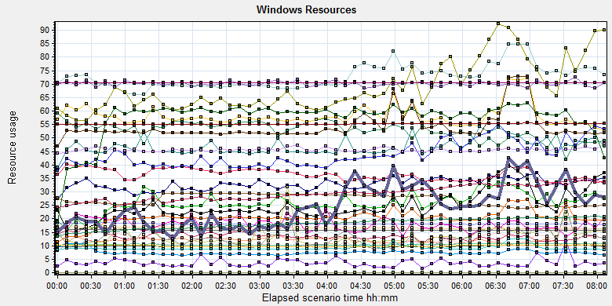
Color | Scale | Measurement | Minimum | Average | Maximum | Std. Deviation
 | 0.1 | % Disk Time (PhysicalDisk _Total):10.184.129.108 | 9.95 | 134.866 | 17542.543 | 295.448
 | 1 | % Idle Time (PhysicalDisk _Total):10.184.129.108 | 0 | 52.799 | 91.693 | 18.243
 | 100 | % Interrupt Time (Processor _Total):10.184.129.108 | 0 | 0.135 | 0.864 | 0.12
 | 10 | % Privileged Time (Processor _Total):10.184.129.108 | 0.434 | 5.825 | 20.712 | 2.32
 | 10 | % Processor Time (Process CloudDataUploadService):10.184.129.108 | 0 | 3.284 | 15.979 | 1.923
 | 1 | % Processor Time (Processor _Total):10.184.129.108 | 12.847 | 72.711 | 99.913 | 13.398
 | 0.01 | Available MBytes (Memory):10.184.129.108 | 2084 | 2717.657 | 3122 | 211.437
 | 0.0001 | Avg. Disk Bytes/Transfer (PhysicalDisk _Total):10.184.129.108 | 4191.256 | 117907.37 | 877899.776 | 97928.907
 | 10 | Avg. Disk Queue Length (PhysicalDisk _Total):10.184.129.108 | 0.099 | 1.349 | 175.425 | 2.955
 | 10 | Avg. Disk Write Queue Length (PhysicalDisk _Total):10.184.129.108 | 0.099 | 1.144 | 31.772 | 1.2
 | 0.001 | Bytes Total/sec (Server):10.184.129.108 | 17170.559 | 18044.889 | 19502.884 | 296.474
 | 1E-07 | Cache Bytes (Memory):10.184.129.108 | 125460480 | 181756193.752 | 216334336 | 19303822.948
 | 1E-09 | Committed Bytes (Memory):10.184.129.108 | 9820307456 | 10478556614.155 | 11228426240 | 219700022.087
 | 0.001 | Context Switches/sec (System):10.184.129.108 | 6361.167 | 36410.315 | 101352.389 | 17613.215
 | 10 | Current Disk Queue Length (PhysicalDisk _Total):10.184.129.108 | 0 | 1.305 | 178 | 3.074
 | 1E-05 | Disk Read Bytes/sec (PhysicalDisk _Total):10.184.129.108 | 0 | 2589403.687 | 91777911.615 | 2943277.031
 | 1 | Disk Reads/sec (PhysicalDisk _Total):10.184.129.108 | 0 | 24.842 | 664.832 | 26.54
 | 1 | Disk Transfers/sec (PhysicalDisk _Total):10.184.129.108 | 10.296 | 68.612 | 697.376 | 37.635
 | 1E-05 | Disk Write Bytes/sec (PhysicalDisk _Total):10.184.129.108 | 38089.92 | 4676333.11 | 26712560.492 | 3549849.275
 | 1 | Disk Writes/sec (PhysicalDisk _Total):10.184.129.108 | 9.299 | 43.771 | 306.443 | 22.114
 | 0.001 | File Data Operations/sec (System):10.184.129.108 | 950.599 | 9230.32 | 29066.682 | 5103.01
 | 1E-05 | Free Megabytes (LogicalDisk _Total):10.184.129.108 | 1623360 | 1657247.366 | 1690860 | 19554.304
 | 0.001 | Interrupts/sec (Processor _Total):10.184.129.108 | 1066.518 | 7464.157 | 27164.083 | 4599.51
 | 0.001 | Page Faults/sec (Memory):10.184.129.108 | 607.85 | 54211.665 | 155535.713 | 27866.804
 | 0.1 | Page Faults/sec (Process CloudDataUploadService):10.184.129.108 | 0 | 177.926 | 5507.1 | 476.902
 | 1E-06 | Page File Bytes (Process CloudDataUploadService):10.184.129.108 | 43900928 | 45583211.555 | 69660672 | 1256999.203
 | 1 | Page Reads/sec (Memory):10.184.129.108 | 0 | 20.287 | 687.414 | 21.713
 | 0.1 | Pages/sec (Memory):10.184.129.108 | 0 | 572.752 | 4295.179 | 607.413
 | 1E-06 | Pool Nonpaged Bytes (Memory):10.184.129.108 | 54763520 | 55229066.052 | 56254464 | 221972.045
 | 0.0001 | Pool Nonpaged Bytes (Server):10.184.129.108 | 631737 | 701108.223 | 783289 | 20557.685
 | 1E-07 | Pool Paged Bytes (Memory):10.184.129.108 | 156512256 | 158402140.07 | 169381888 | 1450642.628
 | 0.001 | Pool Paged Bytes (Server):10.184.129.108 | 70613 | 70613 | 70613 | 0
 | 1 | Pool Paged Failures (Server):10.184.129.108 | 0 | 0 | 0 | 0
 | 1E-09 | Private Bytes (Process _Total):10.184.129.108 | 9086722048 | 9771609726.084 | 10344050688 | 211313221.185
 | 10 | Processor Queue Length (System):10.184.129.108 | 0 | 2.455 | 41 | 3.731
 | 1 | Split IO/Sec (PhysicalDisk _Total):10.184.129.108 | 0 | 3.622 | 278.886 | 14.342
 | 1E-07 | System Cache Resident Bytes (Memory):10.184.129.108 | 125460480 | 181756575.888 | 216334336 | 19303053.573
 | 0.01 | Threads (Objects):10.184.129.108 | 2317 | 2940.474 | 3678 | 290.345
 | 1E-09 | Working Set (Process _Total):10.184.129.108 | 9504980992 | 9932552123.131 | 10626387968 | 259396038.709

Follow this information we can get that:
The CPU resource has the bottleneck. The average process time is 55%, but if the system has the upload task, the usage will grow up and value is more than 80%.
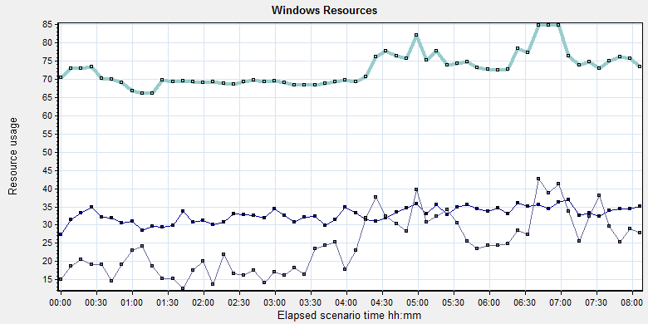
Color | Scale | Measurement | Minimum | Average | Maximum | Std. Deviation
 | 10 | % Processor Time (Process CloudDataUploadService):10.184.129.108 | 0 | 3.284 | 15.979 | 1.923
 | 1 | % Processor Time (Processor _Total):10.184.129.108 | 12.847 | 72.711 | 99.913 | 13.398
 | 10 | Processor Queue Length (System):10.184.129.108 | 0 | 2.455 | 41 | 3.731
Follow the figure we can see that the CPU is under big stress during the testing works. The CPU process time usage is between 70% and 85%. It`s close to 85% threshold value but can accept. The average CPU queue length is 2.5, it small than the threshold value (12= 6*2). The CPU has big stress but it has not bottleneck.
Compare the test scenario which do not start the cloud film services:
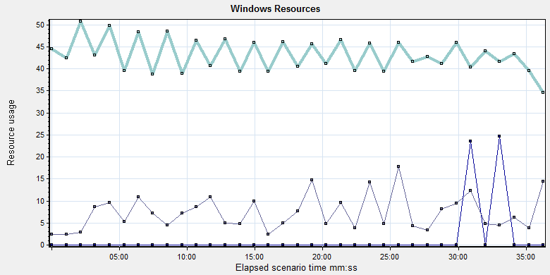
Color | Scale | Measurement | Minimum | Average | Maximum | Std. Deviation
 | 1000 | % Processor Time (Process CloudDataUploadService):10.184.129.108 | 0 | 0.001 | 0.518 | 0.027
 | 1 | % Processor Time (Processor _Total):10.184.129.108 | 5.208 | 43.245 | 85.834 | 17.252
 | 10 | Processor Queue Length (System):10.184.129.108 | 0 | 0.721 | 18 | 1.616
We can see the CPU usage is double. We should enhance the performance for our system to fix the risk.

The memory resource do not has the bottleneck. There are enough resources for system to use.
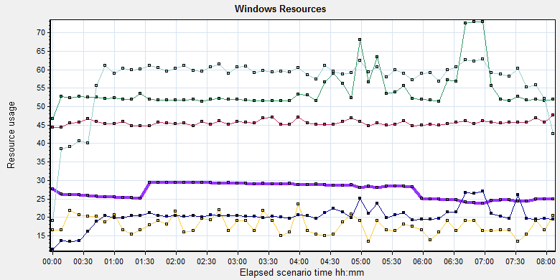
Color | Scale | Measurement | Minimum | Average | Maximum | Std. Deviation
 | 0.01 | Available MBytes (Memory):10.184.129.108 | 2084 | 2717.657 | 3122 | 211.437
 | 0.001 | Page Faults/sec (Memory):10.184.129.108 | 607.85 | 54211.665 | 155535.713 | 27866.804
 | 0.1 | Page Faults/sec (Process CloudDataUploadService):10.184.129.108 | 0 | 177.926 | 5507.1 | 476.902
 | 1E-06 | Page File Bytes (Process CloudDataUploadService):10.184.129.108 | 43900928 | 45583211.555 | 69660672 | 1256999.203
 | 1 | Page Reads/sec (Memory):10.184.129.108 | 0 | 20.287 | 687.414 | 21.713
 | 0.1 | Pages/sec (Memory):10.184.129.108 | 0 | 572.752 | 4295.179 | 607.413

The disk has stress during performance testing works:
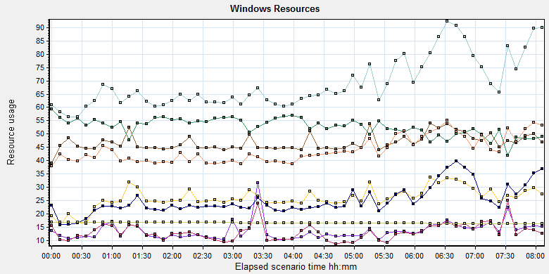
Color |  | Scale | Measurement | Minimum | Average | Maximum | Std. Deviation
 |  | 0.1 | % Disk Time (PhysicalDisk _Total):10.184.129.108 | 9.95 | 134.866 | 17542.543 | 295.448
 |  | 1 | % Idle Time (PhysicalDisk _Total):10.184.129.108 | 0 | 52.799 | 91.693 | 18.243
 |  | 10 | Current Disk Queue Length (PhysicalDisk _Total):10.184.129.108 | 0 | 1.305 | 178 | 3.074
 |  | 1E-05 | Disk Read Bytes/sec (PhysicalDisk _Total):10.184.129.108 | 0 | 2589403.687 | 91777911.615 | 2943277.031
 |  | 1 | Disk Reads/sec (PhysicalDisk _Total):10.184.129.108 | 0 | 24.842 | 664.832 | 26.54
 |  | 1 | Disk Transfers/sec (PhysicalDisk _Total):10.184.129.108 | 10.296 | 68.612 | 697.376 | 37.635
 |  | 1E-05 | Disk Write Bytes/sec (PhysicalDisk _Total):10.184.129.108 | 38089.92 | 4676333.11 | 26712560.492 | 3549849.275
 |  | 1 | Disk Writes/sec (PhysicalDisk _Total):10.184.129.108 | 9.299 | 43.771 | 306.443 | 22.114
 |  | 1E-05 | Free Megabytes (LogicalDisk _Total):10.184.129.108 | 1623360 | 1657247.366 | 1690860 | 19554.304
 | Follow the figure: we can see that there are many disk tasks exist in the system during the testing work. The average Disk read/sec is 24, writes/sec is 44, and transfers/sec is 67. The average disk transfer size is 7M/sec. The disk is busy, but the stress can accept.

SQL Server resource usage analysis
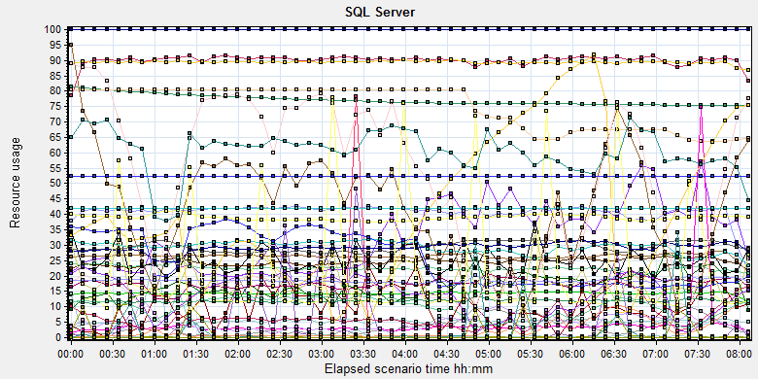
Color | Scale | Measurement | Minimum | Average | Maximum | Std. Deviation
 | 10 | Average Latch Wait Time (ms) (MSSQL$GCPACSWS|Latches):10.184.129.108 | 0.297 | 3.32 | 63.36 | 3.551
 | 1 | Buffer cache hit ratio (MSSQL$GCPACSWS|Buffer Manager):10.184.129.108 | 99.595 | 99.999 | 100 | 0.005
 | 1 | Cache Hit Ratio (MSSQL$GCPACSWS|Catalog Metadata _Total):10.184.129.108 | 75.399 | 77.12 | 81.508 | 1.646
 | 1 | Cache Hit Ratio (MSSQL$GCPACSWS|Cursor Manager by Type _Total):10.184.129.108 | 65.944 | 90.013 | 93.891 | 2.542
 | 1 | Cache Hit Ratio (MSSQL$GCPACSWS|Plan Cache _Total):10.184.129.108 | 78.953 | 89.404 | 96.891 | 3.19
 | 1 | Checkpoint pages/sec (MSSQL$GCPACSWS|Buffer Manager):10.184.129.108 | 0 | 5.942 | 1027.53 | 25.569
 | 0.01 | Connection Memory (KB) (MSSQL$GCPACSWS|Memory Manager):10.184.129.108 | 1520 | 2456.367 | 2880 | 121.973
 | 0.1 | Connection Reset/sec (MSSQL$GCPACSWS|General Statistics):10.184.129.108 | 128.452 | 265.349 | 503.669 | 54.561
 | 1 | Current latch waits (MSOLAP$GCPACSWS|Locks):10.184.129.108 | 0 | 0 | 0 | 0
 | 1 | Cursor flushes (MSSQL$GCPACSWS|Cursor Manager Total):10.184.129.108 | 0 | 0 | 0 | 0
 | 0.0001 | Cursor memory usage (MSSQL$GCPACSWS|Cursor Manager by Type _Total):10.184.129.108 | 128 | 130124.732 | 220960 | 60743.281
 | 10 | Cursor Requests/sec (MSSQL$GCPACSWS|Cursor Manager by Type _Total):10.184.129.108 | 0 | 4.094 | 19.93 | 3.254
 | 0.0001 | Database pages (MSSQL$GCPACSWS|Buffer Manager):10.184.129.108 | 372970 | 389647.744 | 417055 | 8777.629
 | 10 | Errors/sec (MSSQL$GCPACSWS|SQL Errors _Total):10.184.129.108 | 0 | 2.252 | 25.566 | 1.697
 | 10000 | Free list stalls/sec (MSSQL$GCPACSWS|Buffer Manager):10.184.129.108 | 0 | 0 | 1.329 | 0.013
 | 0.0001 | Free pages (MSSQL$GCPACSWS|Buffer Manager):10.184.129.108 | 112 | 37069.235 | 127463 | 29763.089
 | 0.1 | Full Scans/sec (MSSQL$GCPACSWS|Access Methods):10.184.129.108 | 17.644 | 144.114 | 389.367 | 89.089
 | 0.001 | Granted Workspace Memory (KB) (MSSQL$GCPACSWS|Memory Manager):10.184.129.108 | 0 | 24859.714 | 875712 | 64465.078
 | 0.001 | Index Searches/sec (MSSQL$GCPACSWS|Access Methods):10.184.129.108 | 1855.681 | 29432.485 | 122794.879 | 22790.648
 | 1000 | Latch waits/sec (MSOLAP$GCPACSWS|Locks):10.184.129.108 | 0 | 0.01 | 0.664 | 0.057
 | 0.01 | Latch Waits/sec (MSSQL$GCPACSWS|Latches):10.184.129.108 | 107.513 | 2556.56 | 8076.317 | 1314.434
 | 100 | Lazy writes/sec (MSSQL$GCPACSWS|Buffer Manager):10.184.129.108 | 0 | 0.047 | 29.574 | 0.579
 | 0.01 | Lock Memory (KB) (MSSQL$GCPACSWS|Memory Manager):10.184.129.108 | 6368 | 7496.556 | 8048 | 692.543
 | 1 | Lock Timeouts (timeout > 0)/sec (MSSQL$GCPACSWS|Locks _Total):10.184.129.108 | 0 | 0 | 0 | 0
 | 10 | Lock Timeouts/sec (MSSQL$GCPACSWS|Locks _Total):10.184.129.108 | 0 | 0.452 | 702.118 | 8.814
 | 0.1 | Lock Wait Time (ms) (MSSQL$GCPACSWS|Locks _Total):10.184.129.108 | 0 | 47.474 | 17217.454 | 283.718
 | 1 | Lock waits/sec (MSOLAP$GCPACSWS|Locks):10.184.129.108 | 0 | 0 | 0 | 0
 | 100 | Lock Waits/sec (MSSQL$GCPACSWS|Locks _Total):10.184.129.108 | 0 | 0.169 | 13.106 | 0.341
 | 1E-05 | Maximum Workspace Memory (KB) (MSSQL$GCPACSWS|Memory Manager):10.184.129.108 | 2268480 | 2952521.94 | 3151800 | 160501.764
 | 10 | Memory Grants Outstanding (MSSQL$GCPACSWS|Memory Manager):10.184.129.108 | 0 | 1.758 | 8 | 1.346
 | 1 | Memory Grants Pending (MSSQL$GCPACSWS|Memory Manager):10.184.129.108 | 0 | 0 | 0 | 0
 | 0.01 | Number of active cursor plans (MSSQL$GCPACSWS|Cursor Manager by Type _Total):10.184.129.108 | 2 | 1383.472 | 2493 | 649.401
 | 1 | Number of Deadlocks/sec (MSSQL$GCPACSWS|Locks _Total):10.184.129.108 | 0 | 0 | 0 | 0
 | 1 | Number of SuperLatches (MSSQL$GCPACSWS|Latches):10.184.129.108 | 0 | 0 | 0 | 0
 | 0.01 | Optimizer Memory (KB) (MSSQL$GCPACSWS|Memory Manager):10.184.129.108 | 1072 | 1186.655 | 7952 | 419.954
 | 0.1 | Page Deallocations/sec (MSSQL$GCPACSWS|Access Methods):10.184.129.108 | 0 | 67.462 | 3827.681 | 177.677
 | 0.01 | Page life expectancy (MSSQL$GCPACSWS|Buffer Manager):10.184.129.108 | 78 | 4077.08 | 9433 | 2460.215
 | 0.0001 | Page lookups/sec (MSSQL$GCPACSWS|Buffer Manager):10.184.129.108 | 42387.535 | 292237.081 | 816864.834 | 110041.988
 | 0.1 | Page reads/sec (MSSQL$GCPACSWS|Buffer Manager):10.184.129.108 | 0 | 7.502 | 9811.646 | 148.42
 | 1 | Page Splits/sec (MSSQL$GCPACSWS|Access Methods):10.184.129.108 | 0 | 42.023 | 648.93 | 105.741
 | 0.1 | Page writes/sec (MSSQL$GCPACSWS|Buffer Manager):10.184.129.108 | 0 | 23.83 | 990.323 | 83.831
 | 0.01 | Reserved pages (MSSQL$GCPACSWS|Buffer Manager):10.184.129.108 | 0 | 1836.783 | 109268 | 7351.992
 | 0.001 | SQL Cache Memory (KB) (MSSQL$GCPACSWS|Memory Manager):10.184.129.108 | 2280 | 53501.804 | 91792 | 24647.374
 | 0.1 | SQL Compilations/sec (MSSQL$GCPACSWS|SQL Statistics):10.184.129.108 | 108.906 | 185.323 | 345.12 | 19.703
 | 100 | SQL Re-Compilations/sec (MSSQL$GCPACSWS|SQL Statistics):10.184.129.108 | 0 | 0.217 | 60.78 | 1.814
 | 0.0001 | Stolen pages (MSSQL$GCPACSWS|Buffer Manager):10.184.129.108 | 5519 | 97571.021 | 150012 | 33359.183
 | 0.0001 | Target pages (MSSQL$GCPACSWS|Buffer Manager):10.184.129.108 | 524288 | 524288 | 524288 | 0
 | 1E-05 | Target Server Memory (KB) (MSSQL$GCPACSWS|Memory Manager):10.184.129.108 | 4194304 | 4194304 | 4194304 | 0
 | 1 | Tasks Started/sec (MSSQL$GCPACSWS|Broker Activation tempdb):10.184.129.108 | 0 | 0 | 0 | 0
 | 1 | Temp file bytes written/sec (MSOLAP$GCPACSWS|Proc Aggregations):10.184.129.108 | 0 | 0 | 0 | 0
 | 100 | Temp Tables Creation Rate (MSSQL$GCPACSWS|General Statistics):10.184.129.108 | 0 | 0.018 | 6.975 | 0.216
 | 100 | Temp Tables For Destruction (MSSQL$GCPACSWS|General Statistics):10.184.129.108 | 0 | 0.022 | 31 | 0.659
 | 1 | Total deadlocks detected (MSOLAP$GCPACSWS|Locks):10.184.129.108 | 0 | 0 | 0 | 0
 | 0.01 | Total Latch Wait Time (ms) (MSSQL$GCPACSWS|Latches):10.184.129.108 | 359.353 | 6049.325 | 27345.622 | 3493.21
 | 0.0001 | Total pages (MSSQL$GCPACSWS|Buffer Manager):10.184.129.108 | 524288 | 524288 | 524288 | 0
 | 1E-05 | Total Server Memory (KB) (MSSQL$GCPACSWS|Memory Manager):10.184.129.108 | 4194304 | 4194304 | 4194304 | 0
Database result
Follow the SQL server monitor resource, we can find the Database has some issues:
There are some latches and locks exist in the database:
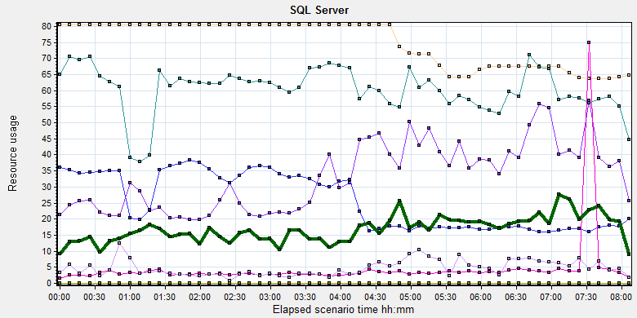
Color | Scale | Measurement | Minimum | Average | Maximum | Std. Deviation
 | 10 | Average Latch Wait Time (ms) (MSSQL$GCPACSWS|Latches):10.184.129.108 | 0.297 | 3.32 | 63.36 | 3.551
 | 1 | Current latch waits (MSOLAP$GCPACSWS|Locks):10.184.129.108 | 0 | 0 | 0 | 0
 | 0.01 | Latch Waits/sec (MSSQL$GCPACSWS|Latches):10.184.129.108 | 107.513 | 2556.56 | 8076.317 | 1314.434
 | 0.01 | Lock Memory (KB) (MSSQL$GCPACSWS|Memory Manager):10.184.129.108 | 6368 | 7496.556 | 8048 | 692.543
 | 1 | Lock Timeouts (timeout > 0)/sec (MSSQL$GCPACSWS|Locks _Total):10.184.129.108 | 0 | 0 | 0 | 0
 | 10 | Lock Timeouts/sec (MSSQL$GCPACSWS|Locks _Total):10.184.129.108 | 0 | 0.452 | 702.118 | 8.814
 | 0.1 | Lock Wait Time (ms) (MSSQL$GCPACSWS|Locks _Total):10.184.129.108 | 0 | 47.474 | 17217.454 | 283.718
 | 1 | Lock waits/sec (MSOLAP$GCPACSWS|Locks):10.184.129.108 | 0 | 0 | 0 | 0
 | 100 | Lock Waits/sec (MSSQL$GCPACSWS|Locks _Total):10.184.129.108 | 0 | 0.169 | 13.106 | 0.341
 | 1 | Number of Deadlocks/sec (MSSQL$GCPACSWS|Locks _Total):10.184.129.108 | 0 | 0 | 0 | 0
 | 1 | Number of SuperLatches (MSSQL$GCPACSWS|Latches):10.184.129.108 | 0 | 0 | 0 | 0
 | 1 | Total deadlocks detected (MSOLAP$GCPACSWS|Locks):10.184.129.108 | 0 | 0 | 0 | 0
 | 0.01 | Total Latch Wait Time (ms) (MSSQL$GCPACSWS|Latches):10.184.129.108 | 359.353 | 6049.325 | 27345.622 | 3493.21

There are 2556 latches every seconds during the testing work (Latch Waits/sec (MSSQL$GCPACSWS|Latches)). That means there are many recourse compete exist in the system. There are also has some locks and lock time out issues. Some SQL statement needs to enhance to fix these issues.
I monitor the database by SQL statement and find the most latch type is ‘CXPACKET’. The root reason is some SQL statement execute time is more than default threshold value 5 seconds. The SQL will execute SQL with multiple threads, there will exist the wait issues. QA team suggests team to enhance the store procedure -wggc.dbo. AFP_SP_GetExamsForSyncToECS performance firstly. If the issues still exist, we should modify the configuration value of database as follow:
Name | Original | Suggest
Cost threshold of parallelism | 5 | 10 or more than 5.
Max degree of parallelism | 0 | Less than number of server
The change of these setting, need more time to verify. There are some SQL statement has the performance issues need to enhance. I will give some suggestion in the append character in the end of document. Please review them and discuss to fix or not thanks.

Test Conclusion
We executed the performance testing scenario for 8 hours. There are 21 errors happened during the testing work. Even some of the final results of them are accepted, but they still caused the issues make the system not health.
The server hardware has some stress. The CPU resource usage is close to the threshold of 85%. Compare with the scenario which the cloud film service is disabled, the CPU usage value is double. It will be a risk for our system.
There are many latches issues and locks exist in our database. The key store procedure for could film service has the performance issues. It cannot meets the requirements.
During the testing works, the attachments upload information as follow:
Type | Count | Size | All
Dicom | 2491 | 9M | 22,419
Dicom Png | 2490 | 1.4M | 3,486
Report Jpg | 1825 | 0.15M | 274
Report PDF | 1825 | 0.12M | 219
 |  |  | 26398 MB
The system uploaded 26.3GB data to server in 8 hours. The result is close to our requirements 30GB. I will add more attachments in next testing work and monitor the result.
Develop team need to fix these issues as soon as possible. QA team will help to team to verify the issues and give more testing works.
The defects and enhancements list as follow:

No. | Type | Descriptions
100048553 | Enhancement | [Performance] The data and log file of ECS database should auto extend with define value not the default one.
100048642 | Defect | [Performance] The upload service will block caused by the SQL statement execute timeout.
100048643 | Defect | [Performance]The print mode and hold time condition in wggc.dbo.sp_getExamsForSyncToECS is wrong.
100048652 | Defect | [Performance]Add index for column SyncToECS on film and report table to enhance performance.
100048653 | Enhancement | [Performance] Add index for column tablename,tablekey,tablevalue on table.Ecs.dbo.UpdateInformation
100048654 | Enhancement | [Performance] Add the index for SQL statement and change the execute rule for forward film and report logic of system.
100048655 | Enhancement | [Performance] Resolve the bookmark lookup issues for SQL statement.

Tune suggestion:
During the testing work we find some SQL statement has performance issues. I collect and give some suggestion to enhance them. The detail information as follow:
- The key store procedure for cloud film upload service:

This SQL will use too many logic read and root cause is the SQL cannot use index to filter the data which column SyncToECS value is 0. The SQL statement execute time is more than 5 seconds and also cause the parallelism issues. From the execute plan we can see this two issues:
92% resource is used to cluster query because the syncToECS column has no index.
I add the index for column syncToECS for report and film table and the execute plan is changed. The performance has a good enhance.

I suggest team to add index to enhance the performance of SQL.

- The trigger SQL:
select top 1 @cdt = [CreateDateTime] from [dbo].[UpdateInformation]
where [TableName] = 'FilmReportStatus' and [TableKey] = 'ExamID' and [TableValue] = @ExamID
order by [CreateDateTime] desc
SET @diff = datediff(second,@cdt,getdate())
if @diff is null OR @diff > 3
INSERT INTO [dbo].[UpdateInformation] (TableName, TableKey, TableValue, CreateDateTime) VALUES('FilmReportStatus', 'ExamID', @ExamID, GETDATE())
The table ‘ecs.dbo. UpdateInformation’ only has cluster key for column ‘updateid’. Suggest add the index for ‘examid’ and include the column ‘createdatetime’.

3. The SQL for forward film or report information:
SELECT JobInstanceUID, ForwardStatus = CASE WHEN ForwardStatus IS NULL THEN -1 ELSE ForwardStatus END,
ForwardFlag = CASE WHEN ForwardFlag IS NULL THEN -1 ELSE ForwardFlag END,ForwardDestination,ModalityType, CallingAE ,CallingIP,PatientName,PatientID,
PatientType = CASE WHEN PatientType IS NULL THEN '' ELSE PatientType END
FROM Printer.dbo.DeliveryJob J INNER JOIN printer.dbo.Session S
ON J.SessionInstanceUID = S.SessionInstanceUID
WHERE J.DeleteStatus = 0 AND (
(ForwardStatus = -1 OR ForwardStatus IS NULL ) OR
(ForwardStatus = 0 AND ForwardFlag = 1)
)
This SQL do not use the index and cause the parallelism issues.
Suggest add index for column sessionInstanceUID on table deliverjob and add index for column DeleteStatus, ForwardStatus on table session.
After add index, this SQL will use index to query data and reduce one parallelism operation. But it still has the lookup query. We can include the lost columns when create the index to resolve this issues. I suggest develop team to check the configuration of system. If the system does not need to forward information, please do not execute this SQL statement. That can reduce the stress for database.

4. These two SQL statements will cause the bookmark lookup query

IF EXISTS(SELECT * FROM dbo.AFP_ExamInfo WHERE AccessionNumber = @AccNO)
if exists(select * from [AFP_FilmInfo]
WHERE ([AccessionNumber] = @AccNO)
and FilmFlag=3
and (DeleteStatus = 0 or DeleteStatus is null)
)
Suggest change ‘Select * from…’ to ‘select [column] from …’ which column is cluster or non-cluster index such as ‘select AccessionNumber from …’.

Testing work （Phase 4）

Test Environment
The detailed hardware configurations of all servers are described as follow:

Computer name | CPU | Memory | HD | OS | Other | Comments
PS Server Panda upgrade | Interl(R) Xeon® CPU E5-2350 @ 1.80 * 6 | 12GB | 1TB | Windows 2008 R2 64bit | SQL server workgroup 2008 | Use the network 100Mbps
Workstation Server | Intel i3-2120 3.3GHz | 2GB | 80GB | Windows 7 SP1 64bit | QTP 11 | 6 virtual machine in server
Terminal | Intel Atom D525 1.8GHz | 4GB | 450GB | Windows Embedded Standard SP1 64bit | UTF 12.0 trail
Cloud Film Server | Interl(R) Xeon® CPU E5-2620 @ 2.40 * 6 | 64GB | 1T | Windows server2016 Standard 64 bit | Mock server from develop
Cloud film DB Server | Interl(R) Xeon® CPU E5-2620 @ 2.40 * 6 | 64GB | 1T | Windows server2016 Standard 64 bit | Mysql 5.6

Test scenario and strategy
Virtual User: 21 Users
Duration: 8 hour
Description: Use the test tool simulates the patient operations. Monitor the server software and hardware resource usage. The detail information as follow:
- Use automation tool simulate the doctor print film work. Simulate 6 GX Platform by using QTP and WinDPSTester tool. Each client prints one film which size is 10MB every 30 seconds.
- Use LR tool simulate 8 K2/K3 terminals to print film. Each client prints one film which size is 10MB random 5 to 10 seconds.
- Use LR tool simulate 8 users to do report archive operations. Each client archive report in random 5 to 30 seconds and size is random with 100kb and 4Mb.
- Use LR tool simulate 8 terminals to print paper reports. Each client prints report random 5 to 10 seconds.
- The OCR setting is not has rule for GX platforms in step1 and other setting are set as default. The OCR service will under the strong stress without configure the rule.
- Simulate 5 users to do the query information, view monitor page, query reconciliation films and report, expand the record, change the status, set holding time and other operations in worklist.
- Monitor the transaction response time.
- Monitor the hardware resource usage on PS.
- Monitor the resource usage for database on PS.
- Start/Stop 2 virtual users every 10 seconds and run the scenario for 8 hours.
- Use the business Upload network bandwidth to 100M.

Note:
We will do the performance testing work under big stress for system. If system can work well under current stress and the transaction process ability meets the requirement, we will give the conclusion the system performance is pass.

Test Tool
Load Runner 12.

Database setting
Memory: Set the min and max memory size to 4GB.
Index fill factor: 80.
File: Increase the data and log files size and the rule is increase 200Mb as fixed size.

IIS setting
Connection: Set the max connection value to 4000 and keep other setting as default.

Test Object version
KIOSK cloud film 3.0.3.0 B25 + ACQ Path + Force Parameter + delete view of available patient, study and alrmMessageList.

Background data
We prepared a background records in the PS system. The data size is calculated by the typical site which printed 3,000 films in a workday. That means the records of films in db should more than 972,000 (3000records / day *54 weeks * 6 workday). QA team had prepared these data with SQL script and automation script. These data can backup and import by DB tool.
The detail data records in DB as follow:

Table Name | Data Volume (records)
printer.dbo.DeliveryJob | 995199
printer.dbo.ImageBox | 3530116
printer.dbo.Page | 314893
printer.dbo.Session | 571212
wggc.dbo.Patient | 1224710
wggc.dbo.Study | 1434574
wggc.dbo.AFP_PrintTerminalInfo | 70
wggc.dbo.Series | 1434524
wggc.dbo.Image | 1434527
wggc.dbo.AFP_FilmInfo | 1420905
wggc.dbo.AFP_ReportInfo | 1232003
wggc.dbo.AFP_ExamInfo | 2308723
wggc.dbo.AFP_PrintTask | 4324918
wggc.dbo.T_Integration_ExamInfo | 1421769
AFP_PrintMode | 523684
wggc.dbo.vi_KIOSK_ExamInfo_Order | 838208

Test Error
There are 71 errors existed in the testing work and I collect the print tasks from the database. The detail information please see the attachment.

Error analyzes:
There are 3 tasks print status is 3 and error code is ‘80905009’. Refer the error code from the follow attachment. It cause by our system that the task is lost response and timeout.
For other tasks the system do not execute the tasks successfully and their status is initial but do not execute.

Test result of PS server

Test result of PS transactions
After the performance testing works, the transactions result of PS print module as follow:
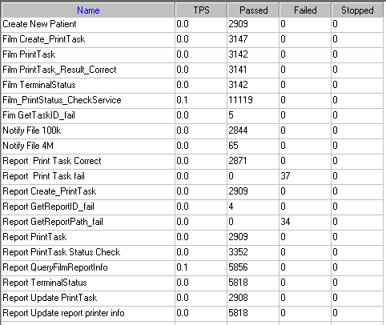

Test Statistic Report of PS
Analysis Summary | Period: 2018/8/24 19:55 - 2018/8/25 4:04

Scenario Name: | E:\ECS\Performance\Script\208\ScenarioPUMA_Reliability_171.lrs
Results in Session: | c:\Users\Administrator\AppData\Local\Temp\res141\res141.lrr
Duration: | 8 hours, 9 minutes and 26 seconds.

Statistics Summary

Maximum Running Vusers: |  | 16
Total Throughput (bytes): |  | 19,903,329
Average Throughput (bytes/second): |  | 678
Total Hits: |  | 20,550
Average Hits per Second: |  | 0.7 | View HTTP Responses Summary
Total Errors: |  | 76

Transaction Summary

Transactions: | Total Passed: 61,959 | Total Failed: 71 | Total Stopped: 0 | Average Response Time

Transaction Name | SLA Status | Minimum | Average | Maximum | Std. Deviation | 90 Percent | Pass | Fail | Stop
Create New Patient |  | 0.094 | 0.182 | 2.808 | 0.169 | 0.281 | 2,909 | 0 | 0
Film Create_PrintTask |  | 0.733 | 4.438 | 75.428 | 8.69 | 15.631 | 3,147 | 0 | 0
Film PrintTask |  | 0.016 | 0.149 | 3.214 | 0.196 | 0.277 | 3,142 | 0 | 0
Film PrintTask_Result_Correct |  | 0 | 0 | 0.016 | 0 | 0 | 3,141 | 0 | 0
Film TerminalStatus |  | 0.014 | 0.093 | 2.059 | 0.141 | 0.203 | 3,142 | 0 | 0
Film_PrintStatus_CheckService |  | 0 | 0.098 | 5.132 | 0.199 | 0.203 | 11,119 | 0 | 0
Fim GetTaskID_fail |  | 0.016 | 0.016 | 0.016 | 0 | 0.016 | 5 | 0 | 0
Notify File 100k |  | 0.125 | 0.635 | 57.55 | 1.375 | 1.076 | 2,844 | 0 | 0
Notify File 4M |  | 0.296 | 0.946 | 4.307 | 0.863 | 1.669 | 65 | 0 | 0
Report Print Task Correct |  | 0 | 0 | 0.016 | 0 | 0 | 2,871 | 0 | 0
Report Print Task fail |  | 0 | 0 | 0 | 0 | 0 | 0 | 37 | 0
Report Create_PrintTask |  | 0.726 | 3.973 | 49.61 | 8.618 | 15.959 | 2,909 | 0 | 0
Report GetReportID_fail |  | 0 | 0 | 0 | 0 | 0 | 4 | 0 | 0
Report GetReportPath_fail |  | 0 | 0 | 0 | 0 | 0 | 0 | 34 | 0
Report PrintTask |  | 0.047 | 0.31 | 6.287 | 0.466 | 0.64 | 2,909 | 0 | 0
Report PrintTask Status Check |  | 0 | 0.104 | 45.038 | 0.789 | 0.203 | 3,352 | 0 | 0
Report QueryFilmReportInfo |  | 0.701 | 3.457 | 106.13 | 7.95 | 10.078 | 5,856 | 0 | 0
Report TerminalStatus |  | 0 | 0.075 | 3.214 | 0.128 | 0.156 | 5,818 | 0 | 0
Report Update PrintTask |  | 0.031 | 0.348 | 6.084 | 0.496 | 0.718 | 2,908 | 0 | 0
Report Update report printer info |  | 0 | 0.076 | 3.204 | 0.13 | 0.163 | 5,818 | 0 | 0

Service Level Agreement Legend: |  | Pass |  | Fail |  | No Data

HTTP Responses Summary

HTTP Responses | Total | Per second
HTTP_200 | 20,550 | 0.7

Follow the summary report, we can see there are 76 failed transactions during the testing work.

Transaction summary result of PS
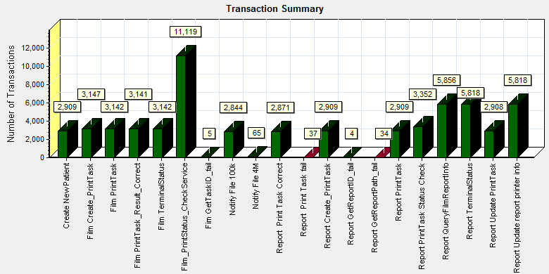
Color | Scale | Measurement
 | 1 | Pass
 | 1 | Fail

We can see that there are 76 transactions failed during the testing works.

Transaction response time result of PS
We can get the transaction response time information from the figure as follow:
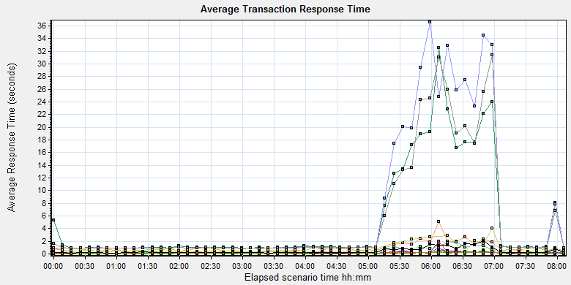
Color | Scale | Measurement | Graph's Minimum | Graph's Average | Graph's Maximum | Graph's Median | Graph's Std. Deviation
 | 1 | Create New Patient | 0.132 | 0.208 | 0.906 | 0.16 | 0.123
 | 1 | Film Create_PrintTask | 0.928 | 5.187 | 32.556 | 1.054 | 7.818
 | 1 | Film PrintTask | 0.066 | 0.159 | 0.569 | 0.113 | 0.116
 | 1 | Film PrintTask_Result_Correct | 0 | 0 | 0 | 0 | 0
 | 1 | Film TerminalStatus | 0.045 | 0.101 | 0.344 | 0.062 | 0.081
 | 1 | Film_PrintStatus_CheckService | 0.037 | 0.106 | 0.448 | 0.061 | 0.101
 | 1 | Fim GetTaskID_fail | 0.016 | 0.016 | 0.016 | 0.016 | 0
 | 1 | Notify File 100k | 0.329 | 0.822 | 5.079 | 0.448 | 0.83
 | 1 | Notify File 4M | 0.296 | 0.978 | 3.996 | 0.697 | 0.78
 | 1 | Report Print Task Correct | 0 | 0 | 0.001 | 0 | 0
 | 1 | Report Create_PrintTask | 0.87 | 6.628 | 36.572 | 0.996 | 10.889
 | 1 | Report GetReportID_fail | 0 | 0 | 0 | 0 | 0
 | 1 | Report PrintTask | 0.129 | 0.404 | 1.84 | 0.202 | 0.424
 | 1 | Report PrintTask Status Check | 0.033 | 0.123 | 1.947 | 0.061 | 0.251
 | 1 | Report QueryFilmReportInfo | 0.862 | 5.396 | 31.346 | 0.982 | 8.773
 | 1 | Report TerminalStatus | 0.029 | 0.093 | 0.377 | 0.056 | 0.084
 | 1 | Report Update PrintTask | 0.141 | 0.446 | 2.083 | 0.246 | 0.439
Transaction response time

This figure information shows all transaction response time. We can analysis that there are some transaction`s response time are not stably after the scenario execute 5 hours. The result cannot accepted by our design.

Test result of Web service

Test result of web transactions
After the performance testing works, the transactions result of we module as follow:
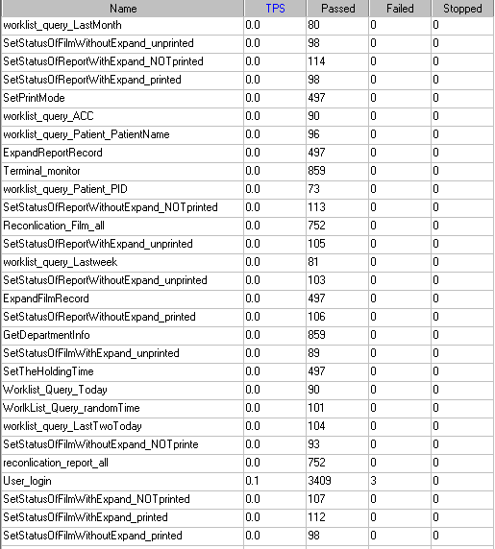
Follow the figure, we can see that there are 3 transactions failed.

Test Statistic Report of Web
Analysis Summary | Period: 24/08/2018 20:21:58 - 25/08/2018 04:23:47

Scenario Name: | D:\Performance\ScenarioPUMA_Reliability_171.lrs
Results in Session: | c:\Users\administrator\appdata\local\temp\res1219\res1219.lrr
Duration: | 8 hours, 1 minute and 49 seconds.

Statistics Summary

Maximum Running Vusers: | 5
Total Throughput (bytes): | 993,022,015
Average Throughput (bytes/second): | 34,349
None | 34,348.738
Total Hits: | 81,033
None | 81,033
Average Hits per Second: | 2.803
None | 2.803
Total Errors: | 24

You can define SLA data using the SLA configuration wizard
You can analyze transaction behavior using the Analyze Transaction mechanism

Transaction Summary

Transactions: | Total Passed: 10,570 | Total Failed: 3 | Total Stopped: 0 | Average Response Time

 | Pass | Fail | Stop
Total | 10,570 | 3 | 0

Transaction Name | Minimum | Average | Maximum | Std. Deviation | 90 Percent | Pass | Fail | Stop
ExpandFilmRecord | 0.034 | 0.167 | 1.122 | 0.189 | 0.489 | 497 | 0 | 0
ExpandReportRecord | 0.006 | 0.021 | 4.281 | 0.194 | 0.014 | 497 | 0 | 0
GetDepartmentInfo | 0.005 | 0.008 | 0.241 | 0.009 | 0.011 | 859 | 0 | 0
Reconlication_Film_all | 0.154 | 0.281 | 3.743 | 0.238 | 0.443 | 752 | 0 | 0
reconlication_report_all | 0.022 | 0.092 | 4.135 | 0.225 | 0.19 | 752 | 0 | 0
SetPrintMode | 0.018 | 0.184 | 6.298 | 0.377 | 0.38 | 497 | 0 | 0
SetStatusOfFilmWithExpand_NOTprinted | 0.071 | 0.42 | 4.269 | 0.482 | 0.852 | 107 | 0 | 0
SetStatusOfFilmWithExpand_printed | 0.087 | 0.406 | 1.978 | 0.364 | 0.882 | 112 | 0 | 0
SetStatusOfFilmWithExpand_unprinted | 0.099 | 0.395 | 1.654 | 0.337 | 0.773 | 89 | 0 | 0
SetStatusOfFilmWithoutExpand_NOTprinte | 0.042 | 0.188 | 2.796 | 0.318 | 0.339 | 93 | 0 | 0
SetStatusOfFilmWithoutExpand_printed | 0.052 | 0.163 | 1.256 | 0.197 | 0.34 | 98 | 0 | 0
SetStatusOfFilmWithoutExpand_unprinted | 0.041 | 0.159 | 0.523 | 0.123 | 0.324 | 98 | 0 | 0
SetStatusOfReportWithExpand_NOTprinted | 0.052 | 0.233 | 4.455 | 0.441 | 0.523 | 114 | 0 | 0
SetStatusOfReportWithExpand_printed | 0.041 | 0.192 | 1.4 | 0.218 | 0.377 | 98 | 0 | 0
SetStatusOfReportWithExpand_unprinted | 0.04 | 0.152 | 1.237 | 0.192 | 0.302 | 105 | 0 | 0
SetStatusOfReportWithoutExpand_NOTprinted | 0.047 | 0.16 | 1.003 | 0.164 | 0.318 | 113 | 0 | 0
SetStatusOfReportWithoutExpand_printed | 0.049 | 0.235 | 1.65 | 0.284 | 0.543 | 106 | 0 | 0
SetStatusOfReportWithoutExpand_unprinted | 0.042 | 0.199 | 2.606 | 0.327 | 0.309 | 103 | 0 | 0
SetTheHoldingTime | 0.02 | 0.111 | 1.765 | 0.176 | 0.246 | 497 | 0 | 0
Terminal_monitor | 0.114 | 0.187 | 1.822 | 0.156 | 0.303 | 859 | 0 | 0
User_login | 0.192 | 0.321 | 22.382 | 0.552 | 0.437 | 3,409 | 3 | 0
worklist_query_ACC | 0.008 | 0.016 | 0.058 | 0.007 | 0.021 | 90 | 0 | 0
worklist_query_LastMonth | 0.016 | 0.056 | 1.124 | 0.125 | 0.057 | 80 | 0 | 0
worklist_query_LastTwoToday | 0.016 | 0.066 | 0.837 | 0.108 | 0.089 | 104 | 0 | 0
worklist_query_Lastweek | 0.015 | 0.084 | 3.248 | 0.355 | 0.069 | 81 | 0 | 0
worklist_query_Patient_PatientName | 0.008 | 0.025 | 0.334 | 0.042 | 0.035 | 96 | 0 | 0
worklist_query_Patient_PID | 0.008 | 0.028 | 0.265 | 0.039 | 0.048 | 73 | 0 | 0
Worklist_Query_Today | 0.021 | 0.085 | 1.205 | 0.19 | 0.071 | 90 | 0 | 0
WorlkList_Query_randomTime | 0.016 | 0.055 | 0.352 | 0.051 | 0.077 | 101 | 0 | 0

Service Level Agreement Legend: |  | Pass |  | Fail |  | No Data

HTTP Responses Summary

HTTP Responses | Total | Per second
HTTP_200 | 77,621 | 2.685
HTTP_302 | 3,412 | 0.118

Follow the summary report, we can see there are 3 transactions failed and cause 24 errors.

Transaction summary result of Web
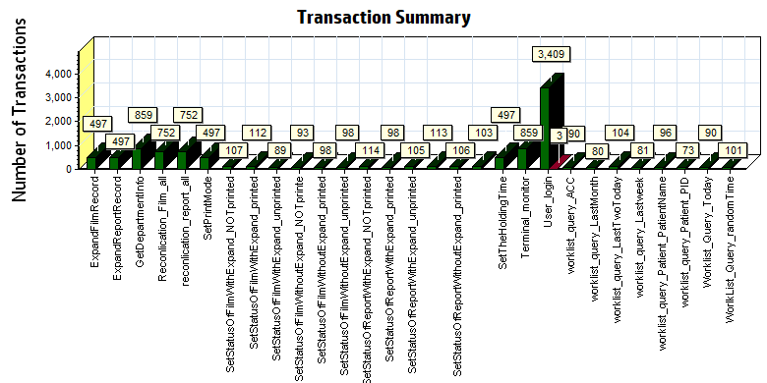
Color | Scale | Measurement
 | 1 | Pass
 | 1 | Fail

We can see that there are 3 transaction failed during the testing works.

Transaction response time result of Web
We can get the transaction response time information from the figure as follow:
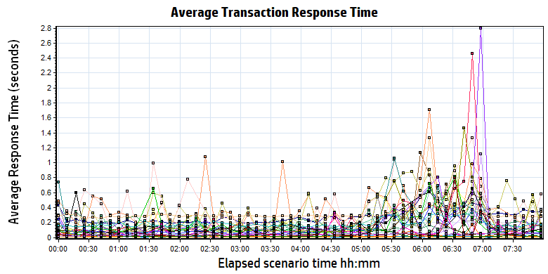
Color | Scale | Measurement | Minimum | Average | Maximum | Std. Deviation
 | 1 | ExpandFilmRecord | 0.034 | 0.167 | 1.122 | 0.189
 | 1 | ExpandReportRecord | 0.006 | 0.021 | 4.281 | 0.194
 | 1 | GetDepartmentInfo | 0.005 | 0.008 | 0.241 | 0.009
 | 1 | Reconlication_Film_all | 0.154 | 0.281 | 3.743 | 0.238
 | 1 | reconlication_report_all | 0.022 | 0.092 | 4.135 | 0.225
 | 1 | SetPrintMode | 0.018 | 0.184 | 6.298 | 0.377
 | 1 | SetStatusOfFilmWithExpand_NOTprinted | 0.071 | 0.420 | 4.269 | 0.482
 | 1 | SetStatusOfFilmWithExpand_printed | 0.087 | 0.406 | 1.978 | 0.364
 | 1 | SetStatusOfFilmWithExpand_unprinted | 0.099 | 0.395 | 1.654 | 0.337
 | 1 | SetStatusOfFilmWithoutExpand_NOTprinte | 0.042 | 0.188 | 2.796 | 0.318
 | 1 | SetStatusOfFilmWithoutExpand_printed | 0.052 | 0.163 | 1.256 | 0.197
 | 1 | SetStatusOfFilmWithoutExpand_unprinted | 0.041 | 0.159 | 0.523 | 0.123
 | 1 | SetStatusOfReportWithExpand_NOTprinted | 0.052 | 0.233 | 4.455 | 0.441
 | 1 | SetStatusOfReportWithExpand_printed | 0.041 | 0.192 | 1.400 | 0.218
 | 1 | SetStatusOfReportWithExpand_unprinted | 0.040 | 0.152 | 1.237 | 0.192
 | 1 | SetStatusOfReportWithoutExpand_NOTprinted | 0.047 | 0.160 | 1.003 | 0.164
 | 1 | SetStatusOfReportWithoutExpand_printed | 0.049 | 0.235 | 1.650 | 0.284
 | 1 | SetStatusOfReportWithoutExpand_unprinted | 0.042 | 0.199 | 2.606 | 0.327
 | 1 | SetTheHoldingTime | 0.020 | 0.111 | 1.765 | 0.176
 | 1 | Terminal_monitor | 0.114 | 0.187 | 1.822 | 0.156
 | 1 | User_login | 0.192 | 0.321 | 22.382 | 0.552
 | 1 | worklist_query_ACC | 0.008 | 0.016 | 0.058 | 0.007
 | 1 | worklist_query_LastMonth | 0.016 | 0.056 | 1.124 | 0.125
 | 1 | worklist_query_LastTwoToday | 0.016 | 0.066 | 0.837 | 0.108
 | 1 | worklist_query_Lastweek | 0.015 | 0.084 | 3.248 | 0.355
 | 1 | worklist_query_Patient_PatientName | 0.008 | 0.025 | 0.334 | 0.042
 | 1 | worklist_query_Patient_PID | 0.008 | 0.028 | 0.265 | 0.039
 | 1 | Worklist_Query_Today | 0.021 | 0.085 | 1.205 | 0.190
 | 1 | WorlkList_Query_randomTime | 0.016 | 0.055 | 0.352 | 0.051

Follow the figure: we can see that the transaction average response time is less than 2 seconds. But some transactions response time is not smoothly after the scenario execute for 5 hours. We should monitor that and try to fix the issues.

Performance bottleneck analysis

Hardware usage analysis
During the testing work, we use the test tool to monitor the server hardware usage include the CPU, Memory, hard disk and etc.
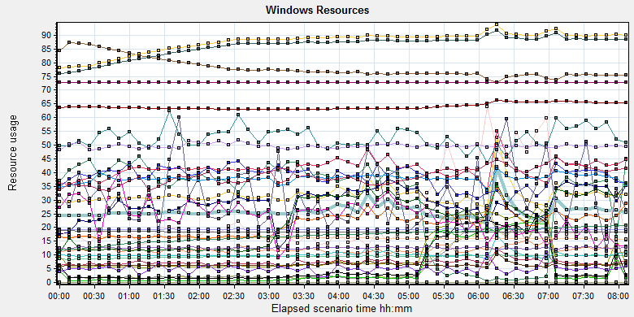
Color | Scale | Measurement | Minimum | Average | Maximum | Std. Deviation
 | 0.01 | % Disk Time (PhysicalDisk _Total):10.184.129.108 | 4.815 | 565.896 | 18742.503 | 1173.851
 | 1 | % Idle Time (PhysicalDisk _Total):10.184.129.108 | 0 | 30.458 | 95.871 | 23.674
 | 100 | % Interrupt Time (Processor _Total):10.184.129.108 | 0 | 0.073 | 0.48 | 0.066
 | 10 | % Privileged Time (Processor _Total):10.184.129.108 | 0.043 | 3.179 | 10.214 | 1.524
 | 10 | % Processor Time (Process CloudDataUploadService):10.184.129.108 | 0 | 2.866 | 17.708 | 1.988
 | 1 | % Processor Time (Processor _Total):10.184.129.108 | 0.521 | 26.015 | 76.563 | 12.073
 | 0.01 | Available MBytes (Memory):10.184.129.108 | 6979 | 7801.717 | 8854 | 367.401
 | 0.0001 | Avg. Disk Bytes/Transfer (PhysicalDisk _Total):10.184.129.108 | 4096 | 119607.254 | 878848 | 86179.873
 | 1 | Avg. Disk Queue Length (PhysicalDisk _Total):10.184.129.108 | 0.048 | 5.659 | 187.425 | 11.738
 | 10 | Avg. Disk Write Queue Length (PhysicalDisk _Total):10.184.129.108 | 0 | 2.44 | 49.966 | 2.412
 | 0.001 | Bytes Total/sec (Server):10.184.129.108 | 18703.504 | 19308.306 | 21537.481 | 324.432
 | 1E-07 | Cache Bytes (Memory):10.184.129.108 | 110297088 | 170467216.718 | 214482944 | 23656345.122
 | 1E-09 | Committed Bytes (Memory):10.184.129.108 | 8284762112 | 9419856984.395 | 10384244736 | 379992861.243
 | 0.001 | Context Switches/sec (System):10.184.129.108 | 3907.278 | 41258.228 | 115170.623 | 19927.533
 | 1 | Current Disk Queue Length (PhysicalDisk _Total):10.184.129.108 | 0 | 5.637 | 250 | 15.729
 | 1E-06 | Disk Read Bytes/sec (PhysicalDisk _Total):10.184.129.108 | 0 | 5285258.142 | 96513376.486 | 9880662.073
 | 0.1 | Disk Reads/sec (PhysicalDisk _Total):10.184.129.108 | 0 | 64.229 | 1138.95 | 106.58
 | 0.1 | Disk Transfers/sec (PhysicalDisk _Total):10.184.129.108 | 2.325 | 102.76 | 1160.872 | 105.081
 | 1E-05 | Disk Write Bytes/sec (PhysicalDisk _Total):10.184.129.108 | 0 | 5267153.049 | 27752449.916 | 3796033.595
 | 1 | Disk Writes/sec (PhysicalDisk _Total):10.184.129.108 | 0 | 38.531 | 221.174 | 20.049
 | 0.001 | File Data Operations/sec (System):10.184.129.108 | 437.401 | 10106.456 | 33519.516 | 5689.21
 | 1E-05 | Free Megabytes (LogicalDisk _Total):10.184.129.108 | 1579591 | 1618343.592 | 1657235 | 22537.965
 | 0.01 | Interrupts/sec (Processor _Total):10.184.129.108 | 894.269 | 3788.471 | 17849.68 | 2122.148
 | 0.0001 | Page Faults/sec (Memory):10.184.129.108 | 3450.132 | 64273.792 | 193144.395 | 31184.975
 | 0.1 | Page Faults/sec (Process CloudDataUploadService):10.184.129.108 | 0 | 236.614 | 5491.044 | 521.736
 | 1E-06 | Page File Bytes (Process CloudDataUploadService):10.184.129.108 | 46993408 | 49671704.881 | 98713600 | 1685486.828
 | 1 | Page Reads/sec (Memory):10.184.129.108 | 0 | 21.037 | 637.366 | 27.137
 | 0.1 | Pages/sec (Memory):10.184.129.108 | 0 | 226.263 | 2951.497 | 308.426
 | 1E-06 | Pool Nonpaged Bytes (Memory):10.184.129.108 | 62640128 | 64019502.822 | 67129344 | 1035170.521
 | 1E-05 | Pool Nonpaged Bytes (Server):10.184.129.108 | 1101321 | 1260662.412 | 1381193 | 41863.138
 | 1E-07 | Pool Paged Bytes (Memory):10.184.129.108 | 181805056 | 183819062.643 | 191578112 | 1592227.001
 | 0.001 | Pool Paged Bytes (Server):10.184.129.108 | 72789 | 72789.105 | 73045 | 5.183
 | 1 | Pool Paged Failures (Server):10.184.129.108 | 0 | 0 | 0 | 0
 | 1E-08 | Private Bytes (Process _Total):10.184.129.108 | 7456563200 | 8613156441.97 | 9508622336 | 383291804.372
 | 100 | Processor Queue Length (System):10.184.129.108 | 0 | 0.315 | 34 | 1.261
 | 1 | Split IO/Sec (PhysicalDisk _Total):10.184.129.108 | 0 | 4.923 | 197.03 | 12.448
 | 1E-07 | System Cache Resident Bytes (Memory):10.184.129.108 | 110297088 | 170467930.6 | 214482944 | 23656703.296
 | 0.01 | Threads (Objects):10.184.129.108 | 3106 | 3879.783 | 4782 | 315.891
 | 1E-08 | Working Set (Process _Total):10.184.129.108 | 7656009728 | 8765459644.759 | 9811816448 | 388223904.863

Follow this information we can get that:
The CPU resource has the bottleneck. The average process time is 55%, but if the system has the upload task, the usage will grow up and value is more than 80%.
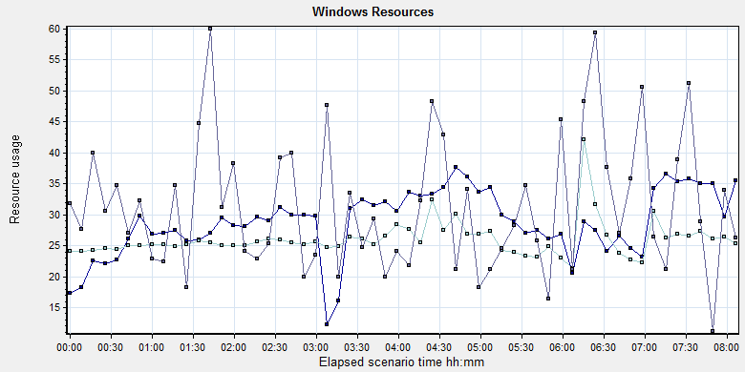
Color | Scale | Measurement | Minimum | Average | Maximum | Std. Deviation
 | 10 | % Processor Time (Process CloudDataUploadService):10.184.129.108 | 0 | 2.866 | 17.708 | 1.988
 | 1 | % Processor Time (Processor _Total):10.184.129.108 | 0.521 | 26.015 | 76.563 | 12.073
 | 100 | Processor Queue Length (System):10.184.129.108 | 0 | 0.315 | 34 | 1.261
Follow the figure we can see that the CPU does not has bottleneck during the testing works. The CPU process time usage is between 25% and 40%. It`s under 85% threshold value can accept. The average CPU queue length is 0.3, it small than the threshold value (12= 6*2). The CPU resource has not bottleneck.

The memory resource do not has the bottleneck. There are enough resources for system to use.
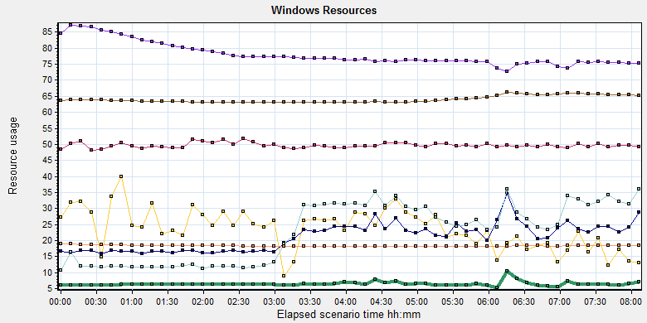
Color | Scale | Measurement | Minimum | Average | Maximum | Std. Deviation
 |  | 0.01 | Available MBytes (Memory):10.184.129.108 | 6979 | 7801.717 | 8854
 |  | 0.0001 | Page Faults/sec (Memory):10.184.129.108 | 3450.132 | 64273.792 | 193144.395
 |  | 0.1 | Page Faults/sec (Process CloudDataUploadService):10.184.129.108 | 0 | 236.614 | 5491.044
 |  | 1E-06 | Page File Bytes (Process CloudDataUploadService):10.184.129.108 | 46993408 | 49671704.881 | 98713600
 |  | 1 | Page Reads/sec (Memory):10.184.129.108 | 0 | 21.037 | 637.366
 |  | 0.1 | Pages/sec (Memory):10.184.129.108 | 0 | 226.263 | 2951.497

The disk has stress during performance testing works:
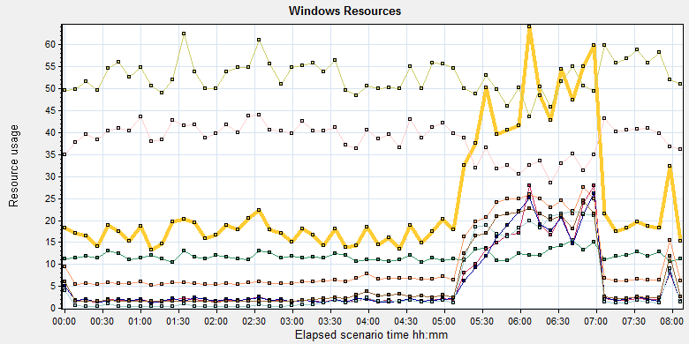
 | 0.01 | % Disk Time (PhysicalDisk _Total):10.184.129.108 | 4.815 | 565.896 | 18742.503 | 1173.851
 | 0.0001 | Avg. Disk Bytes/Transfer (PhysicalDisk _Total):10.184.129.108 | 4096 | 119607.254 | 878848 | 86179.873
 | 1 | Avg. Disk Queue Length (PhysicalDisk _Total):10.184.129.108 | 0.048 | 5.659 | 187.425 | 11.738
 | 10 | Avg. Disk Write Queue Length (PhysicalDisk _Total):10.184.129.108 | 0 | 2.44 | 49.966 | 2.412
 | 1 | Current Disk Queue Length (PhysicalDisk _Total):10.184.129.108 | 0 | 5.637 | 250 | 15.729
 | 1E-06 | Disk Read Bytes/sec (PhysicalDisk _Total):10.184.129.108 | 0 | 5285258.142 | 96513376.486 | 9880662.073
 | 0.1 | Disk Reads/sec (PhysicalDisk _Total):10.184.129.108 | 0 | 64.229 | 1138.95 | 106.58
 | 0.1 | Disk Transfers/sec (PhysicalDisk _Total):10.184.129.108 | 2.325 | 102.76 | 1160.872 | 105.081
 | 1E-05 | Disk Write Bytes/sec (PhysicalDisk _Total):10.184.129.108 | 0 | 5267153.049 | 27752449.916 | 3796033.595
 | 1 | Disk Writes/sec (PhysicalDisk _Total):10.184.129.108 | 0 | 38.531 | 221.174 | 20.049
Follow the figure: we can see that there are many disk tasks exist in the system during the testing work. The average Disk read/sec is 64, writes/sec is 38, and transfers/sec is 102. The average disk transfer size is 10M/sec. The disk is busy, but the stress can accept.

SQL Server resource usage analysis
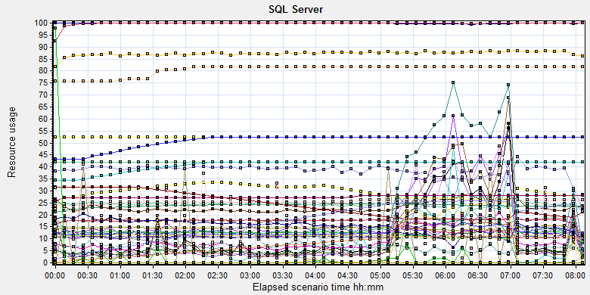
Color | Scale | Measurement | Minimum | Average | Maximum | Std. Deviation
 | 10 | Average Latch Wait Time (ms) (MSSQL$GCPACSWS|Latches):10.184.129.108 | 0.03 | 1.772 | 55.339 | 2.19
 | 1 | Buffer cache hit ratio (MSSQL$GCPACSWS|Buffer Manager):10.184.129.108 | 74.061 | 99.911 | 100 | 0.443
 | 1 | Cache Hit Ratio (MSSQL$GCPACSWS|Catalog Metadata _Total):10.184.129.108 | 20.074 | 23.916 | 24.589 | 0.69
 | 1 | Cache Hit Ratio (MSSQL$GCPACSWS|Cursor Manager by Type _Total):10.184.129.108 | 62.921 | 99.782 | 100 | 1.389
 | 1 | Cache Hit Ratio (MSSQL$GCPACSWS|Plan Cache _Total):10.184.129.108 | 53.863 | 87.241 | 96.751 | 3.917
 | 1 | Checkpoint pages/sec (MSSQL$GCPACSWS|Buffer Manager):10.184.129.108 | 0 | 6.902 | 174.835 | 19.527
 | 0.01 | Connection Memory (KB) (MSSQL$GCPACSWS|Memory Manager):10.184.129.108 | 2008 | 2308.297 | 3064 | 214.286
 | 0.1 | Connection Reset/sec (MSSQL$GCPACSWS|General Statistics):10.184.129.108 | 72.411 | 173.341 | 419.149 | 50.289
 | 1 | Current latch waits (MSOLAP$GCPACSWS|Locks):10.184.129.108 | 0 | 0 | 0 | 0
 | 1 | Cursor flushes (MSSQL$GCPACSWS|Cursor Manager Total):10.184.129.108 | 0 | 0 | 0 | 0
 | 0.01 | Cursor memory usage (MSSQL$GCPACSWS|Cursor Manager by Type _Total):10.184.129.108 | 1504 | 2552.508 | 2616 | 68.159
 | 10 | Cursor Requests/sec (MSSQL$GCPACSWS|Cursor Manager by Type _Total):10.184.129.108 | 0 | 3.828 | 21.918 | 3.395
 | 0.0001 | Database pages (MSSQL$GCPACSWS|Buffer Manager):10.184.129.108 | 45690 | 296782.481 | 335454 | 26765.435
 | 10 | Errors/sec (MSSQL$GCPACSWS|SQL Errors _Total):10.184.129.108 | 0 | 2.422 | 12.622 | 1.774
 | 1 | Free list stalls/sec (MSSQL$GCPACSWS|Buffer Manager):10.184.129.108 | 0 | 0 | 0 | 0
 | 0.0001 | Free pages (MSSQL$GCPACSWS|Buffer Manager):10.184.129.108 | 38 | 38932.19 | 379614 | 48132.326
 | 0.1 | Full Scans/sec (MSSQL$GCPACSWS|Access Methods):10.184.129.108 | 2.325 | 122.5 | 408.79 | 92.369
 | 0.01 | Granted Workspace Memory (KB) (MSSQL$GCPACSWS|Memory Manager):10.184.129.108 | 0 | 1178.981 | 181696 | 4117.121
 | 0.001 | Index Searches/sec (MSSQL$GCPACSWS|Access Methods):10.184.129.108 | 415.473 | 14478.989 | 44534.112 | 13393.156
 | 1 | Latch waits/sec (MSOLAP$GCPACSWS|Locks):10.184.129.108 | 0 | 0 | 0 | 0
 | 0.01 | Latch Waits/sec (MSSQL$GCPACSWS|Latches):10.184.129.108 | 73.838 | 1284.254 | 6618.044 | 463.56
 | 100 | Lazy writes/sec (MSSQL$GCPACSWS|Buffer Manager):10.184.129.108 | 0 | 0.076 | 11.957 | 0.347
 | 0.01 | Lock Memory (KB) (MSSQL$GCPACSWS|Memory Manager):10.184.129.108 | 7560 | 8061.499 | 8184 | 232.034
 | 1 | Lock Timeouts (timeout > 0)/sec (MSSQL$GCPACSWS|Locks _Total):10.184.129.108 | 0 | 0 | 0 | 0
 | 10 | Lock Timeouts/sec (MSSQL$GCPACSWS|Locks _Total):10.184.129.108 | 0 | 0.932 | 14.946 | 1.223
 | 0.1 | Lock Wait Time (ms) (MSSQL$GCPACSWS|Locks _Total):10.184.129.108 | 0 | 114.118 | 17198.646 | 386.314
 | 1 | Lock waits/sec (MSOLAP$GCPACSWS|Locks):10.184.129.108 | 0 | 0 | 0 | 0
 | 10 | Lock Waits/sec (MSSQL$GCPACSWS|Locks _Total):10.184.129.108 | 0 | 0.619 | 10.96 | 0.818
 | 1E-05 | Maximum Workspace Memory (KB) (MSSQL$GCPACSWS|Memory Manager):10.184.129.108 | 1784160 | 2395154.529 | 3151800 | 511410.476
 | 10 | Memory Grants Outstanding (MSSQL$GCPACSWS|Memory Manager):10.184.129.108 | 0 | 0.935 | 17 | 1.992
 | 1 | Memory Grants Pending (MSSQL$GCPACSWS|Memory Manager):10.184.129.108 | 0 | 0 | 0 | 0
 | 1 | Number of active cursor plans (MSSQL$GCPACSWS|Cursor Manager by Type _Total):10.184.129.108 | 16 | 27.413 | 28 | 0.571
 | 10000 | Number of Deadlocks/sec (MSSQL$GCPACSWS|Locks _Total):10.184.129.108 | 0 | 0 | 0.332 | 0.012
 | 1 | Number of SuperLatches (MSSQL$GCPACSWS|Latches):10.184.129.108 | 0 | 0 | 0 | 0
 | 0.01 | Optimizer Memory (KB) (MSSQL$GCPACSWS|Memory Manager):10.184.129.108 | 1080 | 1088.572 | 3728 | 29.173
 | 10 | Page Deallocations/sec (MSSQL$GCPACSWS|Access Methods):10.184.129.108 | 0 | 1.357 | 113.59 | 5.799
 | 1E-05 | Page life expectancy (MSSQL$GCPACSWS|Buffer Manager):10.184.129.108 | 2 | 500005.814 | 4294967 | 1368908.289
 | 0.0001 | Page lookups/sec (MSSQL$GCPACSWS|Buffer Manager):10.184.129.108 | 10335.193 | 166730.23 | 986065.673 | 90038.782
 | 0.01 | Page reads/sec (MSSQL$GCPACSWS|Buffer Manager):10.184.129.108 | 0 | 530.042 | 10866.127 | 1197.764
 | 10 | Page Splits/sec (MSSQL$GCPACSWS|Access Methods):10.184.129.108 | 0 | 1.511 | 9.965 | 1.536
 | 1 | Page writes/sec (MSSQL$GCPACSWS|Buffer Manager):10.184.129.108 | 0 | 7.074 | 146.304 | 19.572
 | 0.1 | Reserved pages (MSSQL$GCPACSWS|Buffer Manager):10.184.129.108 | 0 | 124.792 | 21080 | 481.339
 | 0.0001 | SQL Cache Memory (KB) (MSSQL$GCPACSWS|Memory Manager):10.184.129.108 | 1960 | 73486.628 | 112608 | 35523.14
 | 0.1 | SQL Compilations/sec (MSSQL$GCPACSWS|SQL Statistics):10.184.129.108 | 71.409 | 111.479 | 174.709 | 14.028
 | 1000 | SQL Re-Compilations/sec (MSSQL$GCPACSWS|SQL Statistics):10.184.129.108 | 0 | 0.014 | 1.993 | 0.098
 | 0.0001 | Stolen pages (MSSQL$GCPACSWS|Buffer Manager):10.184.129.108 | 6148 | 173407.994 | 259350 | 76879.99
 | 0.0001 | Target pages (MSSQL$GCPACSWS|Buffer Manager):10.184.129.108 | 524288 | 524288 | 524288 | 0
 | 1E-05 | Target Server Memory (KB) (MSSQL$GCPACSWS|Memory Manager):10.184.129.108 | 4194304 | 4194304 | 4194304 | 0
 | 1 | Tasks Started/sec (MSSQL$GCPACSWS|Broker Activation tempdb):10.184.129.108 | 0 | 0 | 0 | 0
 | 1 | Temp file bytes written/sec (MSOLAP$GCPACSWS|Proc Aggregations):10.184.129.108 | 0 | 0 | 0 | 0
 | 1000 | Temp Tables Creation Rate (MSSQL$GCPACSWS|General Statistics):10.184.129.108 | 0 | 0.002 | 4.982 | 0.075
 | 1 | Temp Tables For Destruction (MSSQL$GCPACSWS|General Statistics):10.184.129.108 | 0 | 0 | 0 | 0
 | 1 | Total deadlocks detected (MSOLAP$GCPACSWS|Locks):10.184.129.108 | 0 | 0 | 0 | 0
 | 0.01 | Total Latch Wait Time (ms) (MSSQL$GCPACSWS|Latches):10.184.129.108 | 10.3 | 2316.655 | 25356.058 | 2667.544
 | 0.0001 | Total pages (MSSQL$GCPACSWS|Buffer Manager):10.184.129.108 | 431452 | 509122.665 | 524288 | 28789.224
 | 1E-05 | Total Server Memory (KB) (MSSQL$GCPACSWS|Memory Manager):10.184.129.108 | 3451616 | 4072981.316 | 4194304 | 230313.796

Follow the SQL server monitor resource, we can find the Database has some issues:
There are some latches and locks exist in the database:
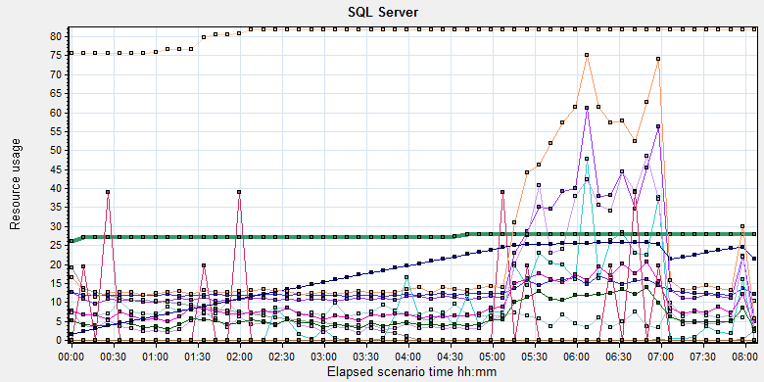
Color | Scale | Measurement | Minimum | Average | Maximum | Std. Deviation
 | 10 | Average Latch Wait Time (ms) (MSSQL$GCPACSWS|Latches):10.184.129.108 | 0.03 | 1.772 | 55.339 | 2.19
 | 1 | Checkpoint pages/sec (MSSQL$GCPACSWS|Buffer Manager):10.184.129.108 | 0 | 6.902 | 174.835 | 19.527
 | 1 | Free list stalls/sec (MSSQL$GCPACSWS|Buffer Manager):10.184.129.108 | 0 | 0 | 0 | 0
 | 0.0001 | Free pages (MSSQL$GCPACSWS|Buffer Manager):10.184.129.108 | 38 | 38932.19 | 379614 | 48132.326
 | 1 | Latch waits/sec (MSOLAP$GCPACSWS|Locks):10.184.129.108 | 0 | 0 | 0 | 0
 | 0.01 | Latch Waits/sec (MSSQL$GCPACSWS|Latches):10.184.129.108 | 73.838 | 1284.254 | 6618.044 | 463.56
 | 100 | Lazy writes/sec (MSSQL$GCPACSWS|Buffer Manager):10.184.129.108 | 0 | 0.076 | 11.957 | 0.347
 | 0.01 | Lock Memory (KB) (MSSQL$GCPACSWS|Memory Manager):10.184.129.108 | 7560 | 8061.499 | 8184 | 232.034
 | 1 | Lock Timeouts (timeout > 0)/sec (MSSQL$GCPACSWS|Locks _Total):10.184.129.108 | 0 | 0 | 0 | 0
 | 10 | Lock Timeouts/sec (MSSQL$GCPACSWS|Locks _Total):10.184.129.108 | 0 | 0.932 | 14.946 | 1.223
 | 0.1 | Lock Wait Time (ms) (MSSQL$GCPACSWS|Locks _Total):10.184.129.108 | 0 | 114.118 | 17198.646 | 386.314
 | 1 | Lock waits/sec (MSOLAP$GCPACSWS|Locks):10.184.129.108 | 0 | 0 | 0 | 0
 | 10 | Lock Waits/sec (MSSQL$GCPACSWS|Locks _Total):10.184.129.108 | 0 | 0.619 | 10.96 | 0.818
 | 1 | Number of active cursor plans (MSSQL$GCPACSWS|Cursor Manager by Type _Total):10.184.129.108 | 16 | 27.413 | 28 | 0.571
 | 10000 | Number of Deadlocks/sec (MSSQL$GCPACSWS|Locks _Total):10.184.129.108 | 0 | 0 | 0.332 | 0.012
 | 1 | Number of SuperLatches (MSSQL$GCPACSWS|Latches):10.184.129.108 | 0 | 0 | 0 | 0
 | 0.0001 | Stolen pages (MSSQL$GCPACSWS|Buffer Manager):10.184.129.108 | 6148 | 173407.994 | 259350 | 76879.99
 | 1 | Total deadlocks detected (MSOLAP$GCPACSWS|Locks):10.184.129.108 | 0 | 0 | 0 | 0
 | 0.01 | Total Latch Wait Time (ms) (MSSQL$GCPACSWS|Latches):10.184.129.108 | 10.3 | 2316.655 | 25356.058 | 2667.544

There are 1284 latches every seconds during the testing work (Latch Waits/sec (MSSQL$GCPACSWS|Latches)). That means there are many recourse compete exist in the system. There are also has some locks and lock time out issues. Some SQL statement needs to enhance to fix these issues.
We can see the lock and latches index increased quickly after the scenario execute 5 hours. We should identify what happened at that time.

Test Conclusion
We executed the performance testing scenario for 8 hours. There are 79 errors happened during the testing work. Even some of the final results of them are accepted, but they still caused the issues make the system not health. We change some configuration for database such as change parameter and delete some views. Bu the result still cannot accept.
The server hardware has some stress. The server hardware resource has not bottleneck.
There are many latches issues and locks exist in our database. The system is not smoothly after the scenario execute after 5 hours. We should more testing work to identify the issues.
During the testing works, the attachments upload information as follow:
Type | Count | Size | All
Dicom | 2446 | 9M | 22,014M
Dicom Png | 2446 | 1.4M | 3,424M
Report Jpg | 2885 | 0.15M | 432.75M
Report PDF | 2885 | 0.12M | 346.2M
 |  |  | 26,217 MB
The system uploaded 26.217GB data to server in 8 hours. The result is close to our requirements 30GB. I will add more attachments in next testing work and monitor the result.
During the testing works, we find the scenario has some issues after the 5 hours. QA team will continue the testing works and identify the root cause reason. The performance result does not meet the requirements for this phase testing works.

Testing work （Phase 5）

Test Environment
The detailed hardware configurations of all servers are described as follow:

Computer name | CPU | Memory | HD | OS | Other | Comments
PS Server Panda upgrade | Interl(R) Xeon® CPU E5-2350 @ 1.80 * 6 | 12GB | 1TB | Windows 2008 R2 64bit | SQL server workgroup 2008 | Use the network 100Mbps
Workstation Server | Intel i3-2120 3.3GHz | 2GB | 80GB | Windows 7 SP1 64bit | QTP 11 | 6 virtual machine in server
Terminal | Intel Atom D525 1.8GHz | 4GB | 450GB | Windows Embedded Standard SP1 64bit | UTF 12.0 trail
Cloud Film Server | Huawei Cloud 3 4CORE | 8G | 40GB +  200GB | Windows Server 2016
Cloud film DB Server | Huawei Cloud 3 2CORE | 8G | 40GB | Huaiwei cloud offer | MySQL 5.7

Test scenario and strategy
Virtual User: 21 Users
Duration: 8 hour
Description: Use the test tool simulates the patient operations. Monitor the server software and hardware resource usage. The detail information as follow:
- Use automation tool simulate the doctor print film work. Simulate 6 GX Platform by using QTP and WinDPSTester tool. Each client prints one film which size is 10MB every 60 seconds.
- Use LR tool simulate 8 K2/K3 terminals to print film. Each client prints one film which size is 10MB random 10 to 30 seconds.
- Use LR tool simulate 8 users to do report archive operations. Each client archive report in random 10 to 30 seconds and size is random with 100kb and 4Mb.
- Use LR tool simulate 8 terminals to print paper reports. Each client prints report random 5 to 10 seconds.
- The OCR setting is not has rule for GX platforms in step1 and other setting are set as default. The OCR service will under the strong stress without configure the rule.
- Simulate 5 users to do the query information, view monitor page, query reconciliation films and report, expand the record, change the status, set holding time and other operations in worklist.
- Monitor the transaction response time.
- Monitor the hardware resource usage on PS.
- Monitor the resource usage for database on PS.
- Start/Stop 1 virtual user every 5 seconds and run the scenario for 8 hours.
- Use the business Upload network bandwidth to 100M.

Note:
We will do the performance testing work under big stress for system. If system can work well under current stress and the transaction process ability meets the requirement, we will give the conclusion the system performance is pass.

Test Tool
Load Runner 12.

Database setting
Memory: Set the min and max memory size to 4GB.
Index fill factor: 80.
File: Increase the data and log files size and the rule is increase 500Mb as fixed size.

IIS setting
Connection: Set the max connection value to 4000 and keep other setting as default.

Test Object version
KIOSK cloud film 3.0.3.0 B26 + 2 update SQL scripts + Force Parameter + delete view of available patient, available study, alrmMessageList, filmmedia and study. + cost parallel value = 30 + max parallel = 12

Background data
We prepared a background records in the PS system. The data size is calculated by the typical site which printed 3,000 films in a workday. That means the records of films in db should more than 972,000 (3000records / day *54 weeks * 6 workday). QA team had prepared these data with SQL script and automation script. These data can backup and import by DB tool.
The detail data records in DB as follow:

Table Name | Data Volume (records)
printer.dbo.DeliveryJob | 995199
printer.dbo.ImageBox | 3530116
printer.dbo.Page | 314893
printer.dbo.Session | 571212
wggc.dbo.Patient | 1224710
wggc.dbo.Study | 1434574
wggc.dbo.AFP_PrintTerminalInfo | 70
wggc.dbo.Series | 1434524
wggc.dbo.Image | 1434527
wggc.dbo.AFP_FilmInfo | 1420905
wggc.dbo.AFP_ReportInfo | 1232003
wggc.dbo.AFP_ExamInfo | 2308723
wggc.dbo.AFP_PrintTask | 4324918
wggc.dbo.T_Integration_ExamInfo | 1421769
AFP_PrintMode | 523684
wggc.dbo.vi_KIOSK_ExamInfo_Order | 838208

Test Error
There are 4 errors existed in the testing work s. The system creates print tasks failed. The detail information please sees the attachment.

Error analyzes:
These errors caused by the system try to create film print task and the system do not return the taskID. We should monitor these issues and try to fix them.

Test result of PS server

Test result of PS transactions
After the performance testing works, the transactions result of PS print module as follow:

N/A
Data lost by error opertations, please refer the chapter of ‘Test Statistic Report of PS’.

Test Statistic Report of PS
Analysis Summary | Period: 2018/8/30 18:56 - 2018/8/31 2:59

Scenario Name: | E:\ECS\Performance\Script\208\ScenarioPUMA_Reliability_171.lrs
Results in Session: | C:\Users\Administrator\AppData\Local\Temp\res175\res175.lrr
Duration: | 8 hours, 3 minutes and 12 seconds.

Statistics Summary

Maximum Running Vusers: |  | 16
Total Throughput (bytes): |  | 16,742,276
Average Throughput (bytes/second): |  | 577
Total Hits: |  | 17,292
Average Hits per Second: |  | 0.596 | View HTTP Responses Summary
Total Errors: |  | 4

You can define SLA data using the SLA configuration wizard
You can analyze transaction behavior using the Analyze Transaction mechanism

Transaction Summary

Transactions: | Total Passed: 55,397 | Total Failed: 0 | Total Stopped: 2 | Average Response Time

Transaction Name | SLA Status | Minimum | Average | Maximum | Std. Deviation | 90 Percent | Pass | Fail | Stop
Create New Patient |  | 0.078 | 0.13 | 0.693 | 0.054 | 0.187 | 2,726 | 0 | 0
Film Create_PrintTask |  | 0.667 | 5.079 | 34.579 | 2.35 | 7.426 | 2,691 | 0 | 0
Film PrintTask |  | 0.016 | 0.05 | 0.452 | 0.044 | 0.094 | 2,687 | 0 | 0
Film PrintTask_Result_Correct |  | 0 | 0 | 0.016 | 0.001 | 0 | 2,686 | 0 | 0
Film TerminalStatus |  | 0 | 0.032 | 1.072 | 0.047 | 0.062 | 2,687 | 0 | 0
Film_PrintStatus_CheckService |  | 0 | 0.028 | 1.234 | 0.041 | 0.051 | 9,228 | 0 | 0
Fim GetTaskID_fail |  | 0.001 | 0.002 | 0.002 | 0 | 0.002 | 4 | 0 | 0
Notify File 100k |  | 0.047 | 0.219 | 6.599 | 0.211 | 0.374 | 2,669 | 0 | 0
Notify File 4M |  | 0.187 | 0.427 | 1.239 | 0.224 | 0.702 | 57 | 0 | 0
Report Print Task Correct |  | 0 | 0 | 0.016 | 0 | 0 | 2,721 | 0 | 0
Report Create_PrintTask |  | 0.406 | 2.084 | 32.023 | 2.472 | 5.929 | 2,723 | 0 | 1
Report PrintTask |  | 0.016 | 0.054 | 0.764 | 0.063 | 0.102 | 2,722 | 0 | 0
Report PrintTask Status Check |  | 0 | 0.029 | 0.583 | 0.036 | 0.055 | 2,721 | 0 | 0
Report QueryFilmReportInfo |  | 0.39 | 2.07 | 33.09 | 2.491 | 5.975 | 5,449 | 0 | 1
Report TerminalStatus |  | 0 | 0.027 | 1.668 | 0.046 | 0.047 | 5,452 | 0 | 0
Report Update PrintTask |  | 0.016 | 0.066 | 1.794 | 0.08 | 0.133 | 2,722 | 0 | 0
Report Update report printer info |  | 0 | 0.027 | 1.083 | 0.046 | 0.047 | 5,452 | 0 | 0

Service Level Agreement Legend: |  | Pass |  | Fail |  | No Data

HTTP Responses Summary

HTTP Responses | Total | Per second
HTTP_200 | 17,292 | 0.596

Follow the summary report, we can see there are 4 failed transactions during the testing work. (Fim GetTaskID_fail)

Transaction summary result of PS
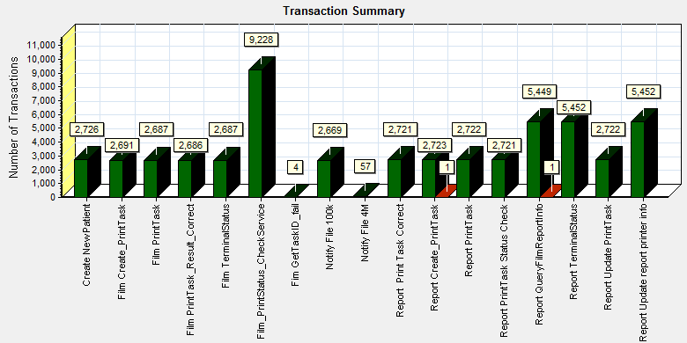
Color | Scale | Measurement
 | 1 | Pass
 | 1 | Stop
Description: Displays the number of transactions that passed, failed, stopped, or ended with errors.
We can see that there are 4 transactions failed during the testing works.

Transaction response time result of PS
We can get the transaction response time information from the figure as follow:
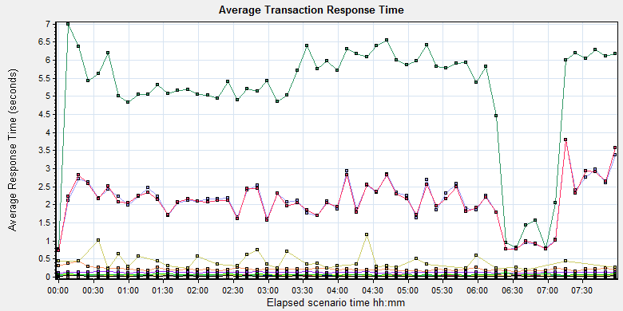
Color | Scale | Measurement | Minimum | Average | Maximum | Std. Deviation
 | 1 | Create New Patient | 0.078 | 0.13 | 0.693 | 0.054
 | 1 | Film Create_PrintTask | 0.667 | 5.079 | 34.579 | 2.35
 | 1 | Film PrintTask | 0.016 | 0.05 | 0.452 | 0.044
 | 1 | Film PrintTask_Result_Correct | 0 | 0 | 0.016 | 0.001
 | 1 | Film TerminalStatus | 0 | 0.032 | 1.072 | 0.047
 | 1 | Film_PrintStatus_CheckService | 0 | 0.028 | 1.234 | 0.041
 | 1 | Fim GetTaskID_fail | 0.001 | 0.002 | 0.002 | 0
 | 1 | Notify File 100k | 0.047 | 0.219 | 6.599 | 0.211
 | 1 | Notify File 4M | 0.187 | 0.427 | 1.239 | 0.224
 | 1 | Report Print Task Correct | 0 | 0 | 0.016 | 0
 | 1 | Report Create_PrintTask | 0.406 | 2.084 | 32.023 | 2.472
 | 1 | Report PrintTask | 0.016 | 0.054 | 0.764 | 0.063
 | 1 | Report PrintTask Status Check | 0 | 0.029 | 0.583 | 0.036
 | 1 | Report QueryFilmReportInfo | 0.39 | 2.07 | 33.09 | 2.491
 | 1 | Report TerminalStatus | 0 | 0.027 | 1.668 | 0.046
 | 1 | Report Update PrintTask | 0.016 | 0.066 | 1.794 | 0.08
 | 1 | Report Update report printer info | 0 | 0.027 | 1.083 | 0.046
Transaction response time

This figure information shows all transaction response time. We can analysis that there are some transaction`s response time are more than 2 seconds.
Color | Scale | Measurement | Minimum | Average | Maximum | Std. Deviation
 | 1 | Film Create_PrintTask | 0.667 | 5.079 | 34.579 | 2.35
 | 1 | Report Create_PrintTask | 0.406 | 2.084 | 32.023 | 2.472
 | 1 | Report QueryFilmReportInfo | 0.39 | 2.07 | 33.09 | 2.491
These transactions execute under big stress which cause by the database. The database resource contend make the transactions response time high.

Test result of Web service

Test result of web transactions
After the performance testing works, the transactions result of we module as follow:
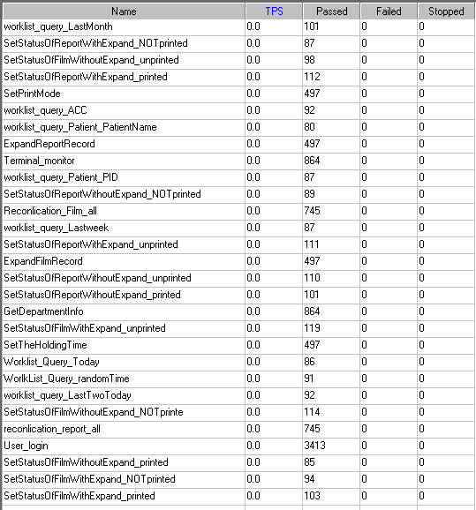
Follow the figure, we can see that there are no transactions failed.

Test Statistic Report of Web
Analysis Summary | Period: 30/08/2018 19:18:06 - 31/08/2018 03:20:15

Scenario Name: | D:\Performance\ScenarioPUMA_Reliability_171.lrs
Results in Session: | c:\Users\administrator\appdata\local\temp\res1238\res1238.lrr
Duration: | 8 hours, 2 minutes and 9 seconds.

Statistics Summary

Maximum Running Vusers: |  | 5
Total Throughput (bytes): |  | 1,199,250,048
Average Throughput (bytes/second): |  | 41,454
Total Hits: |  | 89,378
Average Hits per Second: |  | 3.089 | View HTTP Responses Summary

Transaction Summary

Transactions: | Total Passed: 11,585 | Total Failed: 0 | Total Stopped: 0 | Average Response Time

Transaction Name | Minimum | Average | Maximum | 90 Percent | Pass | Fail | Stop
ExpandFilmRecord | 0.087 | 0.128 | 3.97 | 0.176 | 550 | 0 | 0
ExpandReportRecord | 0.005 | 0.009 | 0.168 | 0.012 | 548 | 0 | 0
GetDepartmentInfo | 0.005 | 0.007 | 0.058 | 0.01 | 946 | 0 | 0
Reconlication_Film_all | 0.344 | 0.543 | 5.439 | 0.935 | 818 | 0 | 0
reconlication_report_all | 0.021 | 0.034 | 0.386 | 0.051 | 820 | 0 | 0
SetPrintMode | 0.013 | 0.056 | 0.541 | 0.091 | 547 | 0 | 0
SetStatusOfFilmWithExpand_NOTprinted | 0.106 | 0.164 | 0.428 | 0.248 | 100 | 0 | 0
SetStatusOfFilmWithExpand_printed | 0.111 | 0.184 | 2.269 | 0.245 | 115 | 0 | 0
SetStatusOfFilmWithExpand_unprinted | 0.11 | 0.167 | 0.622 | 0.23 | 128 | 0 | 0
SetStatusOfFilmWithoutExpand_NOTprinte | 0.022 | 0.067 | 0.517 | 0.112 | 125 | 0 | 0
SetStatusOfFilmWithoutExpand_printed | 0.019 | 0.06 | 0.281 | 0.105 | 90 | 0 | 0
SetStatusOfFilmWithoutExpand_unprinted | 0.02 | 0.071 | 0.357 | 0.121 | 108 | 0 | 0
SetStatusOfReportWithExpand_NOTprinted | 0.022 | 0.063 | 0.32 | 0.103 | 96 | 0 | 0
SetStatusOfReportWithExpand_printed | 0.022 | 0.07 | 0.349 | 0.147 | 124 | 0 | 0
SetStatusOfReportWithExpand_unprinted | 0.021 | 0.065 | 0.413 | 0.105 | 120 | 0 | 0
SetStatusOfReportWithoutExpand_NOTprinted | 0.023 | 0.066 | 0.376 | 0.113 | 100 | 0 | 0
SetStatusOfReportWithoutExpand_printed | 0.022 | 0.065 | 0.304 | 0.126 | 109 | 0 | 0
SetStatusOfReportWithoutExpand_unprinted | 0.022 | 0.082 | 0.534 | 0.132 | 118 | 0 | 0
SetTheHoldingTime | 0.012 | 0.037 | 0.318 | 0.065 | 544 | 0 | 0
Terminal_monitor | 0.116 | 0.18 | 1.161 | 0.223 | 946 | 0 | 0
User_login | 0.191 | 0.3 | 1.998 | 0.455 | 3,747 | 0 | 0
worklist_query_ACC | 0.008 | 0.014 | 0.061 | 0.018 | 99 | 0 | 0
worklist_query_LastMonth | 0.04 | 0.075 | 0.218 | 0.13 | 110 | 0 | 0
worklist_query_LastTwoToday | 0.038 | 0.07 | 0.245 | 0.104 | 103 | 0 | 0
worklist_query_Lastweek | 0.04 | 0.07 | 0.17 | 0.097 | 98 | 0 | 0
worklist_query_Patient_PatientName | 0.007 | 0.017 | 0.037 | 0.022 | 86 | 0 | 0
worklist_query_Patient_PID | 0.007 | 0.032 | 1.437 | 0.024 | 97 | 0 | 0
Worklist_Query_Today | 0.019 | 0.049 | 0.217 | 0.071 | 92 | 0 | 0
WorlkList_Query_randomTime | 0.044 | 0.079 | 0.256 | 0.107 | 101 | 0 | 0

Service Level Agreement Legend: |  | Pass |  | Fail |  | No Data

HTTP Responses Summary

HTTP Responses | Total | Per second
HTTP_200 | 85,590.4 | 2.959
HTTP_302 | 3,787.8 | 0.131

Follow the summary report, we can see there are no transactions failed.

Transaction summary result of Web
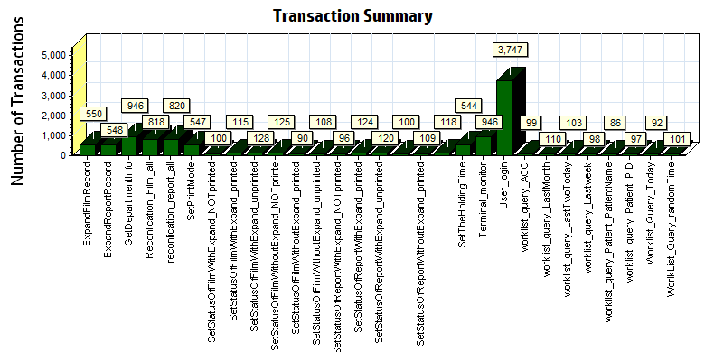
Color | Scale | Measurement
 | 1 | Pass

We can see that there are 3 transaction failed during the testing works.

Transaction response time result of Web
We can get the transaction response time information from the figure as follow:
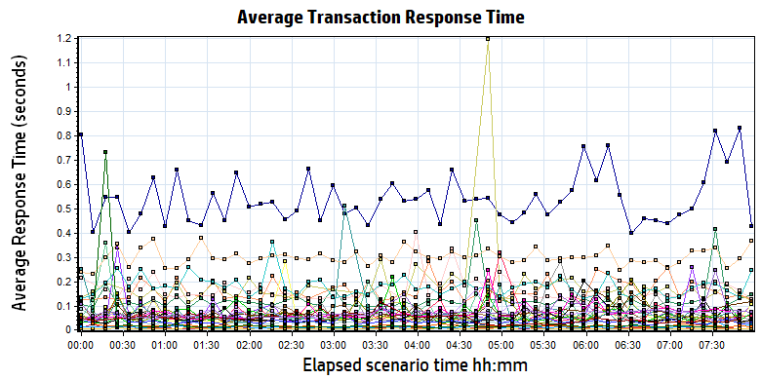
Color | Scale | Measurement | Minimum | Average | Maximum | Std. Deviation
 | 1 | ExpandFilmRecord | 0.087 | 0.128 | 3.970 | 0.203
 | 1 | ExpandReportRecord | 0.005 | 0.009 | 0.168 | 0.009
 | 1 | GetDepartmentInfo | 0.005 | 0.007 | 0.058 | 0.004
 | 1 | Reconlication_Film_all | 0.344 | 0.543 | 5.439 | 0.341
 | 1 | reconlication_report_all | 0.021 | 0.034 | 0.386 | 0.028
 | 1 | SetPrintMode | 0.013 | 0.056 | 0.541 | 0.057
 | 1 | SetStatusOfFilmWithExpand_NOTprinted | 0.106 | 0.164 | 0.428 | 0.061
 | 1 | SetStatusOfFilmWithExpand_printed | 0.111 | 0.184 | 2.269 | 0.202
 | 1 | SetStatusOfFilmWithExpand_unprinted | 0.110 | 0.167 | 0.622 | 0.074
 | 1 | SetStatusOfFilmWithoutExpand_NOTprinte | 0.022 | 0.067 | 0.517 | 0.061
 | 1 | SetStatusOfFilmWithoutExpand_printed | 0.019 | 0.060 | 0.281 | 0.042
 | 1 | SetStatusOfFilmWithoutExpand_unprinted | 0.020 | 0.071 | 0.357 | 0.060
 | 1 | SetStatusOfReportWithExpand_NOTprinted | 0.022 | 0.063 | 0.320 | 0.046
 | 1 | SetStatusOfReportWithExpand_printed | 0.022 | 0.070 | 0.349 | 0.056
 | 1 | SetStatusOfReportWithExpand_unprinted | 0.021 | 0.065 | 0.413 | 0.055
 | 1 | SetStatusOfReportWithoutExpand_NOTprinted | 0.023 | 0.066 | 0.376 | 0.049
 | 1 | SetStatusOfReportWithoutExpand_printed | 0.022 | 0.065 | 0.304 | 0.050
 | 1 | SetStatusOfReportWithoutExpand_unprinted | 0.022 | 0.082 | 0.534 | 0.093
 | 1 | SetTheHoldingTime | 0.012 | 0.037 | 0.318 | 0.034
 | 1 | Terminal_monitor | 0.116 | 0.180 | 1.161 | 0.143
 | 1 | User_login | 0.191 | 0.300 | 1.998 | 0.169
 | 1 | worklist_query_ACC | 0.008 | 0.014 | 0.061 | 0.006
 | 1 | worklist_query_LastMonth | 0.040 | 0.075 | 0.218 | 0.032
 | 1 | worklist_query_LastTwoToday | 0.038 | 0.070 | 0.245 | 0.030
 | 1 | worklist_query_Lastweek | 0.040 | 0.070 | 0.170 | 0.023
 | 1 | worklist_query_Patient_PatientName | 0.007 | 0.017 | 0.037 | 0.005
 | 1 | worklist_query_Patient_PID | 0.007 | 0.032 | 1.437 | 0.143
 | 1 | Worklist_Query_Today | 0.019 | 0.049 | 0.217 | 0.024
 | 1 | WorlkList_Query_randomTime | 0.044 | 0.079 | 0.256 | 0.035

Transaction response time
Follow the figure: we can see that the transaction average response time is less than 2 seconds. The transaction works very smoothly.

Performance bottleneck analysis

Hardware usage analysis
During the testing work, we use the test tool to monitor the server hardware usage include the CPU, Memory, hard disk and etc.
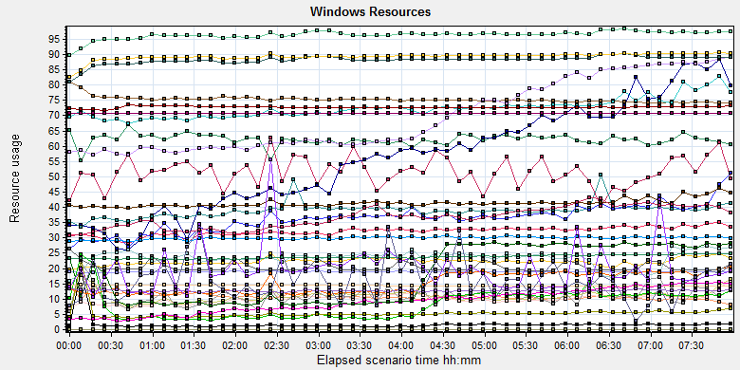
Color | Scale | Measurement | Minimum | Average | Maximum | Std. Deviation
 | 0.1 | % Disk Time (PhysicalDisk _Total):10.184.129.108 | 2.898 | 108.281 | 5176.554 | 122.041
 | 1 | % Idle Time (PhysicalDisk _Total):10.184.129.108 | 0 | 62.202 | 96.945 | 19.018
 | 1000 | % Interrupt Time (Processor _Total):10.184.129.108 | 0 | 0.051 | 0.477 | 0.056
 | 10 | % Privileged Time (Processor _Total):10.184.129.108 | 0 | 2.225 | 9.542 | 1.278
 | 10 | % Processor Time (Process CloudDataUploadService):10.184.129.108 | 0 | 5.605 | 52.083 | 4.104
 | 1 | % Processor Time (Processor _Total):10.184.129.108 | 0 | 23.332 | 85.59 | 11.907
 | 0.01 | Available MBytes (Memory):10.184.129.108 | 7087 | 7532.171 | 8396 | 126.282
 | 0.0001 | Avg. Disk Bytes/Transfer (PhysicalDisk _Total):10.184.129.108 | 3956.364 | 107537.662 | 1937779.2 | 102142.411
 | 10 | Avg. Disk Queue Length (PhysicalDisk _Total):10.184.129.108 | 0.029 | 1.083 | 51.766 | 1.22
 | 10 | Avg. Disk Write Queue Length (PhysicalDisk _Total):10.184.129.108 | 0.026 | 0.996 | 29.988 | 0.877
 | 0.001 | Bytes Total/sec (Server):10.184.129.108 | 17187.92 | 18978.266 | 21209.676 | 224.907
 | 1E-07 | Cache Bytes (Memory):10.184.129.108 | 223813632 | 237956603.215 | 264339456 | 6305258.629
 | 1E-08 | Committed Bytes (Memory):10.184.129.108 | 8722276352 | 9639898671.106 | 10144079872 | 154348362.016
 | 0.001 | Context Switches/sec (System):10.184.129.108 | 3065.535 | 32178.613 | 104416.735 | 19619.596
 | 10 | Current Disk Queue Length (PhysicalDisk _Total):10.184.129.108 | 0 | 1.104 | 116 | 2.98
 | 1E-05 | Disk Read Bytes/sec (PhysicalDisk _Total):10.184.129.108 | 0 | 821489.198 | 86388677.952 | 2027007.729
 | 0.1 | Disk Reads/sec (PhysicalDisk _Total):10.184.129.108 | 0 | 17.282 | 2846.864 | 77.751
 | 0.1 | Disk Transfers/sec (PhysicalDisk _Total):10.184.129.108 | 3.321 | 53.565 | 2865.137 | 80.002
 | 1E-05 | Disk Write Bytes/sec (PhysicalDisk _Total):10.184.129.108 | 12243.54 | 3893755.596 | 175518284.029 | 3850880.648
 | 1 | Disk Writes/sec (PhysicalDisk _Total):10.184.129.108 | 2.989 | 36.283 | 275.233 | 19.206
 | 0.01 | File Data Operations/sec (System):10.184.129.108 | 472.268 | 7238.725 | 28457.518 | 4629.096
 | 1E-05 | Free Megabytes (LogicalDisk _Total):10.184.129.108 | 1415726 | 1442214.866 | 1468136 | 15327.764
 | 0.01 | Interrupts/sec (Processor _Total):10.184.129.108 | 930.055 | 2991.843 | 12885.55 | 1701.892
 | 0.001 | Page Faults/sec (Memory):10.184.129.108 | 283.303 | 41379.21 | 169859.095 | 26619.274
 | 0.01 | Page Faults/sec (Process CloudDataUploadService):10.184.129.108 | 0 | 920.79 | 7886.84 | 1015.757
 | 1E-06 | Page File Bytes (Process CloudDataUploadService):10.184.129.108 | 53489664 | 69549003.896 | 134299648 | 14344368.348
 | 1 | Page Reads/sec (Memory):10.184.129.108 | 0 | 15.207 | 560.259 | 23.272
 | 0.1 | Pages/sec (Memory):10.184.129.108 | 0 | 180.822 | 3227.051 | 293.262
 | 1E-06 | Pool Nonpaged Bytes (Memory):10.184.129.108 | 71675904 | 72753746.196 | 73928704 | 334419.601
 | 1E-05 | Pool Nonpaged Bytes (Server):10.184.129.108 | 1150601 | 1271071.3 | 1397225 | 42036.308
 | 1E-07 | Pool Paged Bytes (Memory):10.184.129.108 | 193261568 | 204446571.345 | 275427328 | 19265696.605
 | 0.001 | Pool Paged Bytes (Server):10.184.129.108 | 70613 | 70613 | 70613 | 0
 | 1 | Pool Paged Failures (Server):10.184.129.108 | 0 | 0 | 0 | 0
 | 1E-08 | Private Bytes (Process _Total):10.184.129.108 | 7928430592 | 8820022050.612 | 9192128512 | 151914974.568
 | 100 | Processor Queue Length (System):10.184.129.108 | 0 | 0.162 | 28 | 0.865
 | 10 | Split IO/Sec (PhysicalDisk _Total):10.184.129.108 | 0 | 1.989 | 192.302 | 6.791
 | 1E-07 | System Cache Resident Bytes (Memory):10.184.129.108 | 223813632 | 237957754.178 | 264339456 | 6306494.073
 | 0.01 | Threads (Objects):10.184.129.108 | 2931 | 3672.426 | 4542 | 355.84
 | 1E-08 | Working Set (Process _Total):10.184.129.108 | 7964983296 | 8929967199.914 | 9444212736 | 145294201.031
Description: Displays a summary of the System Resources usage for each Windows based host.

Follow this information we can get that:
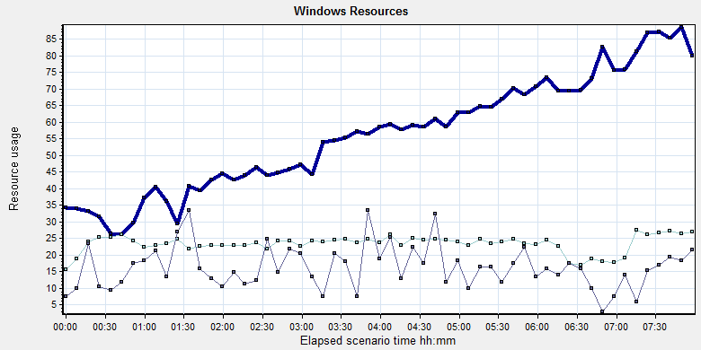
Color | Scale | Measurement | Minimum | Average | Maximum | Std. Deviation
 | 10 | % Processor Time (Process CloudDataUploadService):10.184.129.108 | 0 | 5.605 | 52.083 | 4.104
 | 1 | % Processor Time (Processor _Total):10.184.129.108 | 0 | 23.332 | 85.59 | 11.907
 | 100 | Processor Queue Length (System):10.184.129.108 | 0 | 0.162 | 28 | 0.865

Description: Displays a summary of the System Resources usage for each Windows based host.

Follow the figure we can see that the CPU does not has bottleneck during the testing works. The CPU process time usage is between 5% and 30%. It`s under 85% threshold value can accept. The average CPU queue length is 0.1, it small than the threshold value (12= 6*2).
We can see the cloudDataUploadService CPOU usage increase with the execute time. But the usage value is small can accepted by system. The index value should divided the numbers of CPU.The CPU resource has not bottleneck.

The memory resource do not has the bottleneck. There are enough resources for system to use.
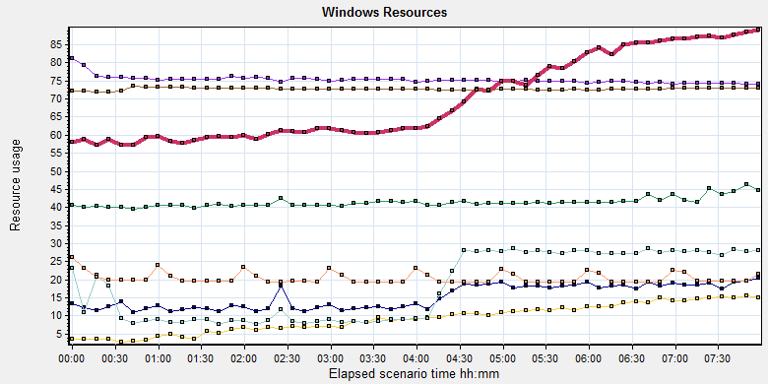
Color | Scale | Measurement | Minimum | Average | Maximum | Std. Deviation
 | 0.01 | Available MBytes (Memory):10.184.129.108 | 7087 | 7532.171 | 8396 | 126.282
 | 0.001 | Page Faults/sec (Memory):10.184.129.108 | 283.303 | 41379.21 | 169859.095 | 26619.274
 | 0.01 | Page Faults/sec (Process CloudDataUploadService):10.184.129.108 | 0 | 920.79 | 7886.84 | 1015.757
 | 1E-06 | Page File Bytes (Process CloudDataUploadService):10.184.129.108 | 53489664 | 69549003.896 | 134299648 | 14344368.348
 | 1 | Page Reads/sec (Memory):10.184.129.108 | 0 | 15.207 | 560.259 | 23.272
 | 0.1 | Pages/sec (Memory):10.184.129.108 | 0 | 180.822 | 3227.051 | 293.262
 | 1E-06 | Pool Nonpaged Bytes (Memory):10.184.129.108 | 71675904 | 72753746.196 | 73928704 | 334419.601
 | 1E-07 | Pool Paged Bytes (Memory):10.184.129.108 | 193261568 | 204446571.345 | 275427328 | 19265696.605
Description: Displays a summary of the System Resources usage for each Windows based host.
Form the memory usage figure, we can see that the page files of CloudDataUploadService increase after the test scenario execute 4 hours. That means this service process ability go slow and many upload tasks blocked in the systems. We should enhance the upload service to finish upload operations quickly.

The disk resource is enough during performance testing works:
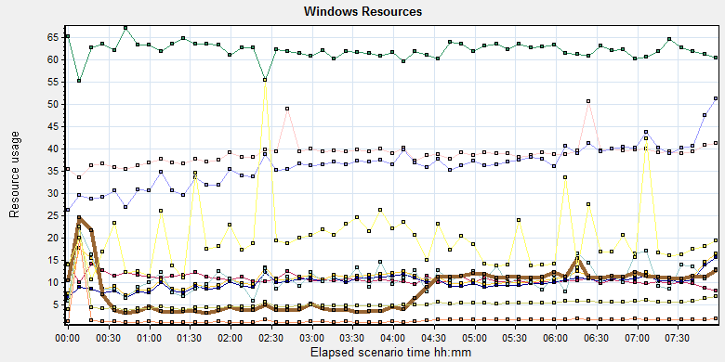
Color | Scale | Measurement | Minimum | Average | Maximum | Std. Deviation
 | 0.1 | % Disk Time (PhysicalDisk _Total):10.184.129.108 | 2.898 | 108.281 | 5176.554 | 122.041
 | 1 | % Idle Time (PhysicalDisk _Total):10.184.129.108 | 0 | 62.202 | 96.945 | 19.018
 | 0.0001 | Avg. Disk Bytes/Transfer (PhysicalDisk _Total):10.184.129.108 | 3956.364 | 107537.662 | 1937779.2 | 102142.411
 | 10 | Avg. Disk Queue Length (PhysicalDisk _Total):10.184.129.108 | 0.029 | 1.083 | 51.766 | 1.22
 | 10 | Avg. Disk Write Queue Length (PhysicalDisk _Total):10.184.129.108 | 0.026 | 0.996 | 29.988 | 0.877
 | 10 | Current Disk Queue Length (PhysicalDisk _Total):10.184.129.108 | 0 | 1.104 | 116 | 2.98
 | 1E-05 | Disk Read Bytes/sec (PhysicalDisk _Total):10.184.129.108 | 0 | 821489.198 | 86388677.952 | 2027007.729
 | 0.1 | Disk Reads/sec (PhysicalDisk _Total):10.184.129.108 | 0 | 17.282 | 2846.864 | 77.751
 | 0.1 | Disk Transfers/sec (PhysicalDisk _Total):10.184.129.108 | 3.321 | 53.565 | 2865.137 | 80.002
 | 1E-05 | Disk Write Bytes/sec (PhysicalDisk _Total):10.184.129.108 | 12243.54 | 3893755.596 | 175518284.029 | 3850880.648
 | 1 | Disk Writes/sec (PhysicalDisk _Total):10.184.129.108 | 2.989 | 36.283 | 275.233 | 19.206
 | 10 | Split IO/Sec (PhysicalDisk _Total):10.184.129.108 | 0 | 1.989 | 192.302 | 6.791
Description: Displays a summary of the System Resources usage for each Windows based host.
Follow the figure: we can see that there are many disk tasks exist in the system during the testing work. The average Disk read/sec is 17, writes/sec is 36, and transfers/sec is 53. The average disk transfer size is 4.5M/sec. The disk is not busy and do not has bottleneck.

SQL Server resource usage analysis
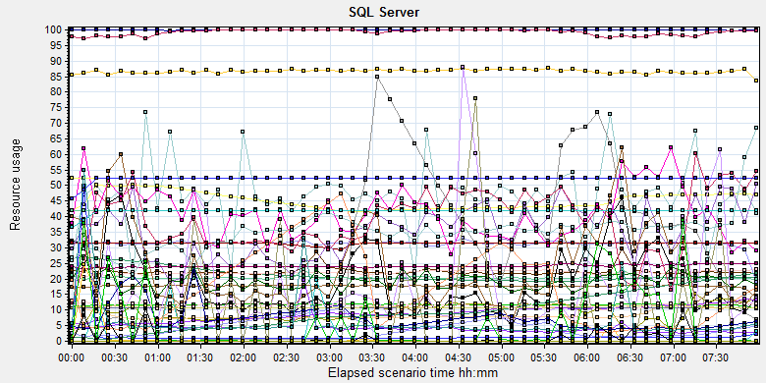
Color | Scale | Measurement | Minimum | Average | Maximum | Std. Deviation
 | 1 | Average Latch Wait Time (ms) (MSSQL$GCPACSWS|Latches):10.184.129.108 | 0 | 4.283 | 2605.789 | 27.372
 | 1 | Buffer cache hit ratio (MSSQL$GCPACSWS|Buffer Manager):10.184.129.108 | 62.495 | 99.987 | 100 | 0.551
 | 1 | Cache Hit Ratio (MSSQL$GCPACSWS|Catalog Metadata _Total):10.184.129.108 | 19.2 | 21.345 | 28.295 | 2.254
 | 1 | Cache Hit Ratio (MSSQL$GCPACSWS|Cursor Manager by Type _Total):10.184.129.108 | 95.366 | 99.205 | 100 | 0.982
 | 1 | Cache Hit Ratio (MSSQL$GCPACSWS|Plan Cache _Total):10.184.129.108 | 74.56 | 86.678 | 96.513 | 3.502
 | 10 | Checkpoint pages/sec (MSSQL$GCPACSWS|Buffer Manager):10.184.129.108 | 0 | 4.682 | 344.745 | 19.33
 | 0.01 | Connection Memory (KB) (MSSQL$GCPACSWS|Memory Manager):10.184.129.108 | 1992 | 2241.486 | 3376 | 173.529
 | 0.1 | Connection Reset/sec (MSSQL$GCPACSWS|General Statistics):10.184.129.108 | 78.047 | 177.525 | 496.866 | 58.558
 | 1 | Current latch waits (MSOLAP$GCPACSWS|Locks):10.184.129.108 | 0 | 0 | 0 | 0
 | 1 | Cursor flushes (MSSQL$GCPACSWS|Cursor Manager Total):10.184.129.108 | 0 | 0 | 0 | 0
 | 0.01 | Cursor memory usage (MSSQL$GCPACSWS|Cursor Manager by Type _Total):10.184.129.108 | 112 | 2199.167 | 2368 | 153.908
 | 10 | Cursor Requests/sec (MSSQL$GCPACSWS|Cursor Manager by Type _Total):10.184.129.108 | 0 | 3.135 | 21.922 | 2.94
 | 0.0001 | Database pages (MSSQL$GCPACSWS|Buffer Manager):10.184.129.108 | 415064 | 451399.026 | 506977 | 26938.293
 | 10 | Errors/sec (MSSQL$GCPACSWS|SQL Errors _Total):10.184.129.108 | 0 | 2.042 | 48.489 | 1.618
 | 1 | Free list stalls/sec (MSSQL$GCPACSWS|Buffer Manager):10.184.129.108 | 0 | 0 | 0 | 0
 | 0.001 | Free pages (MSSQL$GCPACSWS|Buffer Manager):10.184.129.108 | 164 | 26803.377 | 101113 | 26126.897
 | 0.1 | Full Scans/sec (MSSQL$GCPACSWS|Access Methods):10.184.129.108 | 3.984 | 117.691 | 400.735 | 90.918
 | 0.001 | Granted Workspace Memory (KB) (MSSQL$GCPACSWS|Memory Manager):10.184.129.108 | 0 | 18787.893 | 602968 | 64206.788
 | 0.0001 | Index Searches/sec (MSSQL$GCPACSWS|Access Methods):10.184.129.108 | 237.119 | 91513.685 | 466643.311 | 68325.18
 | 1 | Latch waits/sec (MSOLAP$GCPACSWS|Locks):10.184.129.108 | 0 | 0 | 0 | 0
 | 0.1 | Latch Waits/sec (MSSQL$GCPACSWS|Latches):10.184.129.108 | 0 | 19.844 | 12445.793 | 231.945
 | 1000 | Lazy writes/sec (MSSQL$GCPACSWS|Buffer Manager):10.184.129.108 | 0 | 0.001 | 1.661 | 0.029
 | 0.001 | Lock Memory (KB) (MSSQL$GCPACSWS|Memory Manager):10.184.129.108 | 6904 | 8310.658 | 13000 | 1458.062
 | 1 | Lock Timeouts (timeout > 0)/sec (MSSQL$GCPACSWS|Locks _Total):10.184.129.108 | 0 | 0 | 0 | 0
 | 100 | Lock Timeouts/sec (MSSQL$GCPACSWS|Locks _Total):10.184.129.108 | 0 | 0.412 | 13.95 | 0.864
 | 1 | Lock Wait Time (ms) (MSSQL$GCPACSWS|Locks _Total):10.184.129.108 | 0 | 18.729 | 6746.927 | 181.557
 | 1 | Lock waits/sec (MSOLAP$GCPACSWS|Locks):10.184.129.108 | 0 | 0 | 0 | 0
 | 100 | Lock Waits/sec (MSSQL$GCPACSWS|Locks _Total):10.184.129.108 | 0 | 0.193 | 4.318 | 0.311
 | 1E-05 | Maximum Workspace Memory (KB) (MSSQL$GCPACSWS|Memory Manager):10.184.129.108 | 2919480 | 3139321.82 | 3151800 | 42101.205
 | 100 | Memory Grants Outstanding (MSSQL$GCPACSWS|Memory Manager):10.184.129.108 | 0 | 0.353 | 5 | 0.602
 | 1 | Memory Grants Pending (MSSQL$GCPACSWS|Memory Manager):10.184.129.108 | 0 | 0 | 0 | 0
 | 1 | Number of active cursor plans (MSSQL$GCPACSWS|Cursor Manager by Type _Total):10.184.129.108 | 1 | 24.148 | 26 | 1.603
 | 10000 | Number of Deadlocks/sec (MSSQL$GCPACSWS|Locks _Total):10.184.129.108 | 0 | 0.001 | 0.332 | 0.017
 | 1 | Number of SuperLatches (MSSQL$GCPACSWS|Latches):10.184.129.108 | 0 | 0 | 0 | 0
 | 0.01 | Optimizer Memory (KB) (MSSQL$GCPACSWS|Memory Manager):10.184.129.108 | 1080 | 1081.62 | 2080 | 30.237
 | 0.1 | Page Deallocations/sec (MSSQL$GCPACSWS|Access Methods):10.184.129.108 | 0 | 88.731 | 637.666 | 68.683
 | 0.001 | Page life expectancy (MSSQL$GCPACSWS|Buffer Manager):10.184.129.108 | 305 | 9544.228 | 21914 | 5962.034
 | 0.0001 | Page lookups/sec (MSSQL$GCPACSWS|Buffer Manager):10.184.129.108 | 11563.753 | 386375.915 | 1889803.067 | 277336.957
 | 0.1 | Page reads/sec (MSSQL$GCPACSWS|Buffer Manager):10.184.129.108 | 0 | 9.644 | 11296.056 | 197.365
 | 1 | Page Splits/sec (MSSQL$GCPACSWS|Access Methods):10.184.129.108 | 0 | 7.343 | 78.713 | 14.39
 | 1 | Page writes/sec (MSSQL$GCPACSWS|Buffer Manager):10.184.129.108 | 0 | 35.122 | 403.855 | 30.926
 | 0.01 | Reserved pages (MSSQL$GCPACSWS|Buffer Manager):10.184.129.108 | 0 | 2343.491 | 75370 | 8019.871
 | 0.001 | SQL Cache Memory (KB) (MSSQL$GCPACSWS|Memory Manager):10.184.129.108 | 2016 | 16902.224 | 48968 | 12786.083
 | 0.1 | SQL Compilations/sec (MSSQL$GCPACSWS|SQL Statistics):10.184.129.108 | 50.819 | 109.257 | 242.488 | 13.293
 | 100 | SQL Re-Compilations/sec (MSSQL$GCPACSWS|SQL Statistics):10.184.129.108 | 0 | 0.115 | 2.325 | 0.231
 | 0.0001 | Stolen pages (MSSQL$GCPACSWS|Buffer Manager):10.184.129.108 | 5193 | 43578.538 | 108693 | 25739.723
 | 0.0001 | Target pages (MSSQL$GCPACSWS|Buffer Manager):10.184.129.108 | 524288 | 524288 | 524288 | 0
 | 1E-05 | Target Server Memory (KB) (MSSQL$GCPACSWS|Memory Manager):10.184.129.108 | 4194304 | 4194304 | 4194304 | 0
 | 1 | Tasks Started/sec (MSSQL$GCPACSWS|Broker Activation tempdb):10.184.129.108 | 0 | 0 | 0 | 0
 | 1 | Temp file bytes written/sec (MSOLAP$GCPACSWS|Proc Aggregations):10.184.129.108 | 0 | 0 | 0 | 0
 | 100 | Temp Tables Creation Rate (MSSQL$GCPACSWS|General Statistics):10.184.129.108 | 0 | 0.06 | 14.949 | 0.589
 | 10 | Temp Tables For Destruction (MSSQL$GCPACSWS|General Statistics):10.184.129.108 | 0 | 0.1 | 62 | 1.878
 | 1 | Total deadlocks detected (MSOLAP$GCPACSWS|Locks):10.184.129.108 | 0 | 0 | 0 | 0
 | 0.1 | Total Latch Wait Time (ms) (MSSQL$GCPACSWS|Latches):10.184.129.108 | 0 | 63.141 | 49334.517 | 665.827
 | 0.0001 | Total pages (MSSQL$GCPACSWS|Buffer Manager):10.184.129.108 | 442848 | 522408.652 | 524288 | 10356.61
 | 1E-05 | Total Server Memory (KB) (MSSQL$GCPACSWS|Memory Manager):10.184.129.108 | 3542784 | 4179336.879 | 4194304 | 82598.708
Description: Displays a summary of SQL Server Resources.
Database result
Follow the SQL server monitor resource, we can find the Database has some issues:
There are some latches and locks exist in the database:
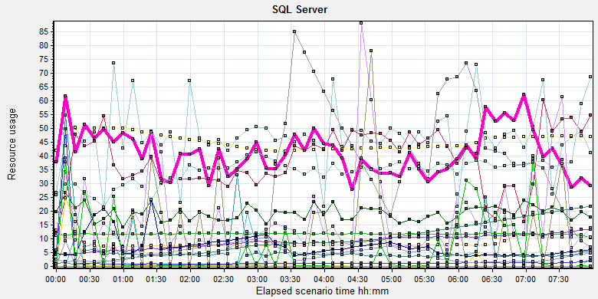
Color | Scale | Measurement | Minimum | Average | Maximum | Std. Deviation
 | 10 | Checkpoint pages/sec (MSSQL$GCPACSWS|Buffer Manager):10.184.129.108 | 0 | 4.682 | 344.745 | 19.33
 | 1 | Current latch waits (MSOLAP$GCPACSWS|Locks):10.184.129.108 | 0 | 0 | 0 | 0
 | 0.0001 | Database pages (MSSQL$GCPACSWS|Buffer Manager):10.184.129.108 | 415064 | 451399.026 | 506977 | 26938.293
 | 1 | Free list stalls/sec (MSSQL$GCPACSWS|Buffer Manager):10.184.129.108 | 0 | 0 | 0 | 0
 | 0.001 | Free pages (MSSQL$GCPACSWS|Buffer Manager):10.184.129.108 | 164 | 26803.377 | 101113 | 26126.897
 | 0.1 | Full Scans/sec (MSSQL$GCPACSWS|Access Methods):10.184.129.108 | 3.984 | 117.691 | 400.735 | 90.918
 | 1 | Latch waits/sec (MSOLAP$GCPACSWS|Locks):10.184.129.108 | 0 | 0 | 0 | 0
 | 0.1 | Latch Waits/sec (MSSQL$GCPACSWS|Latches):10.184.129.108 | 0 | 19.844 | 12445.793 | 231.945
 | 1000 | Lazy writes/sec (MSSQL$GCPACSWS|Buffer Manager):10.184.129.108 | 0 | 0.001 | 1.661 | 0.029
 | 0.001 | Lock Memory (KB) (MSSQL$GCPACSWS|Memory Manager):10.184.129.108 | 6904 | 8310.658 | 13000 | 1458.062
 | 1 | Lock Timeouts (timeout > 0)/sec (MSSQL$GCPACSWS|Locks _Total):10.184.129.108 | 0 | 0 | 0 | 0
 | 100 | Lock Timeouts/sec (MSSQL$GCPACSWS|Locks _Total):10.184.129.108 | 0 | 0.412 | 13.95 | 0.864
 | 1 | Lock Wait Time (ms) (MSSQL$GCPACSWS|Locks _Total):10.184.129.108 | 0 | 18.729 | 6746.927 | 181.557
 | 1 | Lock waits/sec (MSOLAP$GCPACSWS|Locks):10.184.129.108 | 0 | 0 | 0 | 0
 | 100 | Lock Waits/sec (MSSQL$GCPACSWS|Locks _Total):10.184.129.108 | 0 | 0.193 | 4.318 | 0.311
 | 10000 | Number of Deadlocks/sec (MSSQL$GCPACSWS|Locks _Total):10.184.129.108 | 0 | 0.001 | 0.332 | 0.017
 | 1 | Number of SuperLatches (MSSQL$GCPACSWS|Latches):10.184.129.108 | 0 | 0 | 0 | 0
 | 0.1 | Page Deallocations/sec (MSSQL$GCPACSWS|Access Methods):10.184.129.108 | 0 | 88.731 | 637.666 | 68.683
 | 0.001 | Page life expectancy (MSSQL$GCPACSWS|Buffer Manager):10.184.129.108 | 305 | 9544.228 | 21914 | 5962.034
 | 0.0001 | Page lookups/sec (MSSQL$GCPACSWS|Buffer Manager):10.184.129.108 | 11563.753 | 386375.915 | 1889803.067 | 277336.957
 | 0.1 | Page reads/sec (MSSQL$GCPACSWS|Buffer Manager):10.184.129.108 | 0 | 9.644 | 11296.056 | 197.365
 | 1 | Page Splits/sec (MSSQL$GCPACSWS|Access Methods):10.184.129.108 | 0 | 7.343 | 78.713 | 14.39
 | 1 | Page writes/sec (MSSQL$GCPACSWS|Buffer Manager):10.184.129.108 | 0 | 35.122 | 403.855 | 30.926
 | 0.0001 | Stolen pages (MSSQL$GCPACSWS|Buffer Manager):10.184.129.108 | 5193 | 43578.538 | 108693 | 25739.723
 | 1 | Temp file bytes written/sec (MSOLAP$GCPACSWS|Proc Aggregations):10.184.129.108 | 0 | 0 | 0 | 0
 | 100 | Temp Tables Creation Rate (MSSQL$GCPACSWS|General Statistics):10.184.129.108 | 0 | 0.06 | 14.949 | 0.589
 | 1 | Total deadlocks detected (MSOLAP$GCPACSWS|Locks):10.184.129.108 | 0 | 0 | 0 | 0
 | 0.1 | Total Latch Wait Time (ms) (MSSQL$GCPACSWS|Latches):10.184.129.108 | 0 | 63.141 | 49334.517 | 665.827
Description: Displays a summary of SQL Server Resources.

There are 19 latches every seconds during the testing work (Latch Waits/sec (MSSQL$GCPACSWS|Latches)). Compare with the value of phase4 (1284). The system has a big enhance. There are also has some locks, deadlocks and lock time out issues. Some SQL statement needs to enhance to fix these issues. The detail information please the attachments which collect all deadlock information during the testing works.

Test Conclusion
The system cannot meet the requirements as the default setting. The system exist many issues which caused by database SQL statement, configuration and code design.
With the support work from develop team, we made a lot of testing and attempt works. We change many designs and make the system works smoothly. The detail steps as follow:
- Chang the SQL which use ‘Select 1 from …’ in the sub-query code. This design will cause the dead lock when users delete or update the data in film and report table. Please sue the index column or primary key as the queried column to fix the issues.
- Add the index for DeliveryJob table in database printer. The related SQL will cause the high reads issue in the database.
- Add the index on column filmflag, deletestatus for afp_filminfo table in database wggc.
- Delete five views which name as available_patient, available_patient, view_study, filmmedia and AlarmMessageList. Delete these views will reduce the stress of memory and locks for our core workflow tables.
- The core store procedure ‘AFP_SP_GetExamsForSyncToECS’ of cloud film service need enhance. We redesign it use function to get attachment path instead of using join table.
- We change the default value of cost parallel threshold 5 to 60. This parameter means if the SQL statements execute time more than this value, the database will use parallel rules to execute the SQL statement to reduce the response time. This operations will cause the resource contend issue and too much latches and locks.
- Set the force parameter for each databases. It will reduce the execute plans count in the database and reduce the stress of memory resource.

With the changes, we executed the performance testing scenario for 8 hours. There are 5 errors happened during the testing work. It caused by the system when system wants to create the film print task and cannot get the taskID from system. Some transaction response time is increase when the upload service is busy. This is a risk for our system.
There are some deadlocks exist in the database during the testing works. The all information please sees the attachment:

During the testing works, the attachments upload information as follow:
Type | Count | Size | All
Dicom | 2549 | 9M | 22,942M
Dicom Png | 2550 | 1.4M | 3,570M
Report Jpg | 2601 | 0.15M | 390.15M
Report PDF | 2601 | 0.12M | 312.12M
 |  |  | 27,214 MB
The system uploaded 27.214GB data to server in 8 hours. The result is close to our requirements 30GB. All attachments upload to server use 9 hours and 25 minutes. It meet the requirements that the attachments should upload with 3 hours extend. I will add more attachments in next testing work and monitor the result.
After we change the scripts and configuration for our system, the performance test result can meets the requirement of the system. But there are still has some database issues during the testing works.
Now, we should to redesign our system follow the changes before performance testing works and fix the deadlocks in database. QA team will continue the performance testing works after the team finish the tuning works.
Please refer the enhancements and defects list to implement the performance enhance works:
No. | Type | Descriptions
100048831 | defect | Performance] Update the SQL statement to fix the locks issue for system.
100048832 | defect | [Performance]Add index on AFP_filminfo with column filmflag, deletestatus to enhance the performance.
100048835 | defect | [Performance]The store procedure AFP_SP_GetExamForSyncToECS has lock issues.
100048836 | defect | [Performance]Change the cost parallel threshold value from 5 to 60 to reduce the database IO high reads issues.
100048839 | defect | [Performance]There are some deadlocks exist during the performance testing works.
100048840 | enhancement | [Performance]Change the index fill factor to 80.
100048837 | enhancement | [Performance]Change the parameter from simple to force for each data bases.
100048834 | enhancement | [Performance]Redesign the views for system to enhance the performance.

Testing work （Phase 6）

Test Environment
The detailed hardware configurations of all servers are described as follow:

Computer name | CPU | Memory | HD | OS | Other | Comments
PS Server Panda upgrade | Interl(R) Xeon® CPU E5-2350 @ 1.80 * 6 | 12GB | 1TB | Windows 2008 R2 64bit | SQL server workgroup 2008 | Use the network 100Mbps
Workstation Server | Intel i3-2120 3.3GHz | 2GB | 80GB | Windows 7 SP1 64bit | QTP 11 | 6 virtual machine in server
Terminal | Intel Atom D525 1.8GHz | 4GB | 450GB | Windows Embedded Standard SP1 64bit | UTF 12.0 trail
Cloud Film Server | Huawei Cloud 3 4CORE | 8G | 40GB +  200GB | Windows Server 2016
Cloud film DB Server | Huawei Cloud 3 2CORE | 8G | 40GB | Huaiwei cloud offer | MySQL 5.7

Table 1 Hardware Configuration

Test scenario and strategy
Virtual User: 21 Users
Duration: 8 hour
Description: Use the test tool simulates the patient operations. Monitor the server software and hardware resource usage. The detail information as follow:
- Use automation tool simulate the doctor print film work. Simulate 6 GX Platform by using QTP and WinDPSTester tool. Each client prints one film which size is 10MB every 40 seconds.
- Use LR tool simulate 8 K2/K3 terminals to print film. Each client prints one film which size is 10MB random 10 to 30 seconds.
- Use LR tool simulate 8 users to do report archive operations. Each client archive report in random 10 to 30 seconds and size is random with 100kb and 4Mb.
- Use LR tool simulate 8 terminals to print paper reports. Each client prints report random 10 to 30 seconds.
- The OCR setting is not has rule for GX platforms in step1 and other setting are set as default. The OCR service will under the strong stress without configure the rule.
- Simulate 5 users to do the query information, view monitor page, query reconciliation films and report, expand the record, change the status, set holding time and other operations in worklist.
- Monitor the transaction response time.
- Monitor the hardware resource usage on PS.
- Monitor the resource usage for database on PS.
- Start/Stop 1 virtual user every 5 seconds and run the scenario for 8 hours.
- Use the business Upload network bandwidth to 100M.

Note:
We will do the performance testing work under big stress for system. If system can work well under current stress and the transaction process ability meets the requirement, we will give the conclusion the system performance is pass.

Test Tool
Load Runner 12.

Database setting
Memory: Set the min and max memory size to 4GB.
Index fill factor: 80.
File: Increase the data and log files size and the rule is increase 500Mb as fixed size.

IIS setting
Connection: Set the max connection value to 4000 and keep other setting as default.

Test Object version
KIOSK cloud film 3.0.3.0 B26P01

Background data
We prepared a background records in the PS system. The data size is calculated by the typical site which printed 3,000 films in a workday. That means the records of films in db should more than 972,000 (3000records / day *54 weeks * 6 workday). QA team had prepared these data with SQL script and automation script. These data can backup and import by DB tool.
The detail data records in DB as follow:

Table Name | Data Volume (records)
printer.dbo.DeliveryJob | 995199
printer.dbo.ImageBox | 3530116
printer.dbo.Page | 314893
printer.dbo.Session | 571212
wggc.dbo.Patient | 1224710
wggc.dbo.Study | 1434574
wggc.dbo.AFP_PrintTerminalInfo | 70
wggc.dbo.Series | 1434524
wggc.dbo.Image | 1434527
wggc.dbo.AFP_FilmInfo | 1420905
wggc.dbo.AFP_ReportInfo | 1232003
wggc.dbo.AFP_ExamInfo | 2308723
wggc.dbo.AFP_PrintTask | 4324918
wggc.dbo.T_Integration_ExamInfo | 1421769
AFP_PrintMode | 523684
wggc.dbo.vi_KIOSK_ExamInfo_Order | 838208

Test Error
There are 1 errors existed in the testing work s. The system creates print tasks failed. The detail information please sees the attachment.
Action.c(137): Error: Create print task failed. Try again. The accession number is A20180815104602764,K2_6

Error analyzes:
These errors caused by the system try to create film print task and the system do not return the taskID. The film prints out successfully at the next time. We think the result can accepted.

Test result of PS server

Test result of PS transactions
After the performance testing works, the transactions result of PS print module as follow:
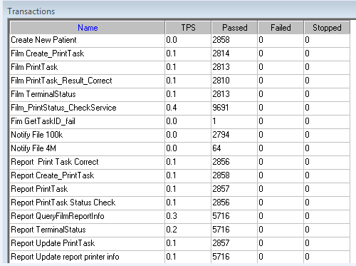

Test Statistic Report of PS
Analysis Summary | Period: 2018/9/1 14:04 - 2018/9/1 22:07

Scenario Name: | E:\ECS\Performance\Script\208\ScenarioPUMA_Reliability_171.lrs
Results in Session: | c:\Users\Administrator\AppData\Local\Temp\res178\res178.lrr
Duration: | 8 hours, 3 minutes and 11 seconds.

Statistics Summary

Maximum Running Vusers: |  | 16
Total Throughput (bytes): |  | 17,555,586
Average Throughput (bytes/second): |  | 606
Total Hits: |  | 18,127
Average Hits per Second: |  | 0.625 | View HTTP Responses Summary
Total Errors: |  | 1

Transaction Summary

Transactions: | Total Passed: 58,090 | Total Failed: 0 | Total Stopped: 0 | Average Response Time

Transaction Name | SLA Status | Minimum | Average | Maximum | Std. Deviation | 90 Percent | Pass | Fail | Stop
Create New Patient |  | 0.078 | 0.131 | 1.529 | 0.071 | 0.187 | 2,858 | 0 | 0
Film Create_PrintTask |  | 0.296 | 0.803 | 7.246 | 0.299 | 0.967 | 2,814 | 0 | 0
Film PrintTask |  | 0.016 | 0.066 | 4.649 | 0.111 | 0.125 | 2,813 | 0 | 0
Film PrintTask_Result_Correct |  | 0 | 0 | 0.016 | 0 | 0 | 2,810 | 0 | 0
Film TerminalStatus |  | 0 | 0.039 | 0.515 | 0.049 | 0.078 | 2,813 | 0 | 0
Film_PrintStatus_CheckService |  | 0 | 0.036 | 1.221 | 0.055 | 0.078 | 9,691 | 0 | 0
Fim GetTaskID_fail |  | 0 | 0 | 0 | 0 | 0 | 1 | 0 | 0
Notify File 100k |  | 0.125 | 0.404 | 8.682 | 0.35 | 0.624 | 2,794 | 0 | 0
Notify File 4M |  | 0.301 | 0.593 | 2.048 | 0.32 | 0.811 | 64 | 0 | 0
Report Print Task Correct |  | 0 | 0 | 0.016 | 0 | 0 | 2,856 | 0 | 0
Report Create_PrintTask |  | 0.437 | 0.615 | 2.669 | 0.142 | 0.794 | 2,858 | 0 | 0
Report PrintTask |  | 0.016 | 0.068 | 1.404 | 0.09 | 0.143 | 2,857 | 0 | 0
Report PrintTask Status Check |  | 0 | 0.036 | 0.718 | 0.05 | 0.075 | 2,856 | 0 | 0
Report QueryFilmReportInfo |  | 0.484 | 0.661 | 6.724 | 0.247 | 0.827 | 5,716 | 0 | 0
Report TerminalStatus |  | 0 | 0.037 | 2.008 | 0.066 | 0.078 | 5,716 | 0 | 0
Report Update PrintTask |  | 0 | 0.082 | 1.732 | 0.109 | 0.172 | 2,857 | 0 | 0
Report Update report printer info |  | 0 | 0.037 | 1.498 | 0.065 | 0.078 | 5,716 | 0 | 0

Service Level Agreement Legend: |  | Pass |  | Fail |  | No Data

HTTP Responses Summary

HTTP Responses | Total | Per second
HTTP_200 | 18,127 | 0.625

Follow the summary report, we can see there are 1 failed transactions during the testing work. (Fim GetTaskID_fail)

Transaction summary result of PS
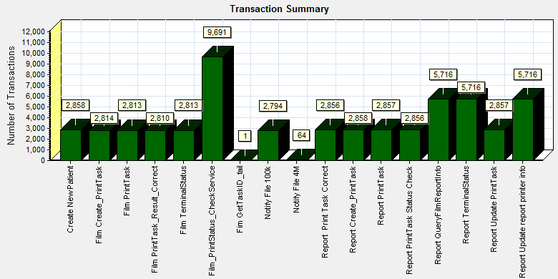
Color | Scale | Measurement
 | 1 | Pass

Description: Displays the number of transactions that passed, failed, stopped, or ended with errors.

We can see that there are 1 transactions failed during the testing works.

Transaction response time result of PS
We can get the transaction response time information from the figure as follow:
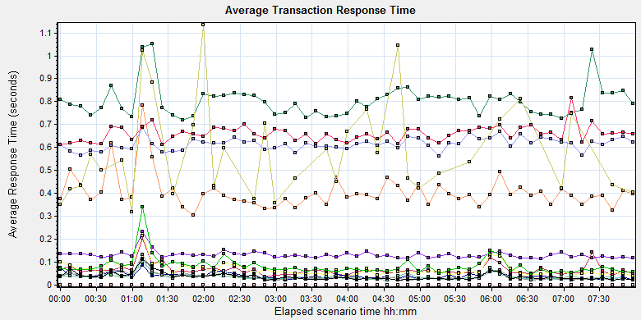
Color | Scale | Measurement | Graph's Minimum | Graph's Average | Graph's Maximum | Graph's Median
 | 1 | Create New Patient | 0.114 | 0.131 | 0.231 | 0.129
 | 1 | Film Create_PrintTask | 0.721 | 0.803 | 1.052 | 0.798
 | 1 | Film PrintTask | 0.038 | 0.066 | 0.204 | 0.06
 | 1 | Film PrintTask_Result_Correct | 0 | 0 | 0 | 0
 | 1 | Film TerminalStatus | 0.021 | 0.039 | 0.084 | 0.038
 | 1 | Film_PrintStatus_CheckService | 0.02 | 0.036 | 0.1 | 0.033
 | 1 | Fim GetTaskID_fail | 0 | 0 | 0 | 0
 | 1 | Notify File 100k | 0.303 | 0.404 | 0.785 | 0.389
 | 1 | Notify File 4M | 0.317 | 0.581 | 1.134 | 0.538
 | 1 | Report Print Task Correct | 0 | 0 | 0 | 0
 | 1 | Report Create_PrintTask | 0.561 | 0.615 | 0.688 | 0.615
 | 1 | Report PrintTask | 0.039 | 0.068 | 0.215 | 0.057
 | 1 | Report PrintTask Status Check | 0.021 | 0.036 | 0.112 | 0.035
 | 1 | Report QueryFilmReportInfo | 0.611 | 0.66 | 0.815 | 0.66
 | 1 | Report TerminalStatus | 0.021 | 0.037 | 0.131 | 0.031
 | 1 | Report Update PrintTask | 0.047 | 0.082 | 0.339 | 0.071
 | 1 | Report Update report printer info | 0.021 | 0.037 | 0.113 | 0.033
Transaction response time

This figure information shows all transaction response time. We can analysis that all transaction`s response time are less than 2 seconds. The performance of the transaction is prefect.

Test result of Web service

Test result of web transactions
After the performance testing works, the transactions result of we module as follow:
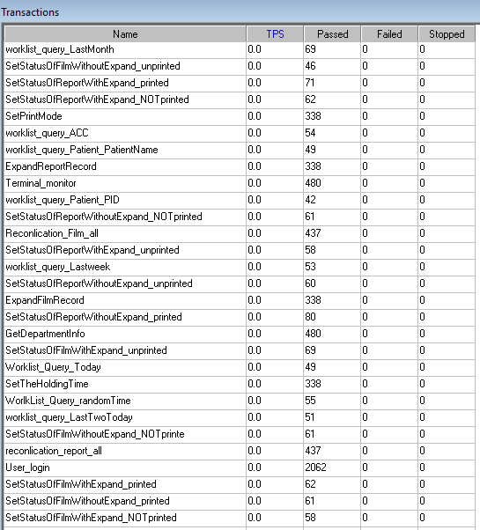
Follow the figure, we can see that there are no transactions failed.

Test Statistic Report of Web
Analysis Summary | Period: 01/09/2018 14:27:23 - 01/09/2018 22:29:32

Scenario Name: | D:\Performance\ScenarioPUMA_Reliability_171.lrs
Results in Session: | c:\Users\administrator\appdata\local\temp\res1239\res1239.lrr
Duration: | 8 hours, 2 minutes and 9 seconds.

Statistics Summary

Maximum Running Vusers: | 5
Total Throughput (bytes): | 643,954,326
Average Throughput (bytes/second): | 22,259
Total Hits: | 53,690
Average Hits per Second: | 1.856

Transaction Summary

Transactions: | Total Passed: 7,025 | Total Failed: 0 | Total Stopped: 0 | Average Response Time

Transaction Name | Minimum | Average | Maximum | Std. Deviation | 90 Percent | Pass | Fail | Stop
ExpandFilmRecord | 0.089 | 0.144 | 6.694 | 0.38 | 0.138 | 367 | 0 | 0
ExpandReportRecord | 0.006 | 0.009 | 0.067 | 0.006 | 0.013 | 368 | 0 | 0
GetDepartmentInfo | 0.005 | 0.008 | 0.037 | 0.003 | 0.011 | 526 | 0 | 0
Reconlication_Film_all | 0.153 | 0.215 | 1.372 | 0.102 | 0.28 | 480 | 0 | 0
reconlication_report_all | 0.021 | 0.055 | 1.143 | 0.076 | 0.091 | 483 | 0 | 0
SetPrintMode | 0.015 | 0.23 | 30.286 | 2.204 | 0.123 | 371 | 0 | 0
SetStatusOfFilmWithExpand_NOTprinted | 0.118 | 0.64 | 30.492 | 3.659 | 0.373 | 68 | 0 | 0
SetStatusOfFilmWithExpand_printed | 0.119 | 0.186 | 0.419 | 0.065 | 0.283 | 67 | 0 | 0
SetStatusOfFilmWithExpand_unprinted | 0.115 | 0.641 | 30.754 | 3.507 | 0.291 | 75 | 0 | 0
SetStatusOfFilmWithoutExpand_NOTprinte | 0.03 | 0.079 | 0.367 | 0.06 | 0.165 | 67 | 0 | 0
SetStatusOfFilmWithoutExpand_printed | 0.033 | 0.535 | 30.14 | 3.541 | 0.251 | 71 | 0 | 0
SetStatusOfFilmWithoutExpand_unprinted | 0.028 | 1.332 | 30.368 | 5.99 | 0.203 | 49 | 0 | 0
SetStatusOfReportWithExpand_NOTprinted | 0.031 | 0.108 | 0.405 | 0.083 | 0.239 | 65 | 0 | 0
SetStatusOfReportWithExpand_printed | 0.023 | 0.094 | 0.627 | 0.086 | 0.16 | 82 | 0 | 0
SetStatusOfReportWithExpand_unprinted | 0.025 | 0.095 | 0.457 | 0.092 | 0.198 | 62 | 0 | 0
SetStatusOfReportWithoutExpand_NOTprinted | 0.023 | 0.081 | 0.489 | 0.066 | 0.145 | 64 | 0 | 0
SetStatusOfReportWithoutExpand_printed | 0.032 | 0.105 | 0.484 | 0.077 | 0.198 | 90 | 0 | 0
SetStatusOfReportWithoutExpand_unprinted | 0.028 | 0.088 | 0.538 | 0.077 | 0.174 | 62 | 0 | 0
SetTheHoldingTime | 0.013 | 0.31 | 34.372 | 2.838 | 0.1 | 368 | 0 | 0
Terminal_monitor | 0.115 | 0.15 | 0.745 | 0.067 | 0.18 | 526 | 0 | 0
User_login | 0.188 | 0.265 | 2.525 | 0.13 | 0.336 | 2,256 | 0 | 0
worklist_query_ACC | 0.011 | 0.019 | 0.319 | 0.039 | 0.021 | 61 | 0 | 0
worklist_query_LastMonth | 0.016 | 0.047 | 0.279 | 0.041 | 0.06 | 77 | 0 | 0
worklist_query_LastTwoToday | 0.013 | 0.039 | 0.136 | 0.021 | 0.059 | 55 | 0 | 0
worklist_query_Lastweek | 0.013 | 0.044 | 0.175 | 0.027 | 0.066 | 55 | 0 | 0
worklist_query_Patient_PatientName | 0.013 | 0.02 | 0.065 | 0.01 | 0.037 | 50 | 0 | 0
worklist_query_Patient_PID | 0.007 | 0.027 | 0.186 | 0.032 | 0.054 | 47 | 0 | 0
Worklist_Query_Today | 0.02 | 0.053 | 0.298 | 0.042 | 0.093 | 52 | 0 | 0
WorlkList_Query_randomTime | 0.016 | 0.055 | 0.537 | 0.069 | 0.081 | 61 | 0 | 0

Service Level Agreement Legend: |  | Pass |  | Fail |  | No Data

Follow the summary report, we can see there are no transactions failed.

Transaction summary result of Web
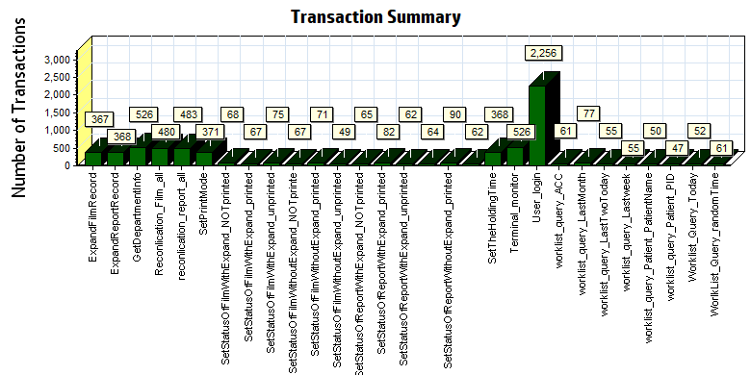
Color | Scale | Measurement
 | 1 | Pass

We can see that there are no transactions failed during the testing works.

Transaction response time result of Web
We can get the transaction response time information from the figure as follow:
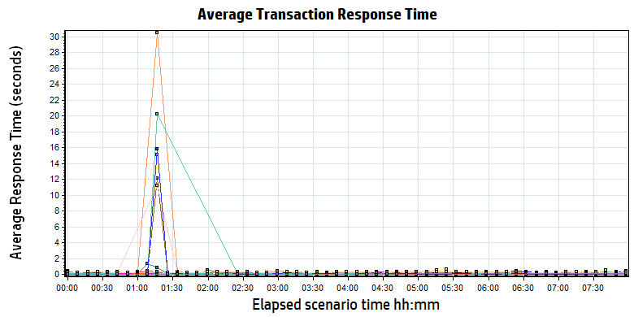
Color | Scale | Measurement | Minimum | Average | Maximum | Std. Deviation
 | 1 | ExpandFilmRecord | 0.089 | 0.144 | 6.694 | 0.380
 | 1 | ExpandReportRecord | 0.006 | 0.009 | 0.067 | 0.006
 | 1 | GetDepartmentInfo | 0.005 | 0.008 | 0.037 | 0.003
 | 1 | Reconlication_Film_all | 0.153 | 0.215 | 1.372 | 0.102
 | 1 | reconlication_report_all | 0.021 | 0.055 | 1.143 | 0.076
 | 1 | SetPrintMode | 0.015 | 0.230 | 30.286 | 2.204
 | 1 | SetStatusOfFilmWithExpand_NOTprinted | 0.118 | 0.640 | 30.492 | 3.659
 | 1 | SetStatusOfFilmWithExpand_printed | 0.119 | 0.186 | 0.419 | 0.065
 | 1 | SetStatusOfFilmWithExpand_unprinted | 0.115 | 0.641 | 30.754 | 3.507
 | 1 | SetStatusOfFilmWithoutExpand_NOTprinte | 0.030 | 0.079 | 0.367 | 0.060
 | 1 | SetStatusOfFilmWithoutExpand_printed | 0.033 | 0.535 | 30.140 | 3.541
 | 1 | SetStatusOfFilmWithoutExpand_unprinted | 0.028 | 1.332 | 30.368 | 5.990
 | 1 | SetStatusOfReportWithExpand_NOTprinted | 0.031 | 0.108 | 0.405 | 0.083
 | 1 | SetStatusOfReportWithExpand_printed | 0.023 | 0.094 | 0.627 | 0.086
 | 1 | SetStatusOfReportWithExpand_unprinted | 0.025 | 0.095 | 0.457 | 0.092
 | 1 | SetStatusOfReportWithoutExpand_NOTprinted | 0.023 | 0.081 | 0.489 | 0.066
 | 1 | SetStatusOfReportWithoutExpand_printed | 0.032 | 0.105 | 0.484 | 0.077
 | 1 | SetStatusOfReportWithoutExpand_unprinted | 0.028 | 0.088 | 0.538 | 0.077
 | 1 | SetTheHoldingTime | 0.013 | 0.310 | 34.372 | 2.838
 | 1 | Terminal_monitor | 0.115 | 0.150 | 0.745 | 0.067
 | 1 | User_login | 0.188 | 0.265 | 2.525 | 0.130
 | 1 | worklist_query_ACC | 0.011 | 0.019 | 0.319 | 0.039
 | 1 | worklist_query_LastMonth | 0.016 | 0.047 | 0.279 | 0.041
 | 1 | worklist_query_LastTwoToday | 0.013 | 0.039 | 0.136 | 0.021
 | 1 | worklist_query_Lastweek | 0.013 | 0.044 | 0.175 | 0.027
 | 1 | worklist_query_Patient_PatientName | 0.013 | 0.020 | 0.065 | 0.010
 | 1 | worklist_query_Patient_PID | 0.007 | 0.027 | 0.186 | 0.032
 | 1 | Worklist_Query_Today | 0.020 | 0.053 | 0.298 | 0.042
 | 1 | WorlkList_Query_randomTime | 0.016 | 0.055 | 0.537 | 0.069

Transaction response time
Follow the figure: we can see that the transaction average response time is less than 2 seconds. Some transaction works not smoothly with short time. It can accepted by design.

Performance bottleneck analysis

Hardware usage analysis
During the testing work, we use the test tool to monitor the server hardware usage include the CPU, Memory, hard disk and etc.
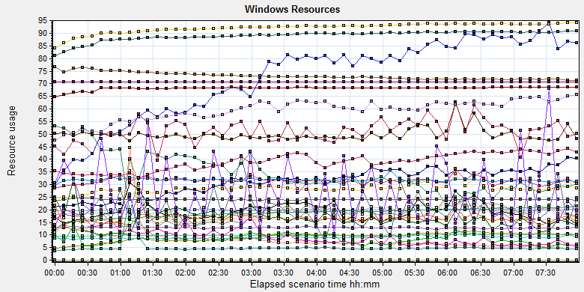
Color | Scale | Measurement | Minimum | Average | Maximum | Std. Deviation
 | 0.1 | % Disk Time (PhysicalDisk _Total):10.184.129.108 | 9.517 | 188.36 | 5360.196 | 176.837
 | 1 | % Idle Time (PhysicalDisk _Total):10.184.129.108 | 0 | 34.24 | 94.72 | 23.123
 | 1000 | % Interrupt Time (Processor _Total):10.184.129.108 | 0 | 0.051 | 0.434 | 0.055
 | 10 | % Privileged Time (Processor _Total):10.184.129.108 | 0.043 | 2.834 | 9.852 | 1.428
 | 10 | % Processor Time (Process CloudDataUploadService):10.184.129.108 | 0 | 3.093 | 19.792 | 2.507
 | 1 | % Processor Time (Processor _Total):10.184.129.108 | 0.723 | 19.865 | 60.838 | 10.069
 | 0.01 | Available MBytes (Memory):10.184.129.108 | 6923 | 7311.758 | 7995 | 152.777
 | 0.0001 | Avg. Disk Bytes/Transfer (PhysicalDisk _Total):10.184.129.108 | 4096 | 83680.405 | 3075746.635 | 122093.443
 | 10 | Avg. Disk Queue Length (PhysicalDisk _Total):10.184.129.108 | 0.095 | 1.884 | 53.602 | 1.768
 | 10 | Avg. Disk Write Queue Length (PhysicalDisk _Total):10.184.129.108 | 0.095 | 1.746 | 38.187 | 1.563
 | 0.001 | Bytes Total/sec (Server):10.184.129.108 | 19190.805 | 19881.011 | 20975.044 | 247.291
 | 1E-07 | Cache Bytes (Memory):10.184.129.108 | 104144896 | 187423164.311 | 225787904 | 18374486.414
 | 1E-09 | Committed Bytes (Memory):10.184.129.108 | 9168683008 | 9850475511.811 | 10286891008 | 173511934.561
 | 0.001 | Context Switches/sec (System):10.184.129.108 | 3503.527 | 31995.467 | 112413.801 | 16811.792
 | 10 | Current Disk Queue Length (PhysicalDisk _Total):10.184.129.108 | 0 | 1.885 | 96 | 2.797
 | 1E-05 | Disk Read Bytes/sec (PhysicalDisk _Total):10.184.129.108 | 0 | 857838.188 | 44974157.862 | 1325383.395
 | 1 | Disk Reads/sec (PhysicalDisk _Total):10.184.129.108 | 0 | 19.324 | 655.084 | 22.527
 | 0.1 | Disk Transfers/sec (PhysicalDisk _Total):10.184.129.108 | 5.978 | 91.554 | 714.94 | 44.654
 | 1E-06 | Disk Write Bytes/sec (PhysicalDisk _Total):10.184.129.108 | 36730.318 | 5073390.506 | 90178532.243 | 5972438.913
 | 1 | Disk Writes/sec (PhysicalDisk _Total):10.184.129.108 | 5.978 | 72.231 | 473.602 | 37.892
 | 0.001 | File Data Operations/sec (System):10.184.129.108 | 564.279 | 9079.588 | 30914.578 | 5124.771
 | 1E-05 | Free Megabytes (LogicalDisk _Total):10.184.129.108 | 1601547 | 1632646.233 | 1662549 | 17978.216
 | 0.01 | Interrupts/sec (Processor _Total):10.184.129.108 | 887.447 | 3184.003 | 13153.48 | 1899.591
 | 0.001 | Page Faults/sec (Memory):10.184.129.108 | 132.821 | 49873.812 | 192345.664 | 28519.987
 | 0.1 | Page Faults/sec (Process CloudDataUploadService):10.184.129.108 | 0 | 95.458 | 5527.291 | 329.917
 | 1E-06 | Page File Bytes (Process CloudDataUploadService):10.184.129.108 | 47333376 | 59453849.217 | 86044672 | 4764226.478
 | 1 | Page Reads/sec (Memory):10.184.129.108 | 0 | 16.579 | 566.31 | 23.458
 | 0.1 | Pages/sec (Memory):10.184.129.108 | 0 | 164.087 | 5094.827 | 259.411
 | 1E-06 | Pool Nonpaged Bytes (Memory):10.184.129.108 | 63868928 | 68232072.361 | 69316608 | 709055.495
 | 1E-05 | Pool Nonpaged Bytes (Server):10.184.129.108 | 1155985 | 1286846.262 | 1423089 | 40418.914
 | 1E-07 | Pool Paged Bytes (Memory):10.184.129.108 | 230330368 | 239869359.018 | 249266176 | 1838900.831
 | 0.001 | Pool Paged Bytes (Server):10.184.129.108 | 70613 | 70613.106 | 70869 | 5.217
 | 1 | Pool Paged Failures (Server):10.184.129.108 | 0 | 0 | 0 | 0
 | 1E-08 | Private Bytes (Process _Total):10.184.129.108 | 7875596288 | 8908288867.779 | 9286062080 | 210580595.299
 | 100 | Processor Queue Length (System):10.184.129.108 | 0 | 0.199 | 30 | 0.947
 | 10 | Split IO/Sec (PhysicalDisk _Total):10.184.129.108 | 0 | 2.693 | 444.375 | 15.968
 | 1E-07 | System Cache Resident Bytes (Memory):10.184.129.108 | 104144896 | 187424040.172 | 225787904 | 18374977.789
 | 0.01 | Threads (Objects):10.184.129.108 | 2749 | 3855.613 | 4568 | 422.775
 | 1E-08 | Working Set (Process _Total):10.184.129.108 | 8045330432 | 9219566661.018 | 9688637440 | 213759547.727
Description: Displays a summary of the System Resources usage for each Windows based host.

Follow this information we can get that:
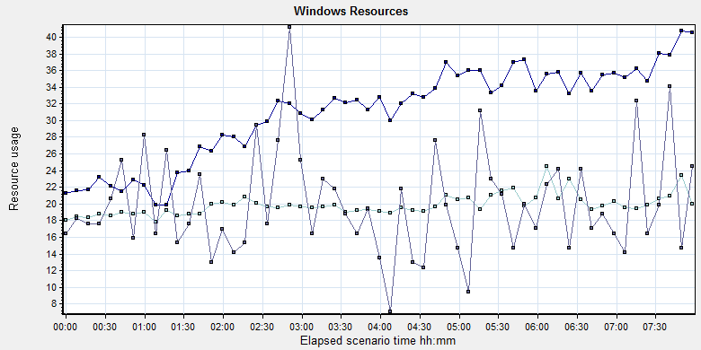
Color | Scale | Measurement | Minimum | Average | Maximum | Std. Deviation
 | 10 | % Processor Time (Process CloudDataUploadService):10.184.129.108 | 0 | 3.093 | 19.792 | 2.507
 | 1 | % Processor Time (Processor _Total):10.184.129.108 | 0.723 | 19.865 | 60.838 | 10.069
 | 100 | Processor Queue Length (System):10.184.129.108 | 0 | 0.199 | 30 | 0.947

Description: Displays a summary of the System Resources usage for each Windows based host.

Follow the figure we can see that the CPU does not has bottleneck during the testing works. The CPU process time usage is between 18% and 22%. It`s under 85% threshold value can accept. The average CPU queue length is 0.199, it small than the threshold value (12= 6*2).
We can see the cloudDataUploadService CPU usage increase with the execute time. But the usage value is small can accepted by system. The index value should divided the numbers of CPU.The CPU resource has not bottleneck.

The memory resource do not has the bottleneck. There are enough resources for system to use.
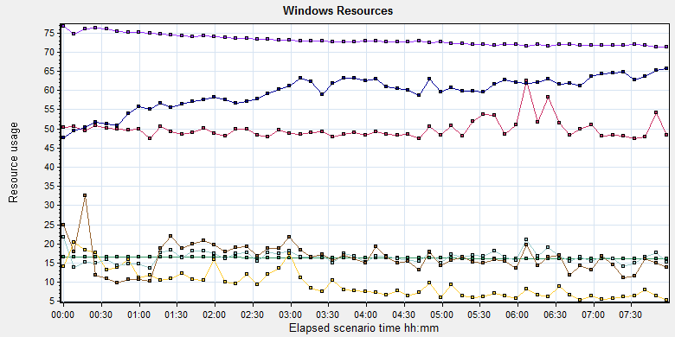
Color | Scale | Measurement | Minimum | Average | Maximum | Std. Deviation
 | 0.01 | Available MBytes (Memory):10.184.129.108 | 6923 | 7311.758 | 7995 | 152.777
 | 1E-05 | Free Megabytes (LogicalDisk _Total):10.184.129.108 | 1601547 | 1632646.233 | 1662549 | 17978.216
 | 0.001 | Page Faults/sec (Memory):10.184.129.108 | 132.821 | 49873.812 | 192345.664 | 28519.987
 | 0.1 | Page Faults/sec (Process CloudDataUploadService):10.184.129.108 | 0 | 95.458 | 5527.291 | 329.917
 | 1E-06 | Page File Bytes (Process CloudDataUploadService):10.184.129.108 | 47333376 | 59453849.217 | 86044672 | 4764226.478
 | 1 | Page Reads/sec (Memory):10.184.129.108 | 0 | 16.579 | 566.31 | 23.458
 | 0.1 | Pages/sec (Memory):10.184.129.108 | 0 | 164.087 | 5094.827 | 259.411
Description: Displays a summary of the System Resources usage for each Windows based host.
Form the memory usage figure, we can see that there are no memory leak and bottleneck issues.
The disk resource is enough during performance testing works:
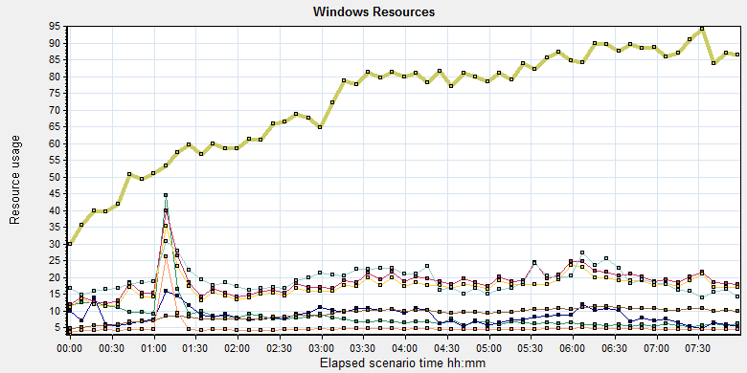
Color | Scale | Measurement | Minimum | Average | Maximum | Std. Deviation
 | 0.1 | % Disk Time (PhysicalDisk _Total):10.184.129.108 | 9.517 | 188.36 | 5360.196 | 176.837
 | 0.0001 | Avg. Disk Bytes/Transfer (PhysicalDisk _Total):10.184.129.108 | 4096 | 83680.405 | 3075746.635 | 122093.443
 | 10 | Avg. Disk Queue Length (PhysicalDisk _Total):10.184.129.108 | 0.095 | 1.884 | 53.602 | 1.768
 | 10 | Avg. Disk Write Queue Length (PhysicalDisk _Total):10.184.129.108 | 0.095 | 1.746 | 38.187 | 1.563
 | 1E-05 | Disk Read Bytes/sec (PhysicalDisk _Total):10.184.129.108 | 0 | 857838.188 | 44974157.862 | 1325383.395
 | 1 | Disk Reads/sec (PhysicalDisk _Total):10.184.129.108 | 0 | 19.324 | 655.084 | 22.527
 | 0.1 | Disk Transfers/sec (PhysicalDisk _Total):10.184.129.108 | 5.978 | 91.554 | 714.94 | 44.654
 | 1E-06 | Disk Write Bytes/sec (PhysicalDisk _Total):10.184.129.108 | 36730.318 | 5073390.506 | 90178532.243 | 5972438.913
 | 1 | Disk Writes/sec (PhysicalDisk _Total):10.184.129.108 | 5.978 | 72.231 | 473.602 | 37.892
Description: Displays a summary of the System Resources usage for each Windows based host.
Follow the figure: we can see that there are many disk tasks exist in the system during the testing work. The average Disk read/sec is 19, writes/sec is 72, and transfers/sec is 91. The average disk transfer size is 5.6M/sec. The disk is not busy and do not has bottleneck. The disk reads increased with the execute time. We guess it caused by the system because some upload attachments are blocked.

SQL Server resource usage analysis
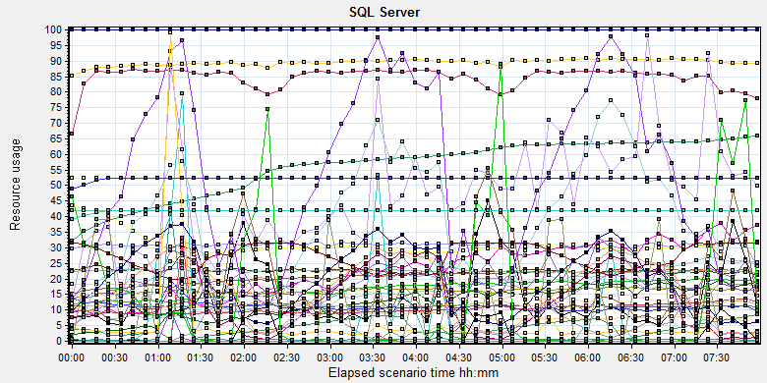
Color | Scale | Measurement | Minimum | Average | Maximum | Std. Deviation
 | 0.01 | Average Latch Wait Time (ms) (MSSQL$GCPACSWS|Latches):10.184.129.108 | 0 | 23.618 | 54594 | 616.254
 | 1 | Buffer cache hit ratio (MSSQL$GCPACSWS|Buffer Manager):10.184.129.108 | 99.634 | 99.994 | 100 | 0.02
 | 1 | Cache Hit Ratio (MSSQL$GCPACSWS|Catalog Metadata _Total):10.184.129.108 | 30.784 | 56.087 | 65.826 | 9.042
 | 1 | Cache Hit Ratio (MSSQL$GCPACSWS|Cursor Manager by Type _Total):10.184.129.108 | 46.751 | 84.634 | 91.02 | 4.218
 | 1 | Cache Hit Ratio (MSSQL$GCPACSWS|Plan Cache _Total):10.184.129.108 | 76.68 | 89.519 | 97.733 | 3.502
 | 1 | Checkpoint pages/sec (MSSQL$GCPACSWS|Buffer Manager):10.184.129.108 | 0 | 15.922 | 329.16 | 38.93
 | 0.01 | Connection Memory (KB) (MSSQL$GCPACSWS|Memory Manager):10.184.129.108 | 1784 | 2273.013 | 3128 | 117.665
 | 0.1 | Connection Reset/sec (MSSQL$GCPACSWS|General Statistics):10.184.129.108 | 76.293 | 206.756 | 492.208 | 67.19
 | 1 | Current latch waits (MSOLAP$GCPACSWS|Locks):10.184.129.108 | 0 | 0 | 0 | 0
 | 1 | Cursor flushes (MSSQL$GCPACSWS|Cursor Manager Total):10.184.129.108 | 0 | 0 | 0 | 0
 | 0.0001 | Cursor memory usage (MSSQL$GCPACSWS|Cursor Manager by Type _Total):10.184.129.108 | 88 | 136342.104 | 324096 | 103846.179
 | 10 | Cursor Requests/sec (MSSQL$GCPACSWS|Cursor Manager by Type _Total):10.184.129.108 | 0 | 3.084 | 23.251 | 3.043
 | 0.0001 | Database pages (MSSQL$GCPACSWS|Buffer Manager):10.184.129.108 | 271700 | 309854.818 | 436102 | 34564.17
 | 10 | Errors/sec (MSSQL$GCPACSWS|SQL Errors _Total):10.184.129.108 | 0 | 2.268 | 18.267 | 1.646
 | 1000 | Free list stalls/sec (MSSQL$GCPACSWS|Buffer Manager):10.184.129.108 | 0 | 0.001 | 5.651 | 0.058
 | 0.0001 | Free pages (MSSQL$GCPACSWS|Buffer Manager):10.184.129.108 | 61 | 88379.516 | 228434 | 75428.225
 | 0.1 | Full Scans/sec (MSSQL$GCPACSWS|Access Methods):10.184.129.108 | 3.654 | 167.718 | 578.252 | 113.749
 | 0.001 | Granted Workspace Memory (KB) (MSSQL$GCPACSWS|Memory Manager):10.184.129.108 | 0 | 13710.525 | 764168 | 58759.366
 | 0.001 | Index Searches/sec (MSSQL$GCPACSWS|Access Methods):10.184.129.108 | 237.148 | 16265.665 | 61176.208 | 13979.064
 | 1 | Latch waits/sec (MSOLAP$GCPACSWS|Locks):10.184.129.108 | 0 | 0 | 0 | 0
 | 1 | Latch Waits/sec (MSSQL$GCPACSWS|Latches):10.184.129.108 | 0 | 11.186 | 675.202 | 11.655
 | 100 | Lazy writes/sec (MSSQL$GCPACSWS|Buffer Manager):10.184.129.108 | 0 | 0.058 | 45.832 | 0.737
 | 0.001 | Lock Memory (KB) (MSSQL$GCPACSWS|Memory Manager):10.184.129.108 | 5976 | 10831.509 | 18368 | 4659.477
 | 1 | Lock Timeouts (timeout > 0)/sec (MSSQL$GCPACSWS|Locks _Total):10.184.129.108 | 0 | 0 | 0 | 0
 | 10 | Lock Timeouts/sec (MSSQL$GCPACSWS|Locks _Total):10.184.129.108 | 0 | 2.258 | 31.217 | 3.341
 | 1 | Lock Wait Time (ms) (MSSQL$GCPACSWS|Locks _Total):10.184.129.108 | 0 | 47.204 | 8228.501 | 165.026
 | 1 | Lock waits/sec (MSOLAP$GCPACSWS|Locks):10.184.129.108 | 0 | 0 | 0 | 0
 | 10 | Lock Waits/sec (MSSQL$GCPACSWS|Locks _Total):10.184.129.108 | 0 | 1.22 | 8.635 | 1.848
 | 1E-05 | Maximum Workspace Memory (KB) (MSSQL$GCPACSWS|Memory Manager):10.184.129.108 | 1846800 | 2700597.857 | 3151800 | 429322.411
 | 100 | Memory Grants Outstanding (MSSQL$GCPACSWS|Memory Manager):10.184.129.108 | 0 | 0.208 | 4 | 0.461
 | 1 | Memory Grants Pending (MSSQL$GCPACSWS|Memory Manager):10.184.129.108 | 0 | 0 | 0 | 0
 | 0.01 | Number of active cursor plans (MSSQL$GCPACSWS|Cursor Manager by Type _Total):10.184.129.108 | 1 | 1414.635 | 3320 | 1071.044
 | 10000 | Number of Deadlocks/sec (MSSQL$GCPACSWS|Locks _Total):10.184.129.108 | 0 | 0.001 | 0.336 | 0.016
 | 1 | Number of SuperLatches (MSSQL$GCPACSWS|Latches):10.184.129.108 | 0 | 0 | 0 | 0
 | 0.01 | Optimizer Memory (KB) (MSSQL$GCPACSWS|Memory Manager):10.184.129.108 | 1088 | 1124.241 | 4784 | 245.041
 | 1 | Page Deallocations/sec (MSSQL$GCPACSWS|Access Methods):10.184.129.108 | 0 | 52.07 | 682.195 | 122.62
 | 0.001 | Page life expectancy (MSSQL$GCPACSWS|Buffer Manager):10.184.129.108 | 23 | 4751.897 | 4294964 | 43779.034
 | 0.0001 | Page lookups/sec (MSSQL$GCPACSWS|Buffer Manager):10.184.129.108 | 7410.342 | 102294.801 | 380480.639 | 55512.378
 | 1 | Page reads/sec (MSSQL$GCPACSWS|Buffer Manager):10.184.129.108 | 0 | 5.405 | 6693.662 | 87.259
 | 1 | Page Splits/sec (MSSQL$GCPACSWS|Access Methods):10.184.129.108 | 0 | 19.822 | 263.709 | 48.68
 | 1 | Page writes/sec (MSSQL$GCPACSWS|Buffer Manager):10.184.129.108 | 0 | 37.695 | 507.362 | 73.538
 | 0.01 | Reserved pages (MSSQL$GCPACSWS|Buffer Manager):10.184.129.108 | 0 | 1704.079 | 95335 | 7342.537
 | 0.001 | SQL Cache Memory (KB) (MSSQL$GCPACSWS|Memory Manager):10.184.129.108 | 1944 | 16372.119 | 32632 | 9815.923
 | 0.1 | SQL Compilations/sec (MSSQL$GCPACSWS|SQL Statistics):10.184.129.108 | 74.738 | 115.271 | 341.769 | 18.911
 | 100 | SQL Re-Compilations/sec (MSSQL$GCPACSWS|SQL Statistics):10.184.129.108 | 0 | 0.144 | 1.993 | 0.241
 | 0.0001 | Stolen pages (MSSQL$GCPACSWS|Buffer Manager):10.184.129.108 | 5438 | 124932.441 | 251688 | 72607.409
 | 0.0001 | Target pages (MSSQL$GCPACSWS|Buffer Manager):10.184.129.108 | 524288 | 524288 | 524288 | 0
 | 1E-05 | Target Server Memory (KB) (MSSQL$GCPACSWS|Memory Manager):10.184.129.108 | 4194304 | 4194304 | 4194304 | 0
 | 1 | Tasks Started/sec (MSSQL$GCPACSWS|Broker Activation tempdb):10.184.129.108 | 0 | 0 | 0 | 0
 | 1 | Temp file bytes written/sec (MSOLAP$GCPACSWS|Proc Aggregations):10.184.129.108 | 0 | 0 | 0 | 0
 | 100 | Temp Tables Creation Rate (MSSQL$GCPACSWS|General Statistics):10.184.129.108 | 0 | 0.135 | 18.926 | 0.828
 | 10 | Temp Tables For Destruction (MSSQL$GCPACSWS|General Statistics):10.184.129.108 | 0 | 0.147 | 46 | 2.265
 | 1 | Total deadlocks detected (MSOLAP$GCPACSWS|Locks):10.184.129.108 | 0 | 0 | 0 | 0
 | 0.01 | Total Latch Wait Time (ms) (MSSQL$GCPACSWS|Latches):10.184.129.108 | 0 | 149.502 | 39098.348 | 1346.357
 | 0.0001 | Total pages (MSSQL$GCPACSWS|Buffer Manager):10.184.129.108 | 482528 | 523187.952 | 524288 | 5512.577
 | 1E-05 | Total Server Memory (KB) (MSSQL$GCPACSWS|Memory Manager):10.184.129.108 | 3860224 | 4185538.306 | 4194304 | 43975.949
Description: Displays a summary of SQL Server Resources.
Database result
Follow the SQL server monitor resource, we can find the Database has some issues:
There are some locks exist in the database:
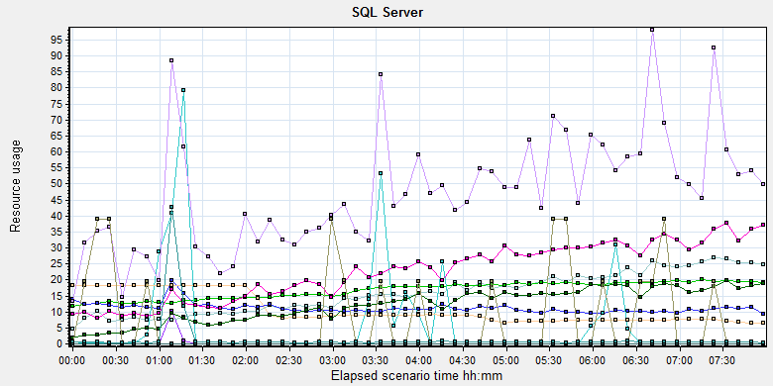
Color | Scale | Measurement | Minimum | Average | Maximum | Std. Deviation
 | 0.01 | Average Latch Wait Time (ms) (MSSQL$GCPACSWS|Latches):10.184.129.108 | 0 | 23.618 | 54594 | 616.254
 | 1 | Checkpoint pages/sec (MSSQL$GCPACSWS|Buffer Manager):10.184.129.108 | 0 | 15.922 | 329.16 | 38.93
 | 0.1 | Full Scans/sec (MSSQL$GCPACSWS|Access Methods):10.184.129.108 | 3.654 | 167.718 | 578.252 | 113.749
 | 1 | Latch waits/sec (MSOLAP$GCPACSWS|Locks):10.184.129.108 | 0 | 0 | 0 | 0
 | 1 | Latch Waits/sec (MSSQL$GCPACSWS|Latches):10.184.129.108 | 0 | 11.186 | 675.202 | 11.655
 | 100 | Lazy writes/sec (MSSQL$GCPACSWS|Buffer Manager):10.184.129.108 | 0 | 0.058 | 45.832 | 0.737
 | 0.001 | Lock Memory (KB) (MSSQL$GCPACSWS|Memory Manager):10.184.129.108 | 5976 | 10831.509 | 18368 | 4659.477
 | 1 | Lock Timeouts (timeout > 0)/sec (MSSQL$GCPACSWS|Locks _Total):10.184.129.108 | 0 | 0 | 0 | 0
 | 10 | Lock Timeouts/sec (MSSQL$GCPACSWS|Locks _Total):10.184.129.108 | 0 | 2.258 | 31.217 | 3.341
 | 1 | Lock Wait Time (ms) (MSSQL$GCPACSWS|Locks _Total):10.184.129.108 | 0 | 47.204 | 8228.501 | 165.026
 | 1 | Lock waits/sec (MSOLAP$GCPACSWS|Locks):10.184.129.108 | 0 | 0 | 0 | 0
 | 10 | Lock Waits/sec (MSSQL$GCPACSWS|Locks _Total):10.184.129.108 | 0 | 1.22 | 8.635 | 1.848
 | 10000 | Number of Deadlocks/sec (MSSQL$GCPACSWS|Locks _Total):10.184.129.108 | 0 | 0.001 | 0.336 | 0.016
 | 1 | Number of SuperLatches (MSSQL$GCPACSWS|Latches):10.184.129.108 | 0 | 0 | 0 | 0
 | 0.01 | Total Latch Wait Time (ms) (MSSQL$GCPACSWS|Latches):10.184.129.108 | 0 | 149.502 | 39098.348 | 1346.357

There are 11 latches every seconds during the testing work (Latch Waits/sec (MSSQL$GCPACSWS|Latches)). Compare with the value of phase5 (19). The system has some enhance. There are also has some locks, deadlocks and lock time out issues. Some SQL statement needs to enhance to fix these issues. The detail information please the attachments which collect all deadlock information during the testing works.

Test Conclusion
The result of this phase testing works is good. There is only 1 test error during the testing works. The transaction average response time is less than 2 seconds and no hardware bottleneck. Even there are some locks and latches exist in the database, but they do not block the main workflow execute operations.
But upload attachments operation doses meet the requirements. I collect the records which created time is in the testing works and status end time is extend 3 hours which required by our design. The detail information as follow:
Type | Count | Size | All
Dicom | 1042 | 9M | 9,378M
Dicom Png | 1042 | 1.4M | 1,433.6M
Report Jpg | 860 | 0.15M | 129M
Report PDF | 860 | 0.12M | 103.2M
 |  |  | 11,043.8 MB

The system uploaded 11GB data to server in 11 hours. The result does not meet the requirements. We will continue to monitor the issues in the next testing works. There are some attachments blocked which cause by our system. The develop team should fixed this issue ASAP.
After the hard works with team, our system has a big enhance. Thanks for the supporting works from develop and QA teams.
Please refer the enhancements and defects list to implement the performance enhance works:
No. | Type | Descriptions
100048858 | defect | [Performance] The upload operations will blocked cause by upload basic data of patient operations.

Testing work （Phase 7）

Test Environment
The detailed hardware configurations of all servers are described as follow:

Computer name | CPU | Memory | HD | OS | Other | Comments
PS Server Panda upgrade | Interl(R) Xeon® CPU E5-2350 @ 1.80 * 6 | 12GB | 1TB | Windows 2008 R2 64bit | SQL server workgroup 2008 | Use the network 100Mbps
Workstation Server | Intel i3-2120 3.3GHz | 2GB | 80GB | Windows 7 SP1 64bit | QTP 11 | 6 virtual machine in server
Terminal | Intel Atom D525 1.8GHz | 4GB | 450GB | Windows Embedded Standard SP1 64bit | UTF 12.0 trail
Cloud Film Server | Huawei Cloud 3 4CORE | 8G | 40GB +  200GB | Windows Server 2016
Cloud film DB Server | Huawei Cloud 3 2CORE | 8G | 40GB | Huaiwei cloud offer | MySQL 5.7

Table 1 Hardware Configuration

Test scenario and strategy
Virtual User: 21 Users
Duration: 8 hour
Description: Use the test tool simulates the patient operations. Monitor the server software and hardware resource usage. The detail information as follow:
- Use automation tool simulate the doctor print film work. Simulate 6 GX Platform by using QTP and WinDPSTester tool. Each client prints one film which size is 10MB every 40 seconds.
- Use LR tool simulate 8 K2/K3 terminals to print film. Each client prints one film which size is 10MB random 10 to 30 seconds.
- Use LR tool simulate 8 users to do report archive operations. Each client archive report in random 10 to 30 seconds and size is random with 100kb and 4Mb.
- Use LR tool simulate 8 terminals to print paper reports. Each client prints report random 10 to 30 seconds.
- The OCR setting is not has rule for GX platforms in step1 and other setting are set as default. The OCR service will under the strong stress without configure the rule.
- Simulate 5 users to do the query information, view monitor page, query reconciliation films and report, expand the record, change the status, set holding time and other operations in worklist.
- Monitor the transaction response time.
- Monitor the hardware resource usage on PS.
- Monitor the resource usage for database on PS.
- Start/Stop 1 virtual user every 5 seconds and run the scenario for 8 hours.
- Use the business Upload network bandwidth to 100M.

Note:
We will do the performance testing work under big stress for system. If system can work well under current stress and the transaction process ability meets the requirement, we will give the conclusion the system performance is pass.

Test Tool
Load Runner 12.

Database setting
Memory: Set the min and max memory size to 4GB.
Index fill factor: 80.
File: Increase the data and log files size and the rule is increase 500Mb as fixed size.

IIS setting
Connection: Set the max connection value to 4000 and keep other setting as default.

Test Object version
KIOSK cloud film 3.0.3.0 B26P01 + CloudUploadService Patch

Background data
We prepared a background records in the PS system. The data size is calculated by the typical site which printed 3,000 films in a workday. That means the records of films in db should more than 972,000 (3000records / day *54 weeks * 6 workday). QA team had prepared these data with SQL script and automation script. These data can backup and import by DB tool.
The detail data records in DB as follow:

Table Name | Data Volume (records)
printer.dbo.DeliveryJob | 995199
printer.dbo.ImageBox | 3530116
printer.dbo.Page | 314893
printer.dbo.Session | 571212
wggc.dbo.Patient | 1224710
wggc.dbo.Study | 1434574
wggc.dbo.AFP_PrintTerminalInfo | 70
wggc.dbo.Series | 1434524
wggc.dbo.Image | 1434527
wggc.dbo.AFP_FilmInfo | 1420905
wggc.dbo.AFP_ReportInfo | 1232003
wggc.dbo.AFP_ExamInfo | 2308723
wggc.dbo.AFP_PrintTask | 4324918
wggc.dbo.T_Integration_ExamInfo | 1421769
AFP_PrintMode | 523684
wggc.dbo.vi_KIOSK_ExamInfo_Order | 838208

Test Error
There are 7 errors existed in the testing work s. The detail information , please see the list:
No | Description | count
1. | No match found for the requested parameter "TaskID" | 1
2 | The system create report print task fail!: From Terminal: Terminal1 and accession number is | 1
3 | Error: Query report records to print from databse failed: the accessionnumber is A201809032052285355 the count is 0 | 1
4 | Error: The report task print failed! taskID: 4377095 From Terminal: Terminal50 | 1
5 | The report task print failed! taskID: 4377096 From Terminal: Terminal20 | 1
6 | The task do not finish correct: TaskID: 4377092 From Terminal: K2_8 | 1
7 | Error: The task do not finish correct: TaskID: 4377153 From Terminal: K2_8 | 1

Error analyzes:
- Error No 1 and No 2 are related errors, the system cannot get the print task Id from system. It made the report print transaction failed.
- The No 3 error means script cannot find the report file to print. The report count is 0 in database. The report does not archive successfully during the testing works.
- The No 4 error means the print task does not finished successfully. The task passed after 40 seconds. It caused by performance script, not error.
- The No 5 error means the print task does not finished successfully. We query the records in database find that the task does not execute as normal. The status of this task is -1, it`s a really error.
- The No 6 error means the print task does not finished successfully. We monitor the records in the database and find the records print status is 1, it`s an error for our system.
- The No 7 error means the print task does not finished successfully. We monitor the records in the database and find the records print status is 3, it`s an error for our system.

Test result of PS server

Test result of PS transactions
After the performance testing works, the transactions result of PS print module as follow:
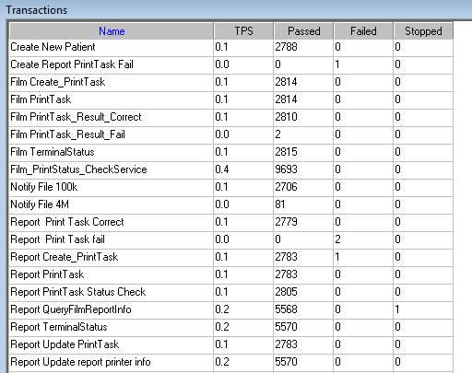

Test Statistic Report of PS
Analysis Summary | Period: 2018/9/3 16:44 - 2018/9/4 0:47

Scenario Name: | E:\ECS\Performance\Script\208\ScenarioPUMA_Reliability_171.lrs
Results in Session: | c:\Users\Administrator\AppData\Local\Temp\res180\res180.lrr
Duration: | 8 hours, 3 minutes and 12 seconds.

Statistics Summary

Maximum Running Vusers: |  | 16
Total Throughput (bytes): |  | 17,563,141
Average Throughput (bytes/second): |  | 606
Total Hits: |  | 18,134
Average Hits per Second: |  | 0.625 | View HTTP Responses Summary
Total Errors: |  | 7

Transaction Summary

Transactions: | Total Passed: 57,164 | Total Failed: 4 | Total Stopped: 1 | Average Response Time

Transaction Name | SLA Status | Minimum | Average | Maximum | Std. Deviation | 90 Percent | Pass | Fail | Stop
Create New Patient |  | 0.078 | 0.151 | 30.564 | 0.877 | 0.172 | 2,788 | 0 | 0
Create Report PrintTask Fail |  | 0 | 0 | 0 | 0 | 0 | 0 | 1 | 0
Film Create_PrintTask |  | 0.778 | 1.275 | 33.715 | 0.908 | 1.669 | 2,814 | 0 | 0
Film PrintTask |  | 0.016 | 0.044 | 1.95 | 0.052 | 0.072 | 2,814 | 0 | 0
Film PrintTask_Result_Correct |  | 0 | 0 | 0.016 | 0 | 0 | 2,810 | 0 | 0
Film PrintTask_Result_Fail |  | 0 | 0 | 0 | 0 | 0 | 2 | 0 | 0
Film TerminalStatus |  | 0 | 0.066 | 39.239 | 1.013 | 0.047 | 2,815 | 0 | 0
Film_PrintStatus_CheckService |  | 0 | 0.033 | 37.834 | 0.52 | 0.047 | 9,693 | 0 | 0
Notify File 100k |  | 0.459 | 1.146 | 7.113 | 0.572 | 1.81 | 2,706 | 0 | 0
Notify File 4M |  | 0.655 | 1.324 | 4.339 | 0.631 | 2.026 | 81 | 0 | 0
Report Print Task Correct |  | 0 | 0 | 0.016 | 0 | 0 | 2,779 | 0 | 0
Report Print Task fail |  | 0 | 0 | 0 | 0 | 0 | 0 | 2 | 0
Report Create_PrintTask |  | 0.621 | 1.063 | 8.268 | 0.348 | 1.482 | 2,783 | 1 | 0
Report PrintTask |  | 0.016 | 0.059 | 30.19 | 0.576 | 0.085 | 2,783 | 0 | 0
Report PrintTask Status Check |  | 0 | 0.039 | 30.595 | 0.583 | 0.047 | 2,805 | 0 | 0
Report QueryFilmReportInfo |  | 0.659 | 1.13 | 39.191 | 0.683 | 1.529 | 5,568 | 0 | 1
Report TerminalStatus |  | 0 | 0.033 | 37.444 | 0.508 | 0.047 | 5,570 | 0 | 0
Report Update PrintTask |  | 0 | 0.054 | 4.664 | 0.107 | 0.094 | 2,783 | 0 | 0
Report Update report printer info |  | 0 | 0.026 | 7.8 | 0.118 | 0.047 | 5,570 | 0 | 0

Service Level Agreement Legend: |  | Pass |  | Fail |  | No Data

HTTP Responses Summary

HTTP Responses | Total | Per second
HTTP_200 | 18,134 | 0.625

Follow the summary report, we can see there are 6 failed transactions during the testing work. 2 films and reports print tasks are failed.

Transaction summary result of PS
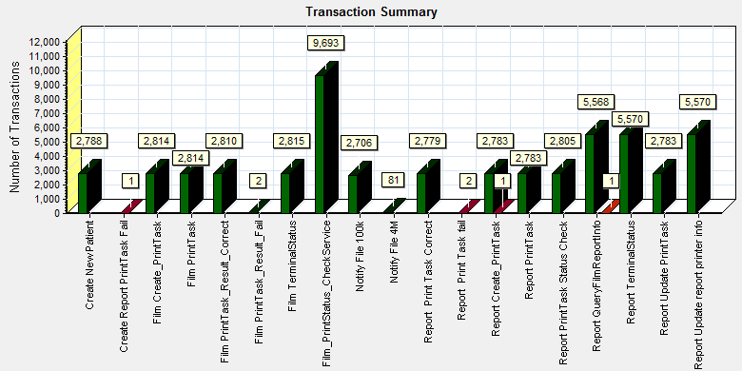
Color | Scale | Measurement
 | 1 | Pass
 | 1 | Fail
 | 1 | Stop

Description: Displays the number of transactions that passed, failed, stopped, or ended with errors.

We can see that there are 6 transactions failed during the testing works.

Transaction response time result of PS
We can get the transaction response time information from the figure as follow:
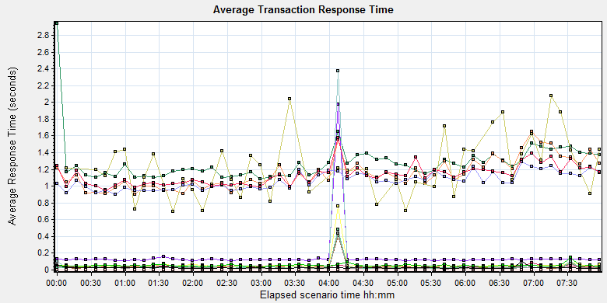
Color | Scale | Measurement | Graph's Minimum | Graph's Average | Graph's Maximum | Graph's Median
 | 1 | Create New Patient | 0.11 | 0.155 | 1.977 | 0.121
 | 1 | Film Create_PrintTask | 1.08 | 1.28 | 2.94 | 1.237
 | 1 | Film PrintTask | 0.033 | 0.044 | 0.083 | 0.043
 | 1 | Film PrintTask_Result_Correct | 0 | 0 | 0 | 0
 | 1 | Film PrintTask_Result_Fail | 0 | 0 | 0 | 0
 | 1 | Film TerminalStatus | 0.017 | 0.073 | 2.377 | 0.029
 | 1 | Film_PrintStatus_CheckService | 0.018 | 0.033 | 0.411 | 0.025
 | 1 | Notify File 100k | 0.896 | 1.149 | 1.655 | 1.106
 | 1 | Notify File 4M | 0.692 | 1.237 | 2.075 | 1.206
 | 1 | Report Print Task Correct | 0 | 0 | 0 | 0
 | 1 | Report Create_PrintTask | 0.9 | 1.064 | 1.289 | 1.047
 | 1 | Report PrintTask | 0.031 | 0.061 | 0.763 | 0.048
 | 1 | Report PrintTask Status Check | 0.017 | 0.036 | 0.483 | 0.026
 | 1 | Report QueryFilmReportInfo | 0.944 | 1.132 | 1.574 | 1.124
 | 1 | Report TerminalStatus | 0.013 | 0.033 | 0.439 | 0.025
 | 1 | Report Update PrintTask | 0.037 | 0.054 | 0.148 | 0.051
 | 1 | Report Update report printer info | 0.017 | 0.026 | 0.103 | 0.024
Transaction response time

This figure information shows all transaction response time. We can analysis that all transaction`s response time are less than 2 seconds. The performance of the transaction is perfect.

Test result of Web service

Test result of web transactions
After the performance testing works, the transactions result of we module as follow:
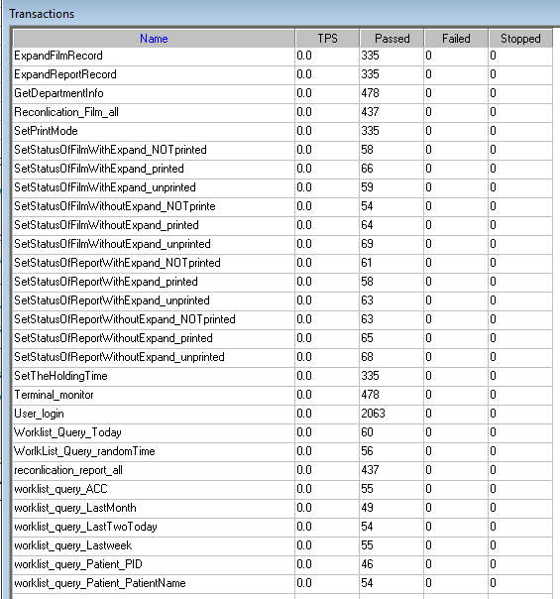
Follow the figure, we can see that there are no transactions failed.

Test Statistic Report of Web
Analysis Summary | Period: 03/09/2018 17:10:33 - 04/09/2018 01:13:13

Scenario Name: | D:\Performance\ScenarioPUMA_Reliability_171.lrs
Results in Session: | c:\Users\administrator\appdata\local\temp\res1241\res1241.lrr
Duration: | 8 hours, 2 minutes and 40 seconds.

Statistics Summary

Maximum Running Vusers: | 5
Total Throughput (bytes): | 638,396,604
Average Throughput (bytes/second): | 22,043
Total Hits: | 48,603
Average Hits per Second: | 1.678

Transaction Summary

Transactions: | Total Passed: 6,410 | Total Failed: 0 | Total Stopped: 0 | Average Response Time

 | Pass | Fail | Stop
Total | 6,410 | 0 | 0

Transaction Name | Minimum | Average | Maximum | Std. Deviation | 90 Percent | Pass | Fail | Stop
ExpandFilmRecord | 0.091 | 0.128 | 4.584 | 0.254 | 0.14 | 335 | 0 | 0
ExpandReportRecord | 0.006 | 0.01 | 0.267 | 0.016 | 0.013 | 335 | 0 | 0
GetDepartmentInfo | 0.005 | 0.008 | 0.227 | 0.011 | 0.011 | 478 | 0 | 0
Reconlication_Film_all | 0.34 | 0.454 | 1.478 | 0.125 | 0.581 | 437 | 0 | 0
reconlication_report_all | 0.022 | 0.047 | 0.417 | 0.041 | 0.072 | 437 | 0 | 0
SetPrintMode | 0.015 | 0.104 | 16.536 | 0.9 | 0.096 | 335 | 0 | 0
SetStatusOfFilmWithExpand_NOTprinted | 0.115 | 0.169 | 0.648 | 0.08 | 0.257 | 58 | 0 | 0
SetStatusOfFilmWithExpand_printed | 0.111 | 0.177 | 0.39 | 0.061 | 0.267 | 66 | 0 | 0
SetStatusOfFilmWithExpand_unprinted | 0.111 | 0.211 | 1.984 | 0.244 | 0.294 | 59 | 0 | 0
SetStatusOfFilmWithoutExpand_NOTprinte | 0.023 | 0.062 | 0.215 | 0.046 | 0.114 | 54 | 0 | 0
SetStatusOfFilmWithoutExpand_printed | 0.028 | 0.073 | 0.251 | 0.049 | 0.136 | 64 | 0 | 0
SetStatusOfFilmWithoutExpand_unprinted | 0.028 | 0.069 | 0.25 | 0.041 | 0.128 | 69 | 0 | 0
SetStatusOfReportWithExpand_NOTprinted | 0.022 | 0.063 | 0.338 | 0.053 | 0.124 | 61 | 0 | 0
SetStatusOfReportWithExpand_printed | 0.028 | 0.067 | 0.362 | 0.06 | 0.125 | 58 | 0 | 0
SetStatusOfReportWithExpand_unprinted | 0.019 | 0.063 | 0.355 | 0.059 | 0.127 | 63 | 0 | 0
SetStatusOfReportWithoutExpand_NOTprinted | 0.026 | 0.07 | 0.408 | 0.063 | 0.111 | 63 | 0 | 0
SetStatusOfReportWithoutExpand_printed | 0.021 | 0.07 | 0.383 | 0.056 | 0.144 | 65 | 0 | 0
SetStatusOfReportWithoutExpand_unprinted | 0.029 | 0.083 | 0.335 | 0.062 | 0.175 | 68 | 0 | 0
SetTheHoldingTime | 0.015 | 0.04 | 0.33 | 0.042 | 0.066 | 335 | 0 | 0
Terminal_monitor | 0.117 | 0.15 | 0.652 | 0.054 | 0.175 | 478 | 0 | 0
User_login | 0.192 | 0.29 | 28.452 | 0.809 | 0.337 | 2,063 | 0 | 0
worklist_query_ACC | 0.011 | 0.014 | 0.023 | 0.003 | 0.018 | 55 | 0 | 0
worklist_query_LastMonth | 0.032 | 0.064 | 0.161 | 0.028 | 0.126 | 49 | 0 | 0
worklist_query_LastTwoToday | 0.031 | 0.058 | 0.134 | 0.019 | 0.082 | 54 | 0 | 0
worklist_query_Lastweek | 0.03 | 0.056 | 0.121 | 0.018 | 0.073 | 55 | 0 | 0
worklist_query_Patient_PatientName | 0.009 | 0.019 | 0.059 | 0.008 | 0.03 | 54 | 0 | 0
worklist_query_Patient_PID | 0.009 | 0.022 | 0.114 | 0.016 | 0.039 | 46 | 0 | 0
Worklist_Query_Today | 0.02 | 0.043 | 0.118 | 0.017 | 0.062 | 60 | 0 | 0
WorlkList_Query_randomTime | 0.035 | 0.067 | 0.188 | 0.025 | 0.093 | 56 | 0 | 0

Service Level Agreement Legend: |  | Pass |  | Fail |  | No Data

HTTP Responses Summary

HTTP Responses | Total | Per second
HTTP_200 | 46,540 | 1.607
HTTP_302 | 2,063 | 0.071

Follow the summary report, we can see there are no transactions failed.

Transaction summary result of Web
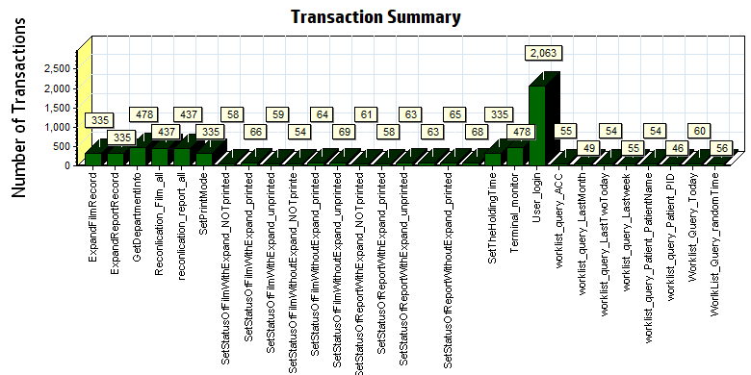
Color | Scale | Measurement
 | 1 | Pass

We can see that there are no transactions failed during the testing works.

Transaction response time result of Web
We can get the transaction response time information from the figure as follow:
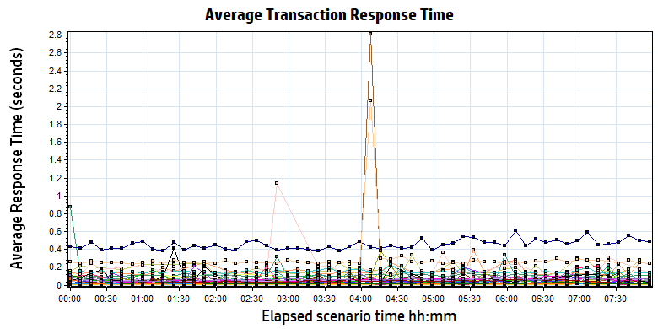
Color | Scale | Measurement | Minimum | Average | Maximum | Std. Deviation
 | 1 | ExpandFilmRecord | 0.091 | 0.128 | 4.584 | 0.254
 | 1 | ExpandReportRecord | 0.006 | 0.010 | 0.267 | 0.016
 | 1 | GetDepartmentInfo | 0.005 | 0.008 | 0.227 | 0.011
 | 1 | Reconlication_Film_all | 0.340 | 0.454 | 1.478 | 0.125
 | 1 | reconlication_report_all | 0.022 | 0.047 | 0.417 | 0.041
 | 1 | SetPrintMode | 0.015 | 0.104 | 16.536 | 0.900
 | 1 | SetStatusOfFilmWithExpand_NOTprinted | 0.115 | 0.169 | 0.648 | 0.080
 | 1 | SetStatusOfFilmWithExpand_printed | 0.111 | 0.177 | 0.390 | 0.061
 | 1 | SetStatusOfFilmWithExpand_unprinted | 0.111 | 0.211 | 1.984 | 0.244
 | 1 | SetStatusOfFilmWithoutExpand_NOTprinte | 0.023 | 0.062 | 0.215 | 0.046
 | 1 | SetStatusOfFilmWithoutExpand_printed | 0.028 | 0.073 | 0.251 | 0.049
 | 1 | SetStatusOfFilmWithoutExpand_unprinted | 0.028 | 0.069 | 0.250 | 0.041
 | 1 | SetStatusOfReportWithExpand_NOTprinted | 0.022 | 0.063 | 0.338 | 0.053
 | 1 | SetStatusOfReportWithExpand_printed | 0.028 | 0.067 | 0.362 | 0.060
 | 1 | SetStatusOfReportWithExpand_unprinted | 0.019 | 0.063 | 0.355 | 0.059
 | 1 | SetStatusOfReportWithoutExpand_NOTprinted | 0.026 | 0.070 | 0.408 | 0.063
 | 1 | SetStatusOfReportWithoutExpand_printed | 0.021 | 0.070 | 0.383 | 0.056
 | 1 | SetStatusOfReportWithoutExpand_unprinted | 0.029 | 0.083 | 0.335 | 0.062
 | 1 | SetTheHoldingTime | 0.015 | 0.040 | 0.330 | 0.042
 | 1 | Terminal_monitor | 0.117 | 0.150 | 0.652 | 0.054
 | 1 | User_login | 0.192 | 0.290 | 28.452 | 0.809
 | 1 | worklist_query_ACC | 0.011 | 0.014 | 0.023 | 0.003
 | 1 | worklist_query_LastMonth | 0.032 | 0.064 | 0.161 | 0.028
 | 1 | worklist_query_LastTwoToday | 0.031 | 0.058 | 0.134 | 0.019
 | 1 | worklist_query_Lastweek | 0.030 | 0.056 | 0.121 | 0.018
 | 1 | worklist_query_Patient_PatientName | 0.009 | 0.019 | 0.059 | 0.008
 | 1 | worklist_query_Patient_PID | 0.009 | 0.022 | 0.114 | 0.016
 | 1 | Worklist_Query_Today | 0.020 | 0.043 | 0.118 | 0.017
 | 1 | WorlkList_Query_randomTime | 0.035 | 0.067 | 0.188 | 0.025

Transaction response time
Follow the figure: we can see that the transaction average response time is less than 2 seconds. Some transaction works not smoothly with short time. It can accepted by design.

Performance bottleneck analysis

Hardware usage analysis
During the testing work, we use the test tool to monitor the server hardware usage include the CPU, Memory, hard disk and etc.
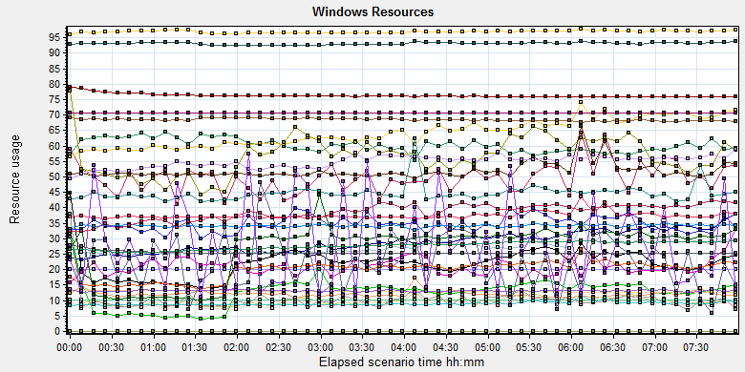
Color | Scale | Measurement | Minimum | Average | Maximum | Std. Deviation
 | 0.1 | % Disk Time (PhysicalDisk _Total):10.184.129.108 | 6.208 | 101.652 | 10480.693 | 175.911
 | 1 | % Idle Time (PhysicalDisk _Total):10.184.129.108 | 0 | 60.157 | 95.559 | 19.488
 | 1000 | % Interrupt Time (Processor _Total):10.184.129.108 | 0 | 0.05 | 0.391 | 0.053
 | 10 | % Privileged Time (Processor _Total):10.184.129.108 | 0.086 | 6.415 | 14.019 | 2.146
 | 10 | % Processor Time (Process CloudDataUploadService):10.184.129.108 | 0 | 2.889 | 21.244 | 2.663
 | 1 | % Processor Time (Processor _Total):10.184.129.108 | 1.327 | 27.366 | 75.086 | 11.037
 | 0.01 | Available MBytes (Memory):10.184.129.108 | 6469 | 6849.931 | 7145 | 70.697
 | 0.0001 | Avg. Disk Bytes/Transfer (PhysicalDisk _Total):10.184.129.108 | 3955.451 | 121233.407 | 2394951.68 | 115479.886
 | 10 | Avg. Disk Queue Length (PhysicalDisk _Total):10.184.129.108 | 0.062 | 1.017 | 104.807 | 1.759
 | 10 | Avg. Disk Write Queue Length (PhysicalDisk _Total):10.184.129.108 | 0.062 | 0.894 | 17.98 | 0.961
 | 0.001 | Bytes Total/sec (Server):10.184.129.108 | 19385.584 | 20059.762 | 21251.108 | 215.452
 | 1E-07 | Cache Bytes (Memory):10.184.129.108 | 247013376 | 277447621.191 | 309092352 | 12336254.821
 | 1E-09 | Committed Bytes (Memory):10.184.129.108 | 9965424640 | 10263890109.508 | 10765983744 | 81463589.895
 | 0.001 | Context Switches/sec (System):10.184.129.108 | 3372.362 | 37528.391 | 121911.218 | 20188.049
 | 10 | Current Disk Queue Length (PhysicalDisk _Total):10.184.129.108 | 0 | 1.042 | 208 | 3.208
 | 1E-05 | Disk Read Bytes/sec (PhysicalDisk _Total):10.184.129.108 | 0 | 1259485.887 | 52392870.104 | 1881499.063
 | 1 | Disk Reads/sec (PhysicalDisk _Total):10.184.129.108 | 0 | 21.991 | 1046.833 | 25.895
 | 1 | Disk Transfers/sec (PhysicalDisk _Total):10.184.129.108 | 5.314 | 56.772 | 1064.768 | 36.664
 | 1E-05 | Disk Write Bytes/sec (PhysicalDisk _Total):10.184.129.108 | 21767.072 | 4475555.02 | 93133947.96 | 3767343.257
 | 1 | Disk Writes/sec (PhysicalDisk _Total):10.184.129.108 | 5.314 | 34.781 | 349.26 | 23.994
 | 0.001 | File Data Operations/sec (System):10.184.129.108 | 487.23 | 8980.148 | 30846.141 | 4818.01
 | 1E-05 | Free Megabytes (LogicalDisk _Total):10.184.129.108 | 1263612 | 1297196.164 | 1328764 | 18874.002
 | 0.01 | Interrupts/sec (Processor _Total):10.184.129.108 | 885.926 | 3414.464 | 13212.095 | 1837.609
 | 0.001 | Page Faults/sec (Memory):10.184.129.108 | 403.873 | 51915.812 | 209867.472 | 25854.32
 | 0.1 | Page Faults/sec (Process CloudDataUploadService):10.184.129.108 | 0 | 209.83 | 5473.782 | 535.553
 | 1E-06 | Page File Bytes (Process CloudDataUploadService):10.184.129.108 | 44494848 | 54850994.634 | 93237248 | 2424996.001
 | 1 | Page Reads/sec (Memory):10.184.129.108 | 0 | 19.812 | 228.17 | 23.873
 | 0.1 | Pages/sec (Memory):10.184.129.108 | 0 | 268.394 | 12354.658 | 378.614
 | 1E-06 | Pool Nonpaged Bytes (Memory):10.184.129.108 | 75739136 | 76313778.554 | 79470592 | 629419.287
 | 1E-05 | Pool Nonpaged Bytes (Server):10.184.129.108 | 1138233 | 1318223.434 | 1454489 | 42648.398
 | 1E-07 | Pool Paged Bytes (Memory):10.184.129.108 | 251559936 | 254530552.662 | 277626880 | 4979641.793
 | 0.001 | Pool Paged Bytes (Server):10.184.129.108 | 70741 | 70741.106 | 70997 | 5.217
 | 1 | Pool Paged Failures (Server):10.184.129.108 | 0 | 0 | 0 | 0
 | 1E-08 | Private Bytes (Process _Total):10.184.129.108 | 9024065536 | 9318300660.621 | 9644642304 | 68357150.192
 | 100 | Processor Queue Length (System):10.184.129.108 | 0 | 0.227 | 26 | 1.126
 | 10 | Split IO/Sec (PhysicalDisk _Total):10.184.129.108 | 0 | 2.775 | 304.108 | 14.983
 | 1E-07 | System Cache Resident Bytes (Memory):10.184.129.108 | 247013376 | 277448590.636 | 309092352 | 12335474.899
 | 0.01 | Threads (Objects):10.184.129.108 | 3054 | 3850.055 | 4385 | 279.194
 | 1E-08 | Working Set (Process _Total):10.184.129.108 | 9283088384 | 9696757011.116 | 10209984512 | 86319601.244
Description: Displays a summary of the System Resources usage for each Windows based host.

Follow this information we can get that:
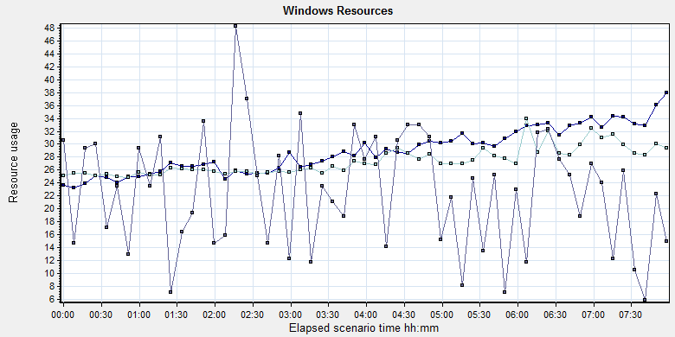
Color | Scale | Measurement | Minimum | Average | Maximum | Std. Deviation
 | 10 | % Processor Time (Process CloudDataUploadService):10.184.129.108 | 0 | 2.889 | 21.244 | 2.663
 | 1 | % Processor Time (Processor _Total):10.184.129.108 | 1.327 | 27.366 | 75.086 | 11.037
 | 100 | Processor Queue Length (System):10.184.129.108 | 0 | 0.227 | 26 | 1.126

Description: Displays a summary of the System Resources usage for each Windows based host.

Follow the figure we can see that the CPU does not has bottleneck during the testing works. The CPU process time usage is between 24% and 34%. It`s under 85% threshold value can accept. The average CPU queue length is 0.227, it small than the threshold value (12= 6*2).
We can see the cloudDataUploadService CPU usage increase with the execute time. But the usage value is small can accepted by system. The index value should divided the numbers of CPU.The CPU resource has not bottleneck.

The memory resource do not has the bottleneck. There are enough resources for system to use.
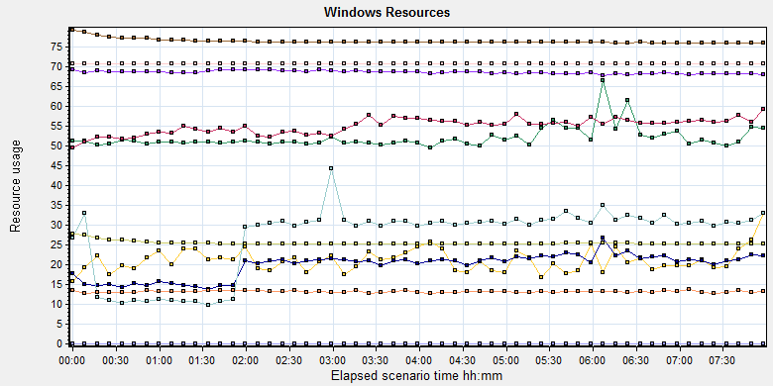
Color |  | Scale | Measurement | Minimum | Average | Maximum | Std. Deviation
 |  | 0.01 | Available MBytes (Memory):10.184.129.108 | 6469 | 6849.931 | 7145 | 70.697
 |  | 0.001 | Page Faults/sec (Memory):10.184.129.108 | 403.873 | 51915.812 | 209867.472 | 25854.32
 |  | 0.1 | Page Faults/sec (Process CloudDataUploadService):10.184.129.108 | 0 | 209.83 | 5473.782 | 535.553
 |  | 1E-06 | Page File Bytes (Process CloudDataUploadService):10.184.129.108 | 44494848 | 54850994.634 | 93237248 | 2424996.001
 |  | 1 | Page Reads/sec (Memory):10.184.129.108 | 0 | 19.812 | 228.17 | 23.873
 |  | 0.1 | Pages/sec (Memory):10.184.129.108 | 0 | 268.394 | 12354.658 | 378.614
 |  | 1E-06 | Pool Nonpaged Bytes (Memory):10.184.129.108 | 75739136 | 76313778.554 | 79470592 | 629419.287
 |  | 1E-05 | Pool Nonpaged Bytes (Server):10.184.129.108 | 1138233 | 1318223.434 | 1454489 | 42648.398
 |  | 1E-07 | Pool Paged Bytes (Memory):10.184.129.108 | 251559936 | 254530552.662 | 277626880 | 4979641.793
 |  | 0.001 | Pool Paged Bytes (Server):10.184.129.108 | 70741 | 70741.106 | 70997 | 5.217
 |  | 1 | Pool Paged Failures (Server):10.184.129.108 | 0 | 0 | 0 | 0
 | Description: Displays a summary of the System Resources usage for each Windows based host.
Form the memory usage figure, we can see that there are no memory leak and bottleneck issues.
The disk resource is enough during performance testing works:
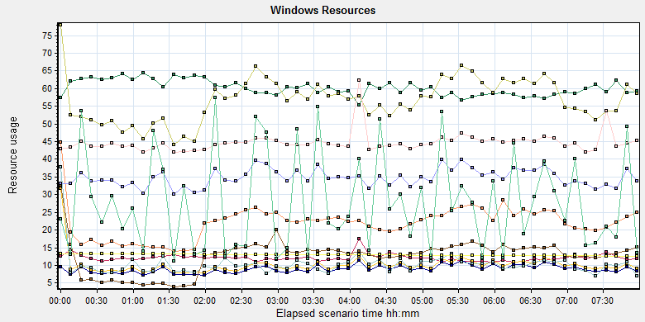
Color | Scale | Measurement | Minimum | Average | Maximum | Std. Deviation
 | 0.1 | % Disk Time (PhysicalDisk _Total):10.184.129.108 | 6.208 | 101.652 | 10480.693 | 175.911
 | 1 | % Idle Time (PhysicalDisk _Total):10.184.129.108 | 0 | 60.157 | 95.559 | 19.488
 | 0.0001 | Avg. Disk Bytes/Transfer (PhysicalDisk _Total):10.184.129.108 | 3955.451 | 121233.407 | 2394951.68 | 115479.886
 | 10 | Avg. Disk Queue Length (PhysicalDisk _Total):10.184.129.108 | 0.062 | 1.017 | 104.807 | 1.759
 | 10 | Avg. Disk Write Queue Length (PhysicalDisk _Total):10.184.129.108 | 0.062 | 0.894 | 17.98 | 0.961
 | 10 | Current Disk Queue Length (PhysicalDisk _Total):10.184.129.108 | 0 | 1.042 | 208 | 3.208
 | 1E-05 | Disk Read Bytes/sec (PhysicalDisk _Total):10.184.129.108 | 0 | 1259485.887 | 52392870.104 | 1881499.063
 | 1 | Disk Reads/sec (PhysicalDisk _Total):10.184.129.108 | 0 | 21.991 | 1046.833 | 25.895
 | 1 | Disk Transfers/sec (PhysicalDisk _Total):10.184.129.108 | 5.314 | 56.772 | 1064.768 | 36.664
 | 1E-05 | Disk Write Bytes/sec (PhysicalDisk _Total):10.184.129.108 | 21767.072 | 4475555.02 | 93133947.96 | 3767343.257
 | 1 | Disk Writes/sec (PhysicalDisk _Total):10.184.129.108 | 5.314 | 34.781 | 349.26 | 23.994
 | 1E-05 | Free Megabytes (LogicalDisk _Total):10.184.129.108 | 1263612 | 1297196.164 | 1328764 | 18874.002
 | 10 | Split IO/Sec (PhysicalDisk _Total):10.184.129.108 | 0 | 2.775 | 304.108 | 14.983
Description: Displays a summary of the System Resources usage for each Windows based host.
Follow the figure: we can see that there are many disk tasks exist in the system during the testing work. The average Disk read/sec is 21, writes/sec is 34, and transfers/sec is 56. The average disk transfer size is 5.5M/sec. The disk is not busy and do not has bottleneck. The disk reads increased with the execute time. We guess it caused by the system because some upload attachments are blocked.

SQL Server resource usage analysis
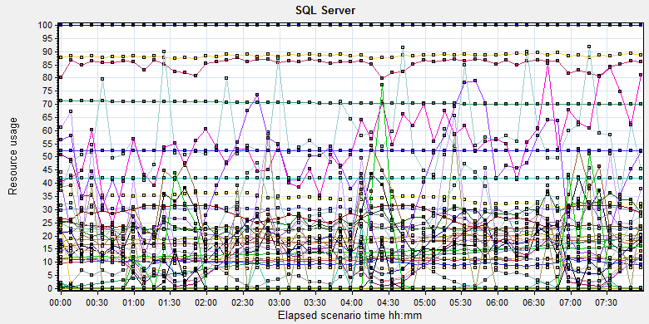
Color | Scale | Measurement | Minimum | Average | Maximum | Std. Deviation
 | 0.1 | Average Latch Wait Time (ms) (MSSQL$GCPACSWS|Latches):10.184.129.108 | 0 | 6.433 | 16114 | 194.391
 | 1 | Buffer cache hit ratio (MSSQL$GCPACSWS|Buffer Manager):10.184.129.108 | 97.163 | 99.995 | 100 | 0.034
 | 1 | Cache Hit Ratio (MSSQL$GCPACSWS|Catalog Metadata _Total):10.184.129.108 | 69.879 | 70.477 | 71.326 | 0.424
 | 1 | Cache Hit Ratio (MSSQL$GCPACSWS|Cursor Manager by Type _Total):10.184.129.108 | 70.127 | 85.229 | 91.027 | 2.815
 | 1 | Cache Hit Ratio (MSSQL$GCPACSWS|Plan Cache _Total):10.184.129.108 | 73.079 | 88.415 | 97.366 | 3.599
 | 10 | Checkpoint pages/sec (MSSQL$GCPACSWS|Buffer Manager):10.184.129.108 | 0 | 5.806 | 239.127 | 21.237
 | 0.01 | Connection Memory (KB) (MSSQL$GCPACSWS|Memory Manager):10.184.129.108 | 1832 | 2320.18 | 2984 | 101.138
 | 0.1 | Connection Reset/sec (MSSQL$GCPACSWS|General Statistics):10.184.129.108 | 71.409 | 176.515 | 519.143 | 63.927
 | 1 | Current latch waits (MSOLAP$GCPACSWS|Locks):10.184.129.108 | 0 | 0 | 0 | 0
 | 1 | Cursor flushes (MSSQL$GCPACSWS|Cursor Manager Total):10.184.129.108 | 0 | 0 | 0 | 0
 | 0.0001 | Cursor memory usage (MSSQL$GCPACSWS|Cursor Manager by Type _Total):10.184.129.108 | 88 | 121486.878 | 479176 | 99140.412
 | 10 | Cursor Requests/sec (MSSQL$GCPACSWS|Cursor Manager by Type _Total):10.184.129.108 | 0 | 3.02 | 20.924 | 2.917
 | 0.0001 | Database pages (MSSQL$GCPACSWS|Buffer Manager):10.184.129.108 | 311525 | 341909.866 | 388935 | 15510.328
 | 10 | Errors/sec (MSSQL$GCPACSWS|SQL Errors _Total):10.184.129.108 | 0 | 2.276 | 14.613 | 1.626
 | 1 | Free list stalls/sec (MSSQL$GCPACSWS|Buffer Manager):10.184.129.108 | 0 | 0 | 0 | 0
 | 0.0001 | Free pages (MSSQL$GCPACSWS|Buffer Manager):10.184.129.108 | 64 | 75890.474 | 204532 | 52911.567
 | 0.1 | Full Scans/sec (MSSQL$GCPACSWS|Access Methods):10.184.129.108 | 2.657 | 137.758 | 776.306 | 119.883
 | 0.001 | Granted Workspace Memory (KB) (MSSQL$GCPACSWS|Memory Manager):10.184.129.108 | 0 | 19855.855 | 610120 | 63252.791
 | 0.001 | Index Searches/sec (MSSQL$GCPACSWS|Access Methods):10.184.129.108 | 161.083 | 19416.958 | 69674.79 | 14330.984
 | 1 | Latch waits/sec (MSOLAP$GCPACSWS|Locks):10.184.129.108 | 0 | 0 | 0 | 0
 | 1 | Latch Waits/sec (MSSQL$GCPACSWS|Latches):10.184.129.108 | 0 | 9.97 | 339.709 | 7.175
 | 100 | Lazy writes/sec (MSSQL$GCPACSWS|Buffer Manager):10.184.129.108 | 0 | 0.005 | 7.297 | 0.127
 | 0.001 | Lock Memory (KB) (MSSQL$GCPACSWS|Memory Manager):10.184.129.108 | 6904 | 9927.774 | 21688 | 4830.31
 | 1 | Lock Timeouts (timeout > 0)/sec (MSSQL$GCPACSWS|Locks _Total):10.184.129.108 | 0 | 0 | 0 | 0
 | 100 | Lock Timeouts/sec (MSSQL$GCPACSWS|Locks _Total):10.184.129.108 | 0 | 0.548 | 18.263 | 1.067
 | 1 | Lock Wait Time (ms) (MSSQL$GCPACSWS|Locks _Total):10.184.129.108 | 0 | 27.04 | 7042.174 | 187.446
 | 1 | Lock waits/sec (MSOLAP$GCPACSWS|Locks):10.184.129.108 | 0 | 0 | 0 | 0
 | 100 | Lock Waits/sec (MSSQL$GCPACSWS|Locks _Total):10.184.129.108 | 0 | 0.262 | 4.981 | 0.4
 | 1E-05 | Maximum Workspace Memory (KB) (MSSQL$GCPACSWS|Memory Manager):10.184.129.108 | 2208600 | 2843911.564 | 3151800 | 279252.17
 | 100 | Memory Grants Outstanding (MSSQL$GCPACSWS|Memory Manager):10.184.129.108 | 0 | 0.254 | 5 | 0.52
 | 1 | Memory Grants Pending (MSSQL$GCPACSWS|Memory Manager):10.184.129.108 | 0 | 0 | 0 | 0
 | 0.01 | Number of active cursor plans (MSSQL$GCPACSWS|Cursor Manager by Type _Total):10.184.129.108 | 1 | 1304.359 | 5448 | 1110.906
 | 10000 | Number of Deadlocks/sec (MSSQL$GCPACSWS|Locks _Total):10.184.129.108 | 0 | 0.001 | 0.334 | 0.02
 | 1 | Number of SuperLatches (MSSQL$GCPACSWS|Latches):10.184.129.108 | 0 | 0 | 0 | 0
 | 0.01 | Optimizer Memory (KB) (MSSQL$GCPACSWS|Memory Manager):10.184.129.108 | 1104 | 1137.632 | 4728 | 234.991
 | 1 | Page Deallocations/sec (MSSQL$GCPACSWS|Access Methods):10.184.129.108 | 0 | 40.757 | 673.572 | 100.622
 | 0.001 | Page life expectancy (MSSQL$GCPACSWS|Buffer Manager):10.184.129.108 | 980 | 10935.62 | 19297 | 5114.717
 | 0.0001 | Page lookups/sec (MSSQL$GCPACSWS|Buffer Manager):10.184.129.108 | 6750.081 | 107761.39 | 356330.098 | 52417.766
 | 0.1 | Page reads/sec (MSSQL$GCPACSWS|Buffer Manager):10.184.129.108 | 0 | 6.114 | 8297.872 | 127.833
 | 1 | Page Splits/sec (MSSQL$GCPACSWS|Access Methods):10.184.129.108 | 0 | 15.558 | 215.807 | 37.273
 | 1 | Page writes/sec (MSSQL$GCPACSWS|Buffer Manager):10.184.129.108 | 0 | 22.881 | 397.041 | 53.37
 | 0.01 | Reserved pages (MSSQL$GCPACSWS|Buffer Manager):10.184.129.108 | 0 | 2475.276 | 76265 | 7901.064
 | 0.001 | SQL Cache Memory (KB) (MSSQL$GCPACSWS|Memory Manager):10.184.129.108 | 2072 | 13131.595 | 27216 | 6686.022
 | 0.1 | SQL Compilations/sec (MSSQL$GCPACSWS|SQL Statistics):10.184.129.108 | 70.08 | 114.506 | 291.622 | 17.333
 | 100 | SQL Re-Compilations/sec (MSSQL$GCPACSWS|SQL Statistics):10.184.129.108 | 0 | 0.176 | 2.657 | 0.299
 | 0.0001 | Stolen pages (MSSQL$GCPACSWS|Buffer Manager):10.184.129.108 | 5759 | 106487.661 | 203260 | 52920.612
 | 0.0001 | Target pages (MSSQL$GCPACSWS|Buffer Manager):10.184.129.108 | 524288 | 524288 | 524288 | 0
 | 1E-05 | Target Server Memory (KB) (MSSQL$GCPACSWS|Memory Manager):10.184.129.108 | 4194304 | 4194304 | 4194304 | 0
 | 1 | Tasks Started/sec (MSSQL$GCPACSWS|Broker Activation tempdb):10.184.129.108 | 0 | 0 | 0 | 0
 | 1 | Temp file bytes written/sec (MSOLAP$GCPACSWS|Proc Aggregations):10.184.129.108 | 0 | 0 | 0 | 0
 | 100 | Temp Tables Creation Rate (MSSQL$GCPACSWS|General Statistics):10.184.129.108 | 0 | 0.075 | 18.26 | 0.684
 | 10 | Temp Tables For Destruction (MSSQL$GCPACSWS|General Statistics):10.184.129.108 | 0 | 0.157 | 52 | 2.326
 | 1 | Total deadlocks detected (MSOLAP$GCPACSWS|Locks):10.184.129.108 | 0 | 0 | 0 | 0
 | 0.01 | Total Latch Wait Time (ms) (MSSQL$GCPACSWS|Latches):10.184.129.108 | 0 | 79.258 | 203374.282 | 2718.61
 | 0.0001 | Total pages (MSSQL$GCPACSWS|Buffer Manager):10.184.129.108 | 524288 | 524288 | 524288 | 0
 | 1E-05 | Total Server Memory (KB) (MSSQL$GCPACSWS|Memory Manager):10.184.129.108 | 4194304 | 4194304 | 4194304 | 0
Description: Displays a summary of SQL Server Resources.
Database result
Follow the SQL server monitor resource, we can find the Database has some issues:
There are some locks exist in the database:
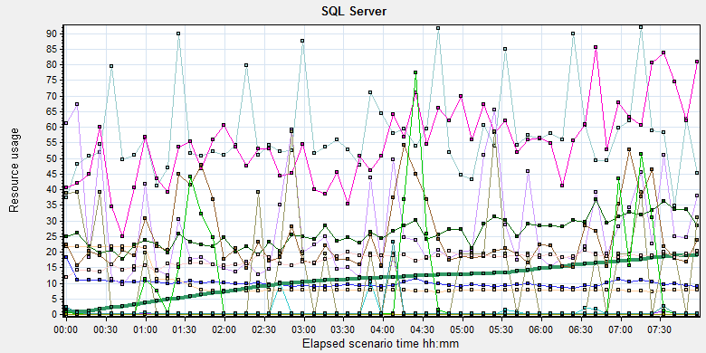
Color |  | Scale | Measurement | Minimum | Average | Maximum | Std. Deviation
 |  | 0.1 | Average Latch Wait Time (ms) (MSSQL$GCPACSWS|Latches):10.184.129.108 | 0 | 6.433 | 16114 | 194.391
 |  | 10 | Checkpoint pages/sec (MSSQL$GCPACSWS|Buffer Manager):10.184.129.108 | 0 | 5.806 | 239.127 | 21.237
 |  | 1 | Current latch waits (MSOLAP$GCPACSWS|Locks):10.184.129.108 | 0 | 0 | 0 | 0
 |  | 1 | Free list stalls/sec (MSSQL$GCPACSWS|Buffer Manager):10.184.129.108 | 0 | 0 | 0 | 0
 |  | 1 | Latch waits/sec (MSOLAP$GCPACSWS|Locks):10.184.129.108 | 0 | 0 | 0 | 0
 |  | 1 | Latch Waits/sec (MSSQL$GCPACSWS|Latches):10.184.129.108 | 0 | 9.97 | 339.709 | 7.175
 |  | 100 | Lazy writes/sec (MSSQL$GCPACSWS|Buffer Manager):10.184.129.108 | 0 | 0.005 | 7.297 | 0.127
 |  | 0.001 | Lock Memory (KB) (MSSQL$GCPACSWS|Memory Manager):10.184.129.108 | 6904 | 9927.774 | 21688 | 4830.31
 |  | 1 | Lock Timeouts (timeout > 0)/sec (MSSQL$GCPACSWS|Locks _Total):10.184.129.108 | 0 | 0 | 0 | 0
 |  | 100 | Lock Timeouts/sec (MSSQL$GCPACSWS|Locks _Total):10.184.129.108 | 0 | 0.548 | 18.263 | 1.067
 |  | 1 | Lock Wait Time (ms) (MSSQL$GCPACSWS|Locks _Total):10.184.129.108 | 0 | 27.04 | 7042.174 | 187.446
 |  | 1 | Lock waits/sec (MSOLAP$GCPACSWS|Locks):10.184.129.108 | 0 | 0 | 0 | 0
 |  | 100 | Lock Waits/sec (MSSQL$GCPACSWS|Locks _Total):10.184.129.108 | 0 | 0.262 | 4.981 | 0.4
 |  | 10000 | Number of Deadlocks/sec (MSSQL$GCPACSWS|Locks _Total):10.184.129.108 | 0 | 0.001 | 0.334 | 0.02
 |  | 1 | Number of SuperLatches (MSSQL$GCPACSWS|Latches):10.184.129.108 | 0 | 0 | 0 | 0
 |  | 0.001 | Page life expectancy (MSSQL$GCPACSWS|Buffer Manager):10.184.129.108 | 980 | 10935.62 | 19297 | 5114.717
 |  | 0.01 | Reserved pages (MSSQL$GCPACSWS|Buffer Manager):10.184.129.108 | 0 | 2475.276 | 76265 | 7901.064
 |  | 100 | SQL Re-Compilations/sec (MSSQL$GCPACSWS|SQL Statistics):10.184.129.108 | 0 | 0.176 | 2.657 | 0.299
 |  | 100 | Temp Tables Creation Rate (MSSQL$GCPACSWS|General Statistics):10.184.129.108 | 0 | 0.075 | 18.26 | 0.684
 |  | 1 | Total deadlocks detected (MSOLAP$GCPACSWS|Locks):10.184.129.108 | 0 | 0 | 0 | 0
 |  | 0.01 | Total Latch Wait Time (ms) (MSSQL$GCPACSWS|Latches):10.184.129.108 | 0 | 79.258 | 203374.282 | 2718.61
There are 10 latches every seconds during the testing work (Latch Waits/sec (MSSQL$GCPACSWS|Latches)). Compare with the value of phase5 (19). The system has some enhance. There are also has some locks, deadlocks and lock time out issues. Some SQL statement needs to enhance to fix these issues. The detail information please sees the attachments which collect all deadlock information during the testing works.

Test Conclusion
The result of this phase testing works is good. There is only 7 test error and 4 main workflows failed during the testing works.
The transaction average response time is less than 2 seconds and no hardware bottleneck. Even there are some locks and latches exist in the database, but they do not block the main workflow execute operations.
Now the upload attachments operation meets the requirements. I collect the records which created time is performance start time and status end time is extend 3 hours after testing works. The detail information as follow:
Type | Count | Size | All
Dicom | 3238 | 9M | 29,142M
Dicom Png | 3238 | 1.4M | 4533.2M
Report Jpg | 2638 | 0.15M | 395.7M
Report PDF | 2638 | 0.12M | 316.56M
 |  |  | 34,387.46 MB

The system uploaded 34.3GB data to server in 11 hours. The result meets the requirements.
During the testing works, we print 2810 films and 2799 reports. Upload 34.3GB data include dicom, dicom png, jpg report and pdf reports. The system thought can meet most scenarios of our clients.
After the hard works with team, our system has a big enhance and meet the requirement. Thanks for the supporting works from develop and QA teams.
I will continue the performance testing work and give big stress to identify the limitation of our system.

<End of document>

